
2025 Premier’s Hicksons Lawyers STEM Scholarship

Future-ready teachers preparing for Future Made in Australia
Krissa Diamante
Canley Vale High School
Sponsored by Hicksons Lawyers


Introduction
Artificial Intelligence (AI) is rapidly transforming the global education landscape, creating new challenges and opportunities for teaching, learning, and leadership. This report draws on insights from a five-week international study tour across the United States (US), United Kingdom (UK), Belgium, and United Arab Emirates (UAE), investigating how educational institutions are adopting AI technologies and reimagining their pedagogical practices.
As AI continues to reshape the educational landscape, schools are increasingly challenged to build ethical, inclusive, and sustainable approaches to AI integration. This report showcases emerging pedagogical practices, human-led strategies, and system-wide innovations that promote AI literacy, AI competency, and the development of AI citizenship among teachers and students.
In the Australian context, these insights arrive at a pivotal moment. Framed within the New South Wales (NSW) educational context, the findings are aligned with the national direction outlined in The Future Made in Australia Act, announced by Prime Minister Anthony Albanese in May 2024 (Parliament of Australia, 2024). The Act outlines a national commitment to strengthen Australia's Innovation and Technology sectors. With an estimated 75% of the fastest-growing future careers requiring digital and STEM capabilities (Leigh et al., 2020; Australian Human Rights Commission, 2023), it is imperative that NSW schools begin to prepare and equip students with the necessary skill sets.
Through international insights and local relevance, this report aims to guide NSW schools and policymakers in embedding AI meaningfully into curriculum, pedagogy, and system design, ensuring every learner is equipped to thrive in an AI-enhanced society.

Focus of Study
The focus of this study was to explore how schools and universities adapt to the growing accessibility, usability and sophistication of AI. Additionally, the study aimed to inquire how AI can assist in improving the learning of students with a language background other than English (LBOTE) and students from lower socioeconomic backgrounds (LSEB).
The study was structured to follow the five research questions:
- To what extent does AI enhance and undermine the knowledge of humanity?
- How can AI improve and develop the literacy skills of students with a LBOTE and students from LSEB?
- How aligned are the goals and expectations of industry and educational institutions in training and skill development?
- How has the integration of AI in teaching and learning improved LBOTE and LSEB students’ high order thinking skills?
- In what ways has AI increased access to knowledge and information, and enhancement of skill amongst LBOTE and low SES students?

Significant Learning
Significant findings revealed that the adoption and integration of AI in classrooms is rapidly evolving. As predicted, educational institutions across the US, UK, Belgium, and UAE are in the early stages of implementing AI tools within their learning environments. However, further research is needed to understand how AI can specifically enhance learning outcomes for students with LBOTE and students from LSEB.
Throughout the tour, teachers and researchers were observed as adaptive and forward-thinking professionals. They demonstrated a strong willingness to navigate the uncertainties of AI by:
- Understanding the AI curve of expertise within their educational context,
- Delivering a human-led pedagogy alongside AI tools,
- Developing AI literacy and competencies skill sets,
- Promoting AI citizenship within their school communities.
This report captures emerging, real-world pedagogical practices observed during the tour. It highlights effective strategies that teachers globally are using to integrate AI into teaching and learning. Overall, there was a shared optimism toward co-creating with AI to transform lessons and assessments that foster higher-order thinking and 21st-century skills, including creativity, communication, collaboration, and critical thinking. As a result, schools globally are working toward upskilling staff to critically evaluate and effectively apply AI tools, including Generative AI, in their practice.

AI curve of expertise
The AI curve of expertise (Figure 1) emerged during the global study tour as a conceptual model illustrating the varying levels of AI engagement among educators within a single school or institution. It categorises staff along a spectrum - from non-technological adopters to highly adaptive adopters, with many educators occupying a middle ground as cautiously inquisitive. Understanding this curve enables school leaders and policymakers to identify existing capacities and target professional development to build collective AI capability.

Logic Studio School
In the UK, Mr Alex Pett, Principal of Logic Studio School in Feltham, exemplifies how recognising the AI curve of expertise can inform effective leadership. He acknowledges his teaching staff as predominantly highly adaptive adopters of AI, and strategically co-designs professional development that empowers educators to lead micro-inquiry workshops. These sessions focus on the practical integration of AI tools such as Suno and MagicSchool AI, supporting lesson planning, assessment design, and feedback processes. Mr Pett also encourages the use of AI to streamline administrative tasks, such as reporting and lesson planning, freeing up time for teachers to prioritise human-led pedagogy in the classroom.
As a result, educators at Logic Studio School are better able to engage in meaningful teacher-student dialogue and adapt lessons to meet individual learning needs.
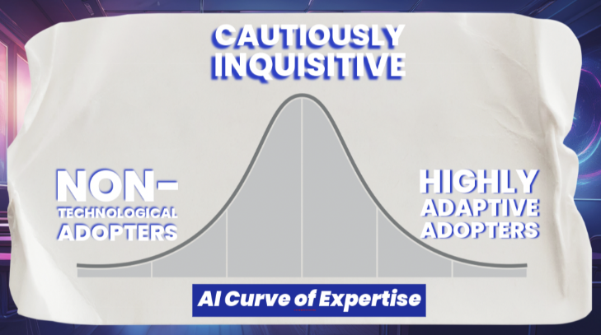
Figure 1: AI Curve of Expertise (By Krissa Diamante)

Deeper Learning 2025 Conference
A similar approach is evident at the High Tech High Graduate School of Education (HTH GSE) in San Diego, California, US. In collaboration with Inkwire, HTH GSE developed The AI Kaleidoscope (Figure 2), an educational chatbot designed to support teachers in lesson planning, curriculum design, and instructional creativity.

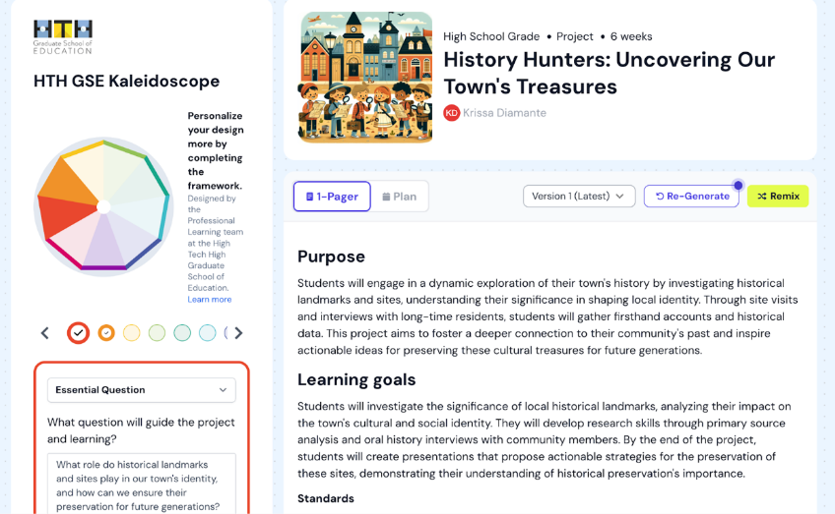
Figure 2: HTH GSE Kaleidoscope - AI-assisted Curriculum Design tool (By Aatash Parikh, CEO of Inkwire)
AI Kaleidoscope allows educators to select relevant deeper learning competencies (Figure 3) and receive guided, inquiry-based suggestions. This positions teachers as active agents to evaluate AI-generated content, refine lesson materials and activities, and promote curriculum alignment, equity, and differentiation, particularly for students with a LBOTE and students from LSEB.
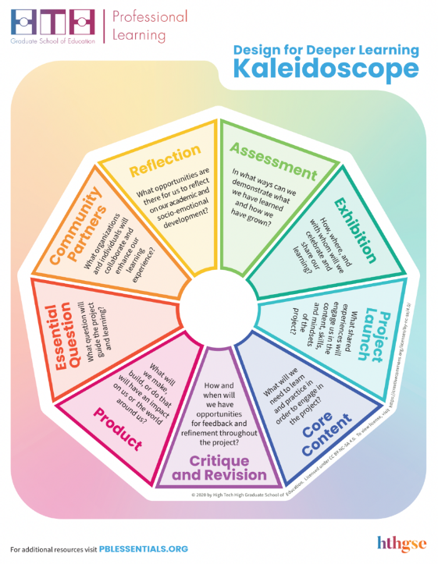
Figure 3: HTH GSE Kaleidoscope - Design for Deeper Learning Competencies (Photo by HTH GSE DL)
AI Kaleidoscope enables teachers to generate differentiated materials at multiple language proficiency levels, incorporate culturally responsive examples tailored to students’ lived experiences, and produce multimodal outputs such as dual-language summaries. The platform promotes inclusive practices by helping teachers design lessons that are contextually grounded and accessible for all learners.
These global examples hold significant relevance for NSW educators and policymakers, particularly in light of the Future Made in Australia Act (2024), which calls for equitable and inclusive innovation across sectors, including education. Recognising and responding to the AI curve of expertise is vital for system leaders aiming to build teacher capacity, promote ethical AI use, and maintain a human-centred pedagogy that supports all students, especially those in underserved communities.

Human-led pedagogy
The increasing sophistication of AI technologies has enabled students and broader school communities to access emerging educational technology tools beyond formal learning environments. This shift presents both opportunity and risk. The overwhelming volume of information, data, and AI-generated experiences has heightened uncertainty and concern, particularly around academic integrity, and underscores the urgent need for students to be positioned as active, critical participants in their learning.
As AI tools become more embedded in educational settings, teachers are increasingly required to strike a careful balance between embracing technological advancements and fostering holistic, human competencies that equip students for both professional and civic life (Chan, 2024). In response, human-led pedagogy has re-emerged as a cornerstone principle—one that ensures AI integration does not replace but enhances the relational, creative, and ethical dimensions of teaching.

London Metropolitan University
At London Metropolitan University, Dr Timos Almpanis and Mr Michael Upton co-chair the AI Steering Group, a cross-disciplinary initiative committed to embedding human-led pedagogies across faculties. This group was formed to address the rising fear of AI-facilitated academic misconduct while also re-framing AI as a tool to support (not threaten) educational integrity. A key assertion of the group is that AI, while powerful, is anthropomorphic. AI lacks consciousness, empathy, and moral judgment. Thus, teachers retain the central role of guiding, modelling, and strengthening essential human qualities in their students – such as metacognition, empathy, and creative problem-solving.
To enact this vision, the AI Steering Group has launched several impactful initiatives:
- a student-led forum that centres discussions on AI’s effects on learning and academic values;
- a cross-discipline partnership to address misconceptions and share practical strategies for responsibly integrating AI into teaching;
- a publicly accessible AI literacy hub on the university library’s website, detailing key competencies needed to critically engage with AI systems.
However, many mainstream AI tools are not originally designed for educational purposes, and their pedagogical alignment remains limited. Research by Holmes, Bialik, and Fadel (2019) highlights this concern, noting that the integration of AI in schools must be accompanied by teacher-led demonstrations and scaffolding to ensure AI tools are used meaningfully within learning contexts.
Dr. Almpanis argues that these limitations can be overcome in primary and secondary education through transparent, teacher-led demonstrations and open dialogue with students about the effective and safe use of AI tools in the classroom. This echoes a broader call for ethical, human-led AI integration, particularly relevant for NSW schools to focus on responsible and inclusive innovation, digital equity, and the development of 21st-century capabilities amongst young Australians.

Hurlingham Prep and Nursery School
Miss Mikaela Elbourne, Head of Digital Strategy and Computing at Hurlingham Prep and Nursery School in London, UK reinforces this ethos. As an early, highly adaptive adopter of AI technologies, Miss Elbourne initiates open conversations with both students and staff around AI’s role in learning. Her work integrates AI meaningfully into the curriculum for students aged 4–11, including a six-week computing unit for Year 6 students exploring tools like Google’s Experiment Page, Teachable Machine and AI text-to-image generators. The unit focuses on recognising AI hallucinations, identifying misinformation, and building critical thinking through student-designed AI models.
Moreover, Miss Elbourne extends this pedagogical vision to the wider school community by encouraging parents to engage in conversations about their children’s interactions with AI technologies, both at school and at home. This triangulated approach (teacher, student, and parent) strengthens a collective understanding of AI’s role in society and reaffirms the importance of human agency in an increasingly automated world.

AI literacy and competencies
Chiu et al., (2024) provides the definition of the terms:
- AI literacy is the ability to understand, interpret, and communicate how AI systems work, including recognising their limitations, biases, and societal impacts.
- AI competency builds upon this by emphasising the responsible, confident, and ethical use of AI tools to enhance teaching, learning, and problem-solving in educational settings.

Arcadia British School
Across the global study tour, schools that demonstrated a strong commitment to AI literacy and competencies did so by integrating explicit opportunities for staff and students to critically engage with AI, not just consume it passively. For example, at Arcadia British School in Dubai, UAE, teachers are supported to build practical AI skills while retaining a strong human-led pedagogy. Mr Alex Gray, Head of Sixth Form, frames AI as a tool to extend teacher capabilities, enabling the design of deeper, more time-efficient learning experiences without sacrificing creativity or empathy. He encourages his staff to use AI thoughtfully and to design learning that develops students’ discernment and ethical judgement, particularly when evaluating AI-generated content.
A key risk highlighted by Mr Gray is cognitive offloading, where students over-rely on AI for answers rather than engaging in reflective, critical inquiry. This trend disproportionately affects students with LBOTE and students from LSEB, who may not have consistent access to the guidance or scaffolding needed to use AI critically. To mitigate this, Gray suggests the integration of custom GPTs into lessons to support structured reasoning and ethical discussions, while aligning activities with frameworks such as the AI Assessment Scale (Perkins et al., 2024), Technological Pedagogical Content Knowledge (TPCK) (Mishra & Koehler, 2008) and Harvard’s Project Zero.
In parallel, Mr Phil Long, Head of Primary STREAM and AI at Arcadia British School, embeds AI literacy into the school’s foundation years. Through early exposure and iterative co-creation with AI, students can build a functional understanding of how AI works and develop critical thinking skills to question, refine and adapt generated outputs. Similar to Mr Gray’s pedagogical approaches, Mr Long invites teaching staff to reposition their role as facilitators of inquiry; co-create, iterate and reflect with AI. Mr Long co-created Arcadia’s AI in Education strategy and developed a personalised AI development framework for staff to improve AI literacy skills. The framework embeds a certified self-paced course for teachers to build foundational understanding, encourages experimentation, and demystifies AI technologies; creating a culture where AI is used to support metacognition, creativity, and inquiry-driven learning.
These examples illustrate how AI literacy and competencies are pedagogical responsibilities, especially in a world increasingly shaped by AI systems. For NSW schools, investing in professional learning frameworks that build these capacities is vital. Doing so enables teachers to evaluate AI outputs critically, design ethically sound learning experiences, and ensure that students, particularly those from marginalised or under-resourced backgrounds, can navigate and shape AI technologies, not be shaped by them.

AI citizenship
AI citizenship represents the intersection of AI literacy and competency, where individuals engage with artificial intelligence critically, ethically, and collaboratively. In educational settings, AI citizenship builds upon the foundation of digital citizenship, urging students and teachers alike to understand algorithms, question data practices, reason ethically, and maintain agency when interacting with AI systems. As AI technologies increasingly influence society, it is no longer sufficient for learners to remain passive consumers. Instead, individuals must become co-creators, ethical evaluators, and informed decision-makers in an AI-driven world (UNESCO, 2025). And so, fostering AI citizenship is a critical step in ensuring young Australians can navigate and contribute to a rapidly evolving digital society with confidence and integrity.

FARI Institute, AI for the Common Good
One international example of how AI Citizenship is being promoted systemically is the work of the FARI Institute, AI for the Common Good in Brussels, Belgium. FARI, a not-for-profit initiative led by the Vrije Universiteit Brussel and Université libre de Bruxelles, positions ethical, transparent, inclusive, and human-centric AI at the core of its mission (FARI, 2025). Through a series of research-based projects, FARI explores AI’s role in strengthening democratic engagement, social equity, and sustainability. Importantly, FARI actively engages the citizens of Brussels in participatory AI development. An example of this is FARI’s AI Happy Hour initiative, launched in early 2024. This monthly session, held at the AI Experience Centre, brings together citizens, researchers, and policymakers from various sectors to discuss real-world implications of AI.
The institute also delivers educational programs, including postgraduate courses and public training sessions, to equip learners with the tools and knowledge to engage in AI governance and ethics. Notably, its AI4GOV-X project, part of the European Union’s Digital Europe Programme, provides public sector professionals with training in AI, data spaces, and digital government transformation through modular online learning and practical workshops. These efforts exemplify how AI citizenship can be cultivated at scale through cross-sector collaboration, public engagement, and targeted education.

Human Intelligence Movement
Similarly, in the US, the Human Intelligence Movement (HIM) advances AI citizenship as a form of transformational literacy. HIM supports schools and organisations in developing ethical, purposeful relationships with AI technologies, emphasising human values and intelligence above technological adoption.
At the 2025 SXSWEdu Conference in Austin, Texas, Dr Shannon Terry, Secretary of HIM, presented the AI Maturity Continuum: a strategic framework outlining five stages of AI integration, from initial awareness to systemic transformation. This continuum places responsibility on leadership roles: Chief Executive Officers, Chief Technology Officers, and Chief Academic Officers to nurture AI citizenship by:
- Implementing education and training programs that build staff AI literacy and competence,
- Establishing robust policies and ethical frameworks that address bias, transparency, and accountability, and
- Extending AI initiatives into the wider community to foster collective understanding and participation in responsible AI use.
For NSW schools and systems, such global models offer clear guidance. Under the Future Made in Australia Act, the emphasis on human-led, values-driven innovation calls for AI education strategies that are inclusive, transparent, and grounded in ethical decision-making. Local curriculum frameworks must now evolve to embed AI citizenship into both teacher professional learning and student experiences, particularly for those with a LBOTE and from LSEB, ensuring no one is excluded from shaping our AI-enhanced future.

Conclusion
The global study tour revealed a global momentum toward redefining pedagogical practices in response to the increasing accessibility and sophistication of AI technologies. A key insight was the concept of the AI Curve of Expertise, which recognises the diversity of teacher readiness and confidence when using AI. From non-technological adopters to highly adaptive innovators, educational leaders who identify and support staff along this curve can strategically grow AI capacity and strengthen collaboration across schools. Schools like Logic Studio School in the UK and Arcadia British School in the UAE have begun implementing professional development frameworks to address this variation, ensuring AI tools are used to extend (not replace) effective teaching. Equally significant is the rise of Human-Led Pedagogy. As AI tools become more prevalent, educators must intentionally preserve the uniquely human elements of teaching: metacognition, empathy, creativity, and connection. Universities such as London Metropolitan University and primary institutions like Hurlingham School Prep and Nursery School model the importance of embedding ethical, age-appropriate, and inclusive AI conversations into everyday practice. The report also highlights the foundational importance of AI Literacy and Competency; understanding how AI works, how to use it responsibly, and how to develop critical thinking around its outputs. These skill sets are particularly essential for students with a LBOTE and from LSEB to navigate learning equitably and confidently in an AI-enhanced environment. Finally, the tour emphasised the growing global movement towards AI Citizenship. Non-profit organisations such as FARI in Belgium and the Human Intelligence Movement in the US are leading forces in equipping citizens with the knowledge, ethics, and agency required in an AI-driven society. These principles should now inform how we design curricula, teacher training, and policy frameworks, such as those supported by Australia’s 2024 Future Made in Australia Act.
These findings will be disseminated through a 5-part podcast series on YouTube called @FutureReadyTeacher, an Adobe Education Vodcast expert interview with Dr Tim Kitchen (featured within the June edition of the Adobe in Education Update Australasia), and a featured speaker session at EDUtechAU 2025 titled ‘Future Ready Teacher: Preparing for a Future Made Classroom’.
The central message for teachers and educational stakeholders is clear: the integration of AI in education must be grounded in human-centric, ethical, and inclusive principles. Effectively preparing students for the future begins with strategically empowering and equipping educators today.

Acknowledgements
- Adobe Education – Dr Tim Kitchen (Senior Education Specialist, APAC) and Martin Ricardo Cisneros (Education Evangelist Adobe K-12), and Claudio Zavala Jr. (Education Evangelist Adobe K-12)
- Arcadia British School – Alex Gray (Head of Sixth Form and Host of The International Classroom Podcast) and Phil Long (Head of Primary STREAM and AI)
- Day of AI – Natasha Banks (Program Director)
- Deeper Learning 2025 Conference – Aatash Parikh (Inkwire, Founder), Rosemarie Biocarles-Rydeen (Professional Learning Facilitator & Designer, High Tech High), Bryanna Hanson (Director of Learning Design, Learning-Centre Collaborative), Katie Weisberg (Director of Strategic Partnership, Learning-Centre Collaborative) and Soraya Ramos (Assessment Design Partner, Envision Learning Partners)
- FARI Institute, AI for the Common Good – Lore Stanson (AI Academy Program Lead)
- HP Education – Brett Salakas (Founder of #aussieED and HP Education Ambassador)
- Hurlingham Prep and Nursery School – Mikaela Elbourne (Head of Computing and Digital Strategy)
- Insight Centre – Dr Anna Denejkina (Associate Director)
- Kardinia International College – Aisha Kristiansen (Head of Innovation & Technology K-12)
- Logic Studio School – Alex Pett (Principal)
- London Metropolitan University – Professor Julie Hall (Vice Chancellor and Chief Executive), Michael Upton (Head of Teaching and Learning Development, Centre for Teaching Enhancement), Dr Timos Almpanis (Principal Lecturer in Digital Education), Dr Elaheh Homayounvala (Course Leader and Senior Lecturer in Artificial Intelligence and Machine Learning), Sabri Dikmen (Liaison, Research and Digital Manager) and The AI Steering Group
- Our Lady of Mercy College Parramatta – Tony Tang (2024 NSW Premier’s Hicksons Lawyer STEM Scholar)
- NSW Department of Education – Dan Hart (Head of AI) and Nigel Shakespeare (Head of TAS, Plumpton High School)
- SXSWEdu 2025 Conference – Don Fraser Jr. (Senior Vice President of Design and Innovation, Education Design Lab), Dr Shannon Terry (Human Intelligence Movement Executive Board Member and Founder & Chief Ideator of The Learning AI-gency), Professor John Broome (Professor of Social Studies Education, Purdue University), Coretta Martin (Co-founder and Chief Strategy Officer, IEP&Me), Lindsay Kincaid (Chief Program Officer, Team4Tech) and Jamie Nunez (Western Regional manager, Common Sense Media)
- Scotch College – Dr Nick Jackson (Digital Technologies Lead)
- The Next Word – Matthew Esterman (Founder and Director)
- University of Kansas – Professor Yong Zhao (Foundation Distinguished Professor)
- University of Leeds – Professor Sarah Howard (Professor of Digital Education & Lead, Centre for Research in Digital Education)
- Vrije Universiteit Brussel (MILO) – Professor Jo Tonduer (Assistant Professor of Teacher Education), Dinaol Urgessa Gita (PhD student, Faculty of Psychology and Educational Science) and Tian Zhao (PhD student, AI in Teacher Education)

References
Artificial Intelligence Office. (2021). UAE National Strategy for Artificial Intelligence 2031. Government of the United Arab Emirates, https://ai.gov.ae/wp-content/uploads/2021/07/UAE-National-Strategy-for-Artificial-Intelligence-2031.pdf
Australian Human Rights Commission [National AI in Schools Taskforce]. (2023). Utilising ethical AI in the Australian Education System. Submission to the Standing Committee on Employment, Education and Training. https://humanrights.gov.au/sites/default/files/inquiry_into_the_use_of_generative_artificial_intelligence_in_the_australian_education_system_14_july_2023_0.pdf
Chan, C. (2024). Holistic competencies and AI in education: A synergistic pathway. Australasian Journal of Educational Technology. Melbourne, Australia, 40(5), pp. 1–12. doi: 10.14742/ajet.10191.
Chiu, T.K.F., Ahmad, Z., Ismailov, M. & Sanusi, I.T. (2024), What are artificial intelligence literacy and competency? A comprehensive framework to support them. Computers and Education Open, vol. 6, 100171. https://doi.org/10.1016/j.caeo.2024.10017
FARI Institute. (2024). FARI - AI for the Common Good. Brussels. Université libre de Bruxelles and Vrije Universiteit Brussel. https://fari.brussels/
Holmes, W., Bialik, M., & Fadel, C. (2019). Artificial Intelligence in Education: Promises and Implications for Teaching and Learning. Center for Curriculum Redesign.
Leigh, K., Hellsing, A., Smith, P., Josifovski, N., Johnston, E., & Leggett, P. (2020). Australia’s STEM Workforce. Office of the Chief Scientist 12. https://www.chiefscientist.gov.au/sites/default/files/2020-07/australias_stem_workforce_-_final.pdf.
Mishra, P. & Koehler, M.J. (2008). Introducing technological pedagogical content knowledge. AACTE Committee on Innovation and Technology (ed.). Handbook of technological pedagogical content knowledge (TPCK) for educators. Routledge, New York, pp. 3–29.
Parliament of Australia (2024), Future Made in Australia Act 2024. Act no. 119 of 2024, Commonwealth of Australia https://www.aph.gov.au/Parliamentary_Business/Bills_LEGislation/Bills_Search_Results/Result?bId=r7219
Perkins, M., Furze, L., Roe, J., & MacVaugh, J. (2024). The Artificial Intelligence Assessment Scale (AIAS): A framework for ethical integration of generative AI in educational assessmen. Journal of University Teaching and Learning Practice. vol. 21, no. 6, https://doi.org/10.53761/q3azde36
UNESCO. (2025). Artificial intelligence in education. United Nations Educational, Scientific and Cultural Organization. https://www.unesco.org/en/digital-education/artificial-intelligence

