
2025 Premier’s Vocational Education in Schools

Linking connections
  - Maximising student potential and long-term opportunities through vocational education in rural and remote communities
Frieda Gorman
Bellingen High School
Sponsored by NSW Department of Education


Introduction
This research was carried out through a comprehensive four-week tour of the Highlands and Islands of Scotland in January 2025. This involved visits to nine schools, ten colleges, research institutions, private training organisations, local councils, employers, community members, Chambers of Commerce, and government agencies.
The aim was to gather insights into best practices for delivering vocational education to high school students in rural and remote areas. A particular focus was given to Scotland’s unique Senior Phase Program, delivered by the University of the Highlands and Islands (UHI), which offers vocational education to school students.

Focus of Study
The focus of this study was to identify best practice methods for strengthening and integrating connections among key players in vocational education – communities, schools, colleges, businesses, government agencies and local industries – with the aim of uniting them around a shared purpose. A key objective was to determine strategies for aligning vocational training with the specific needs of local industries, including their cultural contexts, in order to provide targeted employment pathways and support youth retention in rural areas.
Equally important was to pinpoint methods to enhance school-based processes for delivering vocational education. This included addressing potential conflicts with existing curriculum requirements, exam schedules, timetabling, and administrative systems. By refining these processes, the effectiveness and accessibility of vocational education, particularly in rural and remote contexts, could be significantly improved.
Identifying such methods could notably enhance training and employment opportunities for high school students in New South Wales, equipping them with a sense of responsible citizenship and fostering a commitment to lifelong learning.

Significant Learning

Scottish Credit and Qualifications Framework (SCQF)
The Scottish Credit and Qualifications Framework (SCQF) is widely promoted and accessed in Scottish schools and in the wider community. The SCQF is included in the curriculum to varying degrees and celebrated through the SCQF School Ambassador Recognition Program. Schools are awarded bronze, silver or gold status and strive to reach gold level recognition where SCQF is embedded in school practice, with schools offering a significant range of senior phase pathways. Current vocational education students are involved in promoting benefits to younger students, parents and community through ‘Focus Fortnight’ activities.
There is a distinct focus on ‘no one path’ to a career, where every course is assigned value along this pathway. Alternative courses to traditional higher (HSC-type) subjects include Skills for Work, National Progression Awards, National Certificates at varying levels, Foundation Apprenticeships and the Scottish Baccalaureate across a multitude of subject areas. Additionally, students are able to gain credit points in the SCQF framework to recognise wider achievement and the development of skills for a wide variety of activities such as participation in work experience, young enterprise, voluntary work, leadership and sport refereeing.
Teachers can deliver many of these courses without a lengthy accreditation process in partnerships with colleges and employers, managed by Skills Development Scotland.
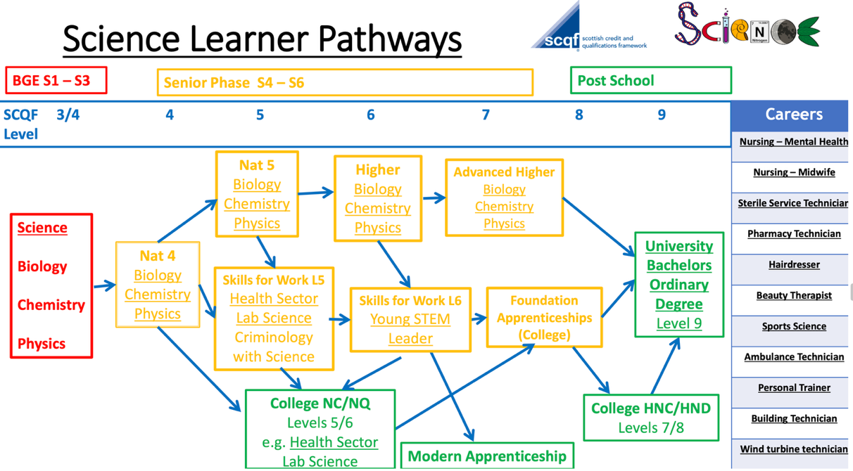
Figure 1 Science Learner Pathways at St Paul’s RC High School Glasgow with Senior Phase courses in yellow available to students in years 10,11 and 12 (photo from St Paul’s handbook)
Teachers across all faculties receive SCQF professional learning and are realising the benefits of delivering vocational education rather than the traditional HSC type of courses.
‘The framework helps schools, pupils and learners see a pathway of progression through a variety of levels and a range of qualifications available. Success for each learner varies and routes to a positive destination can be achieved via different pathways.’ – teacher, St Paul’s RC High School Glasgow
Students are also experiencing the advantages of vocational education, which is becoming apparent through learning conversations:
‘After studying my National Progression Award in Criminology I want to stay on at college and move to the next level at Higher National Certificate. After this I want to get into University for Psychology and become a Forensic Psychologist.’ – Kacey, Year 12, St Pauls RC High School Glasgow

Foundation Apprenticeships (FA)
Foundation Apprenticeships (FA) are an extremely popular work-based learning opportunity for senior-phase secondary school students. Foundation Apprenticeships are similar to School Based Traineeships in New South Wales; however, they are unpaid. Unemployment rates in Scotland are significantly higher for young people compared with adults. Foundation Apprenticeships aim to change this by supporting students to build the skills they’ll need to be successful when they leave school, therefore closing the gap between the classroom and the workplace.
Foundation Apprenticeships are currently available across 12 subjects including civil engineering, scientific technologies, software development, accountancy, food and drink technologies and financial services. Aquaculture Foundation Apprenticeships are currently being trialled to link to fish farming opportunities, a major growth sector in the Scottish rural economy.
Completion of a Foundation Apprenticeship leads to a qualification at the same level of learning as an HSC level subject and can lead to progression to a job, such as a Modern or Graduate Apprenticeship.
Foundation Apprenticeships have an excellent reputation throughout Scotland, in addition to being recognised as entry qualifications by all Scottish colleges and universities.
‘The UK is facing unprecedented economic challenges….So there has never been a more important time to get our skills system right. Scotland is leading the way within the UK on tackling many of these challenges and Foundation Apprenticeships is an excellent example of this. In our publication 'Towards a Twenty-First Century Education System', Foundation Apprenticeships are recognised as beacons of hope in providing young people with the education they need.’ – Olly Newton, Director of Policy and Research, The Edge Foundation
Scotland’s government-led Insight Tariff Scale, which quantifiably measures student attainment across various qualifications, highlights the success of Aberdeenshire’s Foundation Apprenticeships over the 2023/204 academic year. This includes a 58.8% average increase in attainment across the first four years of delivery, 30% attendance increases for FA students, and a 50% increase in engagement particularly in Year 10. Nearly all (98.4%) FA students progress to positive destinations. Skills Development Scotland report a rapidly rising number of Foundation Apprenticeships, from 346 enrolments in 2016 to 4,122 enrolments in 2021 when the most recent data was collected.

Administrative structure of Scottish schools
In the Highlands and Islands, school timetables are carefully designed to ensure students have broad access to vocational learning opportunities. Vocational programs are predominantly scheduled on Fridays and are delivered by a mix of schools, colleges, and private training providers. To support this, schools refrain from timetabling Higher (HSC-type) subjects on Fridays.
Scottish education structures Year 11 and 12 subjects to be completed within a single year. As many students receive university offers based on their Year 11 academic results, Year 12 often provides a valuable opportunity to pursue vocational studies and gain practical skills.
School reports include detailed vocational subject results including comments, formatted to align with each school’s style of reporting. Year 10 subject selection is pathways based where students are encouraged to select a variety of SCQF level courses targeted at future career plans. End of year result certificates focus on overall attainment and achievement rather than solely HSC-type grades.

University of the Highlands and Islands (UHI)
The University of the Highlands and Islands (UHI) is structured as a regional partnership of colleges, universities and research institutions from access level (Year 9 school students) to PhD level. UHI operates across 48 locations, through 10 academic partners, each with its own campus and unique characteristics. UHI also delivers vocational educations classes from most larger high schools across the region. Each academic partner has its own management structure, including a board of management to oversee the institution's activities. UHI is renowned for diverse, flexible partnerships and an excellent reputation for being grounded in communities and driven by their needs. For example, students in Stornoway, Outer Hebrides, can train as nurses and midwives without having to leave their local area. This improves the capacity for more remote areas to build self-sufficiency in core services.
UHI continually develop their curriculum to respond to skills gaps and shortages identified by local employers.
UHI operate a successful Senior Phase program to school students in Years 10-12, with an extremely wide choice of career-focussed vocational subjects which can be studied online or on campus as part of the school timetable. Senior phase courses aim to:
- broaden pupils' curriculum choices,
- enrich pupils' educational experiences,
- help pupils to develop knowledge and skills for employment and further study, and
- help ease pupils transition from school to further learning or employment.
UHI also provides a clear pathway for students to advance through SCQF levels starting in Year 9, with the option to continue their education through school, college and university all within one organisation or even on the same campus.
In 2024, UHI Inverness recorded 750 school students aged 15-17 enrolled in Senior Phase programs. They have experienced a 17% increase in applications over the last three years and are currently unable to meet this growing demand due to restrictions in credit allocations.
UHI’s Scottish Association for Marine Science (SAMS) is a research centre and university with rapidly growing enrolments. SAMS connects with local schools to offer hands-on workshops, lab and field visits, and STEM challenges which connect students with marine science. Students learn about careers, explore real-world science, and engage in activities linked to the school curriculum. This inspires students to remain in the local rural area to continue their tertiary education.

Fee free education
Universities and colleges are fee free for all Scottish residents. This brings many benefits, such as making tertiary education more accessible to students from all backgrounds and enabling graduates to leave college/university with less debt, easing financial pressure. It also encourages economic growth and social values while strengthening Scotland’s reputation and helps keep talented students in the country.

Retaining young people in rural and remote communities
One major challenge is the migration of young people to the cities. According to 2012 population figures, 90% of those leaving the Island of Lewis were in the 16-24 age group, while the majority of newcomers were in the 65-75 age bracket. UHI Stornoway has worked to stem this tide by offering high-demand degree programs locally. Despite these efforts, however, the trend persists. Leaving the island for city life has become a rite of passage for many young people. Parents often encourage their children to experience life in the city, and career advisors tend to push students toward mainland universities as a sign of success. This cultural expectation has created a cycle that, despite interventions, has been hard to break.
There is hope on the horizon with the 'Talented Islands' initiative. This forward-thinking program aims to create incentives for young people to return to the island after completing university or further education. Plans include subsidised pay, guaranteed employment, and housing subsidies to attract talented individuals back to the island. With backing from local businesses and the government, the initiative has the potential to reverse the trend of out-migration and ensure the island’s economic prosperity for future generations. Yet, as with many rural areas a critical issue remains, affordable housing. This shortage makes it difficult to attract young professionals back to the island, even with financial incentives in place. Addressing this housing crisis will be key to the long-term success of the initiative and the island’s future

Develop the Young Workforce (DYW)
Develop the Young Workforce (DYW) is a highly successful £1750 million government investment in youth employment. DYW officers are assigned to every school to support DYW’s Young Person’s Guarantee to offer every 16–24-year-old the opportunity of a job, apprenticeship, further or higher education, training program or volunteering. DYW builds networks of employers, educators, young people and parents to strengthen relationships. Data collected in 2021 shows that more than 22,000 opportunities have been provided thanks to 800 employers signing up with DYW. Other DYW successes include providing a school leavers toolkit, establishing an Apprenticeship Employer Grant, creating a digital resource hub, national programs and packaged activities. As a result of such initiatives the proportion of 16–24-year-olds with qualifications at SCQF level 5 or above has increased from 88.4% in 2019 to 90.9% in 2021.

Local councils
In Scotland, local councils (local authorities) play a crucial role in both education and employment. Their responsibilities in these areas form part of their wider statutory duties to promote the wellbeing and development of their communities. Their roles include:
- managing schools (including responsibility for student attendance and attainment)
- curriculum implementation
- pupil support and inclusion (including school transport, free school meals)
- quality assurance and improvement in education
- economic development (including supporting local businesses, enterprise hubs, and regeneration projects)
- promoting economic growth to create more job opportunities
- employability services (including running apprenticeship scheme, work placements and internships)
- collaborating with schools, colleges, employers, and organisations to prepare young people for work
- participating in community planning partnerships to align education and employment services.
Councils employ teams to work with schools, colleges and employers including the vital role of Schools Program Manager and Employability Officers.

Chambers of Commerce
Chambers of Commerce in Scotland work with schools, colleges, and training providers to bridge skills gaps, promote work-based learning, and support career pathways for young people. By engaging with employers, they help shape relevant training opportunities, support apprenticeships, and improve employability. Their efforts ensure that education aligns with workforce demands, helping students transition into meaningful employment and contributing to local economic growth.

Collaboration
In 2024, a new civil engineering course was launched to address skills shortages and provide clear pathways into employment. This initiative is the result of a collaboration between industry leaders, local employers, colleges, schools, local councils, and chambers of commerce.
The Energy Skills Partnership (ESP), in partnership with the Civil Engineering Contractors Association Scotland (CECA) and several UHI institutions including Inverness, West Highland, and Argyll, has introduced the CECA Scotland Academy Construction Operations NPA course SCQF Level 5. Designed for young people, some still attending school, the program emphasises hands-on, site-based learning, equipping students with the practical skills needed to begin careers as civil engineering operatives. It also supports the Scottish Government’s infrastructure goals by preparing a new generation of skilled workers to meet the demands of the growing alternative energy sector, particularly in rural and remote areas of Scotland.
Graduates of the course are guaranteed a job interview, with participating employers committed to hiring at least 75% of those who successfully complete the program.

Community
Community involvement is strongly evident throughout rural and remote areas of Scotland. An example being the development of ‘The Brickyard’ in Culloden Academy. The Brickyard was built in an area of the school car park, to train construction foundation apprentices in bricklaying, carpentry and decorating. This strong partnership involves local company Morrison Construction and its associated suppliers that support the school by donating materials, offering guidance across several trades, organising mock interviews, and supporting students with their career paths.
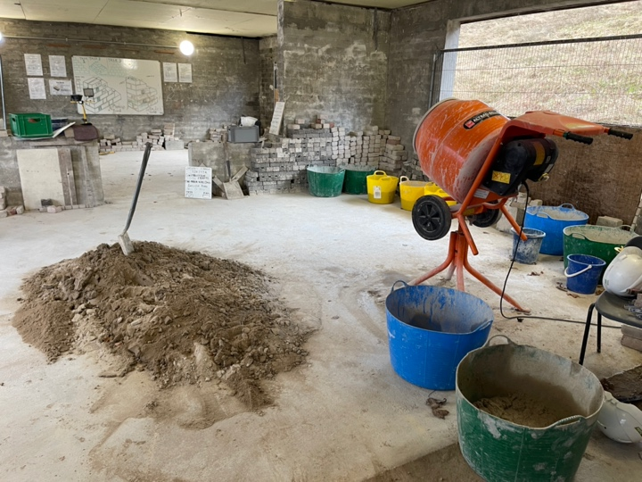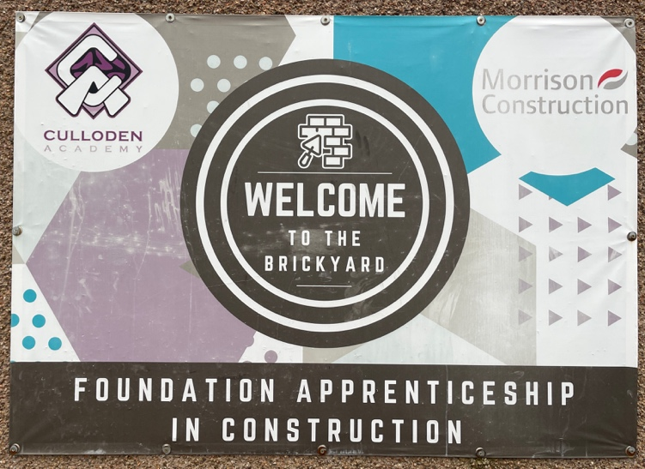
Figure 2 The Brickyard Culloden Academy (photo by Frieda Gorman)
Inverness Kart Raceway delivers an incredibly popular Foundation Apprenticeship in automotive skills where students receive hands on training in the morning followed by using the go karts after lunch. It also acts a youth centre run by a charity providing support to young people. Several local car dealerships and electrical volunteer their expertise and recruit full time apprentices from this program.
UHI’s Sabhal Mòr Ostaig, the Gaelic College on the Isle of Skye, plays a crucial role in preserving Gaelic language and culture. It offers educational and research opportunities through Gaelic-medium courses (including schools programs), supports economic development by building a skilled workforce, and enriches the local culture through arts and community events. The college is a key driver of cultural revitalisation and community engagement in the Highlands and Islands.
Charities such as Rangers Football Club’s Wider Achievement Program has been instrumental in helping young people reconnect with their education and work towards SCQF qualifications, while engaging with industry professionals and developing valuable vocational skills.

Conclusion
The Annual Participation Measure (APM) reports on the education and employment activity of 16–19-year-olds in Scotland and is the source of the Scottish Government’s National Performance indicator. In 2024 this indicator stood at 92.7%, the highest ever percentage using current methodology. This demonstrates that the collective efforts in Scotland are yielding positive results.
Vocational education frameworks can be strengthened by establishing key links and widening partnership connections. One valuable link is the role of an events coordinator and schools program manager, as seen in Inverness, which plays a crucial part in facilitating communication among all parties and supporting student success. Expanding collaboration with local councils, Chambers of Commerce, employers, government agencies, community member and charitable organisations through joint initiatives would ensure training opportunities are aligned with local workforce demands, contributing to sustained economic growth.
Foundation Apprenticeships have proven to be both popular and effective. A significant factor contributing to their success is the limited one-year commitment required from employers, coupled with the absence of any obligation to pay students during the training period. This structure encourages greater participation from local businesses.
To shift traditional perceptions, particularly among parents and the broader community, the promotion of vocational education needs to be intense. Initiatives like the SCQF Ambassador program, alongside targeted advertising through television and social media, effectively highlights the benefits and pathways offered by vocational learning. Access to vocational education must be streamlined by, for example, effectively aligning school timetables with TAFE, as established on Fridays across the Highland and Islands.
Young people who relocate to urban areas for university and career opportunities can be encouraged to return to their communities through targeted incentives, as demonstrated by the success of the Talented Islands Initiative.
Linking education institutions efficiently with employers is crucial for preparing students for the workforce, addressing skills gaps, and fostering economic growth. These partnerships provide valuable real-world learning opportunities, connect students with future career paths, and enable businesses to shape the future workforce.

Acknowledgements
Thank you for the support and collaboration of all who assisted in preparing for and engaging in the study tour and contributed to enriching the overall experience.
Thank you to the NSW Department of Education, whose generous funding of this scholarship made the study tour possible.

References
Edge Foundation 2023, Foundation Apprenticeships: a powerful route to work, Edge Foundation, viewed 29 May 2025, https://www.edge.co.uk/news-and-events/blogs/foundation-apprenticeships/.
Edge Foundation 2023, Foundation Apprenticeships, Edge Foundation, viewed 29 May 2025, https://www.edge.co.uk/news-and-events/blogs/foundation-apprenticeships/.
Scottish Government 2023, Young Person’s Guarantee: Update Report – March 2023, Scottish Government, viewed 29 May 2025, https://www.gov.scot/binaries/content/documents/govscot/publications/progress-report/2023/03/young-persons-guarantee-update-report-march-20232/documents/young-persons-guarantee-update-report/young-persons-guarantee-update-report/govscot%3Adocument/young-persons-guarantee-update-report.pdf.
Skills Development Scotland 2022, Foundation Apprenticeship Report 2022, Skills Development Scotland, viewed 29 May 2025, https://www.skillsdevelopmentscotland.co.uk/media/j4nfmwyz/foundation-apprenticeship-report-2022.pdf.
Skills Development Scotland 2024, Annual Participation Measure 2024 Report, Skills Development Scotland, viewed 29 May 2025, https://www.skillsdevelopmentscotland.co.uk/media/jbndibkf/annual-participation-measure-2024-report.pdf.
Skills Development Scotland 2024, Foundation Apprenticeships, Skills Development Scotland, viewed 29 May 2025, https://www.skillsdevelopmentscotland.co.uk/what-we-do/apprenticeships/foundation-apprenticeships.
University of the Highlands and Islands 2020, Economic Impact Report – September 2020, University of the Highlands and Islands, viewed 30 May 2025, https://www.uhi.ac.uk/en/t4-media/one-web/university/about-uhi/facts-and-figures/publications/pdfs/economic-impact-report-september-2020.pdf.

