
2025 Premier’s History Teachers’ Association History Scholarship

The Spanish Civil War:
  - Revealing and connecting the untold chapters of 20th century Europe
Francisca Castro
Willoughby Girls High School
Sponsored by the NSW History Teachers’ Association


Introduction
The study of the Spanish Civil War [SCW] offers key insights into the ideological and political developments leading to WWII and beyond. Firstly, it highlights the rise of conflicting ideologies, the political tensions that followed, and their global repercussions. Secondly, it underscores the role played by thousands of volunteers, including Australians, who joined the International Brigades [IB] to defend democratic ideals where the League of Nations had failed. Most importantly, the SCW marked the first global battle of WWII, serving as a testing ground for tactics and alliances that would soon dominate global warfare. Its British dimension – through volunteers, media coverage, and political debate – makes it especially relevant to Australia’s past as part of the British Commonwealth. The war revealed the failures of international diplomacy and the impact of breaching the Non-Intervention Agreement, contributing to the spread of authoritarianism.
Understanding these developments is essential for students exploring ideological and political tensions, technological advancements in warfare, and the rise of dictatorships in Spain and elsewhere. It enhances their grasp of core topics in Year 12 Modern History, including Russia and the Soviet Union (1917–1941) and Conflict in Europe (1935–1945).

Focus of Study
This topic was chosen due to the SCW's underrepresentation in Australian syllabi, despite its significance as a precursor to WWII and its relevance to NSW History topics. The study tour included visits to key sites in Australia, Spain, and the UK—museums, archives, prisons, battlefields, as well as other overlooked locations. Conversations with educators and historians, and the collection of resources, have informed the development of a Case Study for classroom use.

Significant Learning
Below is a synthesis of key learnings from the tour and the opportunities these provide for teaching. For each of those included I have considered the opportunities and value these provide for learning in different locations including Australia, the United Kingdom and Spain.

Using sites of historical significance in the classroom

Memorials
In Australia, I attended the unveiling of the memorial located at the Melbourne Trades Hall precinct, the sole monument listing the 70 known Australians who served in the Spanish Civil War as part of the International Brigades. The choir’s rendition of The Internationale and the sense of camaraderie at the ceremony made for a deeply moving experience, one that contrasted starkly with my visit to the other IB’s Memorial monument at Lennox Gardens in Canberra. I also had the pleasure of meeting Professor Judith Keene at the event and, later, Michael Samaras, both authors of literature on the SCW. We discussed several issues, including the impact of not covering this topic in schools. This omission stems largely from the Australian War Memorial’s refusal to include conflicts not involving Australian Defence Forces, a policy that excludes both the Frontier Wars and the SCW.
Though my stay in the United Kingdom was brief, it was packed with memorable moments. I toured the Marx Memorial Library and the International Brigade Memorial Trust (IBMT) in London and attended the unveiling of the Newham International Brigades Memorial at Clapton Community Football Club on 26 April, simultaneously marking the 88th anniversary of the Guernica bombing.
The most endearing event was spending a day with leading historians whose work played a significant role in my understanding of Spain, Professor Sir Paul Preston, Professor Helen Graham, and Dr. Richard Baxell. Our discussions reinforced my belief that the Spanish Civil War was not an isolated event but a critical precursor to World War II. Their insights affirmed that Spain was the first battleground in the global fight against fascism, perfectly supporting the purpose of my study tour. Reflecting on that day, I realise I was so excited that I missed the chance to ask many of the questions I had prepared.
While in London, I visited the National Memorial to the International Brigades (by Ian Walters) in Jubilee Gardens. This honours the 526 British and Irish volunteers who died fighting Franco. Standing before the abstract sculpture, I found myself thinking about how we, as teachers, can guide students to uncover the layered stories behind such public monuments.
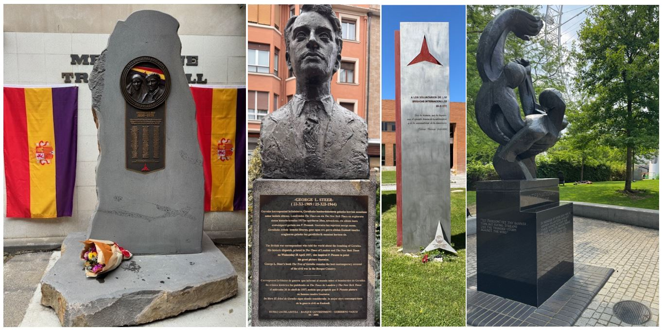
Figure 1: Memorial monuments. The Australian International Brigades unveiled in the Trades Hall in Melbourne on 13 November 2024; to George L. Steer in Guernica, Memorial in Madrid, Spain and Jubilee Gardens, London. (Photos by Francisca Castro).
I had a similar experience walking through Guernica, a town shaped by memory. Here, monuments, statues, and murals vividly recall the events of 26 April 1937. One that stood out was La Agonía del Fuego (by Basque sculptor Nestor Basterretxea), located on the same place where German and Italian bombs fell. This eight-metre-tall abstract piece captures the instant of the explosion and the destruction it unleashed. Looking at it closely, I could almost feel the violence of that moment frozen in form.
While many people recognise the town because of Picasso’s Guernica, its deeper historical significance, especially in the context of the Spanish Civil War and World War II, is less well understood. Most know that this small Basque town was devastated by aerial bombing carried out by Nazi Germany’s Condor Legion and Italian Fascists in support of Franco. But it is important for students to understand that this was one of the first instances of aerial bombardment targeting civilians in modern warfare. Although Franco quickly denied responsibility, I learned – thanks to a bust of British war correspondent George L. Steer on display in the town – that it was Steer who revealed the truth to the world, ultimately inspiring Picasso’s powerful artistic response. Framing the bombing this way helps teachers draw stronger, more meaningful links between the Spanish conflict and the broader escalation of violence leading into WWII.

Stumbling stones
I was particularly struck by the Stumbling Stones (or Stolpersteine) that are appearing across Europe. These small, 10cm² brass tiles are embedded in cobblestone streets and mark the last freely chosen residences of victims of the Nazi regime, including Jews, Sinti and Roma, people with disabilities, dissidents, and other targeted groups.
One that I immediately recognised was dedicated to Francesc Boix Campo, a victim of the Spanish Civil War and photographer. Like many others, he was handed over by Franco to the Nazis and imprisoned in the Mauthausen concentration camp. Later, Boix played a key role in the Nuremberg and Dachau trials, where his photographs helped secure convictions against Nazi war criminals. No doubt, these tiles offer students a powerful and tangible way to begin investigating both the victims of Franco’s regime and Spain’s quiet complicity with Nazi Germany.

Plaques
I noticed how plaques fixed to building façades, and even their absence, can offer powerful opportunities for historical investigation. In Barcelona, for example, Nick Lloyd pointed out a plaque marking the hotel where George Orwell stayed. Directly across the street, another plaque marks the location where Andreu Nin, leader of the POUM, was last seen alive. His disappearance following the May Days of 1937 remains contentious, though his kidnapping and torture under Soviet orders is widely accepted. Exploring this story could lead students into rich discussions about the then clash between Trotskyism and Stalinism.
I was similarly surprised to learn from Dr Almudena Cros about the Spanish government’s refusal to acknowledge the proclamation of the Second Republic (on 14 April 1931) on the façade of the Royal House of the Post Office, a landmark in Madrid where the Republican flag was once raised and jubilant crowds gathered to celebrate the end of the monarchy. Instead, plaques commemorating the 2 May 1808 uprising against Napoleon’s troops, and the victims of the 2004 terrorist attacks stand. Like many public sites of remembrance, both what is remembered here and what is left out, offer valid entry points for students to engage in historical inquiry using the urban landscape as a source.

Prisons and halls of remembrance
There were two places during the study tour where I felt genuinely uneasy. The first was Fort San Cristóbal located on a hilltop on the outskirts of Pamplona. Originally built in 1878, it later became a prison where Republican detainees endured overcrowding, poor sanitation, disease, and torture under Franco’s repressive regime.
The second was the Valle de Cuelgamuros (formerly known as the Valley of the Fallen). This vast site, constructed using the forced labour of post-war political prisoners, was intended to commemorate those who fought and died for the Francoist cause. Its monumental architecture was used to glorify military heroism and the Catholic crusade led by Franco. Although the remains of both Franco and Primo de Rivera were exhumed in 2019, the site remains deeply contested, especially given that over 33,000 people are buried there, including thousands of unidentified Republican victims of the Spanish Civil War.

School programs
The value of learning through sites and monuments exceeded my expectations when I discovered the Solidarity Park Project, coordinated by Sonia Garangou and Rob MacDonald since 2012. This initiative pays tribute to the spirit of international solidarity that emerged after the sinking of the Ciudad de Barcelona on 30 May 1937. The ship, carrying International Brigade volunteers, including at least two Australians and one New Zealander, was torpedoed by a Spanish Nationalist submarine of Italian origin.
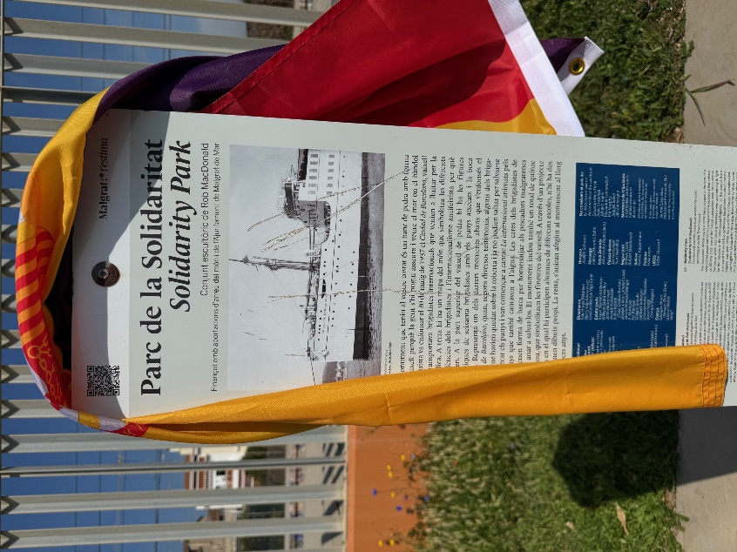
Figure 2: Plaque with information about the Soliditary Park Memorial in Malgrat de Mar, Catalunia (Photo by Francisca Castro)
The project connects schools around the world, inviting students to collaborate in designing sculpted “portholes” for the memorial at Malgrat de Mar, which I had visited during the study tour. I look forward to encouraging schools in Australia to get involved.

Museum visits with scholarly guidance
While visiting museums is a key aspect of historical learning, having an expert guide made this experience truly invaluable. Although I explored a wide range of museums, including interpretation centres, the scope of this report limits me to highlighting two that had the greatest impact.

Refugi 307, Barcelona
This is one of around 1,400 bomb shelters built by civilians during the Spanish Civil War to escape the indiscriminate aerial bombardments. These shelters followed a consistent layout to help people navigate them quickly whenever the sirens sounded. Likely anticipating the spread of the war, European and Russian spies studied these strategies with the aim of protecting their own civilian population in the future. Outside the Refugi, a plaque caught my attention, commemorating the ongoing preservation work initiated by Valerie Gay Powles to safeguard the collective memory of the urbicide that occurred here. This visit encouraged me to rethink how I help students better understand the impact of war on civilians, as well as the resilience they developed in response to Francoist air bombardments.

Museo Nacional Centro de Arte Reina Sofía, Madrid
The focus of my visit here was to appreciate its fascinating permanent exhibition showcasing the art of the 1920s and 1930s, shaped by the Republic’s reforms and the rising ideological tensions of the time. While Guernica is the centrepiece, the museum also offers an extraordinary range of resources to explore the wider sociopolitical forces at play. I was particularly moved by the immense collection of propaganda posters and photographs by Robert Capa, Gerda Taro, and others, whose work provides powerful, firsthand perspectives on the conflict.
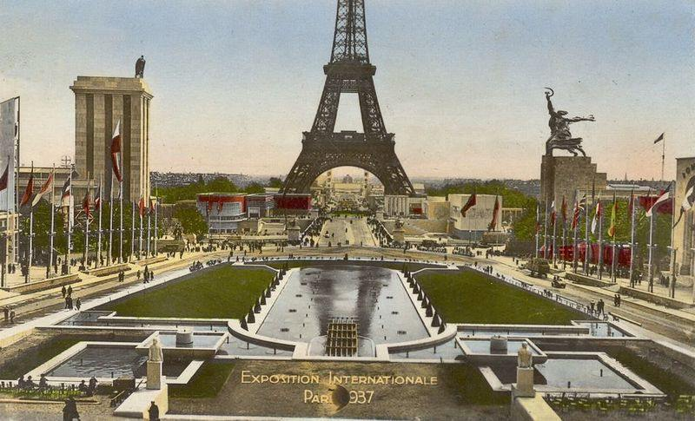
Figure 3: The 1937 Paris International Exposition. Juxtaposing the German and the Soviet Union pavilions identified by contrasting iconography/ideologies and France, represented in the middle and Spain immediately positioned facing the Eiffel Tower. (Photo from Wikimedia Commons).
Many of the works exhibited here were originally assembled for the Pavilion of the Spanish Republic at the 1937 Paris International Exhibition. The material on display in the pavilion sought to garner international support for the Republican cause by showcasing both the cultural strength and the political struggle of the Spanish people, then fighting an ideological proxy war constrained by the Non-Intervention Agreement. More than just an exhibition space, the pavilion was a bold political statement, merging art and activism to communicate the Spanish Republic’s narrative in contrast to the rising fascist ideologies.

Archived historical materials in the classroom
From the outset, I recognised the immense value of archival materials for students to analyse information and evaluate evidence critically. I am grateful to those who took the time to speak with me, especially Dr. Lourdes Prades Artigas and Professor Judith Keene, who highlighted the potential of archives in investigating the International Brigades worldwide. Below, I have synthesised key archival resources that support historical investigations suitable for both Stages 5 and 6.

SIDBRINT (Sistema dʼInformació Digital sobre les Brigades Internacionals (Digital Information System on the International Brigades)
This comprehensive database contains archival material on all known International Brigades volunteers, including identification details, political affiliations, pseudonyms, military units, battles, hospitals, camps, prisons, and key primary documents.

Australian Biography Dictionary
The Australian Biography Dictionary offers accessible information on Australians who volunteered in the Spanish Civil War for various reasons, including anti-fascist motives. It provides details on alternative names, religion, occupation, cultural heritage, and more. For example, Lucy M. Bryce (1897–1968), known for her blood storage techniques developed during the war, and Nugent Bull (1908–1940), who supported the Francoist nationalist cause.

Australia & the Spanish Civil War: Activism & Reaction Archive Library, ANU
This resource covers topics like propaganda, fundraising, aid for children, nurses’ roles, and monuments of remembrance, providing rich, accessible content.

Marx Memorial Library (MML) & International Brigades Memorial Trust (IBMT)
Both institutions house extensive databases with over 60,000 items—including books, pamphlets, newspapers, and archives—spanning topics from Marxist political economy to socialist art. A notable collection is the International Brigades Archive, which documents British and Irish volunteers.
Visiting the Marx Memorial Library was a particularly meaningful experience. On the recommendation of Dr. Richard Baxell, I arranged a guided tour of the institution, which holds a rich collection of archival material relating to socialist history and the International Brigades. It was both inspiring and fascinating to stand in the very space where Lenin worked and published Iskra during his exile in London (circa 1902–1903). The depth of the library’s holdings offered a compelling invitation to further research, and I found myself wishing for more time to engage with its extensive primary sources.

Exploring history through expert-led walking tours
Walking in the footsteps of the International Brigades with experts in Barcelona, Madrid, Canfranc, Belchite, the Ebro, and the Prison of San Cristóbal provided me with invaluable opportunities to deepen my understanding of the Spanish Civil War. While it’s impossible to fully capture the richness of these experiences, I have synthesised key moments with a focus on their teaching and learning potential.

In Barcelona
I spent most of my second day with Nick Lloyd, exploring the Gothic Quarter and strolling along Las Ramblas. At several key sites of civil war significance, Nick brought history to life with photographs, newspaper clippings, and personal objects. Our conversations covered the major political currents of the 1930s - anarchism, socialism, communism, nationalism – as well as the political parties, their leaders, Francoism, and the International Brigades.
We discussed George Orwell’s vivid accounts in Homage to Catalonia and acknowledged the book’s value for understanding the author’s other titles written in the post-war period. We also reflected on the importance of engaging deeply with the historiography available to gain a thorough understanding of the conflict and its broader implications. Nick’s use of diverse sources to tell these stories as we walked left a lasting impression and reminded me of the powerful impact such approaches can have on teaching and learning.

Canfranc International Railway Station
My visit to Canfranc in Aragon was driven by its link to Franco’s dealings with Hitler during WWII. I was especially interested in the tunnel where Franco and Hitler secretly exchanged wolfram and gold, earning its nickname ‘Casablanca in the Pyrenees’. During my visit, I was struck by the numerous bunkers aimed at defending the railway and the powerful wartime narratives shaped by the station’s dramatic setting and strategic importance. This site offers excellent potential for Historic Mystery topics in Elective History or as a historical investigation project for Year 11 students.

The ruins of Belchite
Belchite was deliberately left in ruins by Franco as propaganda, while seemingly included in his ‘War Route of the North,’ attracting visitors to recently conquered towns while the war was still going. I was grateful to visit Belchite and nearby sites of offensive with historians Víctor Pardo Lancina and Jaime Cinca Yago, author of Old Belchite: The Agony of a People (2008). During my visit, I reflected on the ethical dilemmas posed by thanatourism, balancing its potential to erode heritage memory with its role in generating revenue crucial for site preservation.
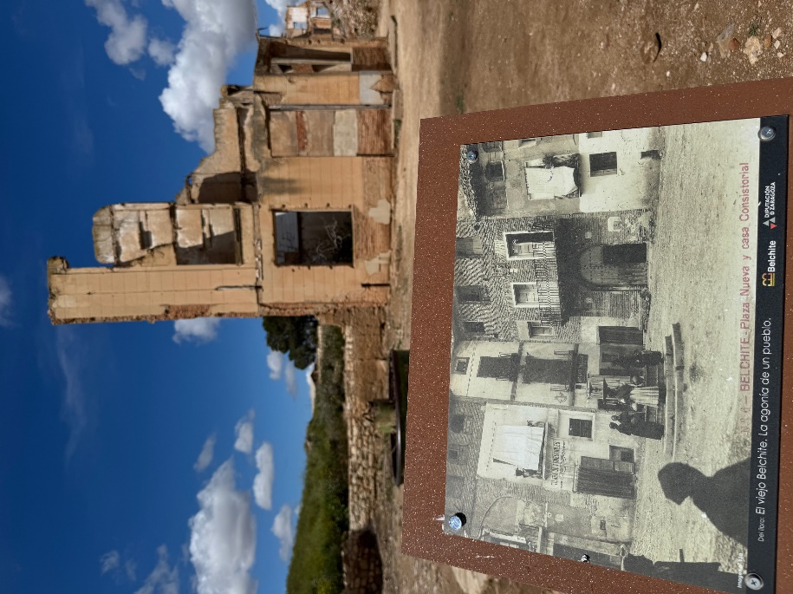
Figure 3: Photo comparing Belchite before and after final air bombardment (Photo by Francisca Castro)

Madrid and Jarama
Madrid and Jarama were key battlegrounds and Republican strongholds during the Spanish Civil War. Yet, a lack of signage and explanation means many passersby miss the history behind the battle-scarred walls.
With insights from Dr. Almudena Cros and Carlos D. Caldarazo, I realised how Francoist Spain’s legacy still echoes today in the models for refurbishing of the Madrid University campus resembling no less than Albert Speer’s Germania plans for Hitler, with grand sporting fields and rigid lines reflecting the orderly society fascist regimes aimed to create. No doubt, this site reveals early evidence of Franco’s alliance with rising fascist dictators before WWII. As a teacher, I see great value in using architectural analysis to help students understand how buildings reflect and shape historical eras.

The war in Ebro and the Cave Hospital
Starting from La Fatarella, I followed Alan Warren’s expert guidance to explore key routes and sites from a different perspective. We met at Marçà-Falset station, where the Brigades trained and prepared for battle. From there, we visited Riverbanks of the Ebro, where the XV Brigade (British) and remnants of the Republican army regrouped after the Aragon retreat.
Staying true to the Republican spirit, we shared lunch at Hostal Can Rius in La Fatarella before visiting two important museums: the 115 Days Interpretation Centre in Corbera d’Ebre, which offers a thorough overview of the Battle of the Ebro, and CEBE in Gandesa, a museum housing an extensive collection of wartime relics, from shrapnel and grenades to personal letters and uniforms. I was amazed by the rich resources and wished I was able to bring them into my classroom.
Two sites especially stayed with me. One was Hill 481, where Jim McNeill and other Australians fought fiercely to defend Gandesa, a vital Nationalist communication hub. While Alan’s vivid, on-site storytelling brought their hardship to life, it was only a pity that I was unable to share this experience with students. The other was the Cave Hospital (La Bisbal de Montsant), a place I knew from Paul Preston’s moving accounts in Perfidious Albion, which continues to resonate with me.

Conclusion
This study has highlighted the intricate links between the Spanish Civil War and the Second World War. When I began the study tour, my primary interest lay in the causes of the war and the lack of recognition given to the International Brigades in Australia. However, as I encountered new evidence of accounts of torture and repression, I came to understand the urgent need to include Spain’s dark history and Franco’s dictatorship – alongside that of Germany and Russia – in our school curriculum. There is also a strong case for studying lesser-known individuals such as Juan Negrín and Andreu Nin, whose efforts were instrumental in resisting the rise of fascism and delaying the onset of global war.
While at first glance the Spanish Civil War might seem peripheral, it quickly became evident that its study enables students to grasp complex ideological concepts – Marxism, communism, liberalism, anarchism, socialism – and major events such as the Great Depression, the May Days of 1937, the rise of dictators, and failure of collective security and collapse of the League of Nations. These are fundamental to understanding the 20th century.
To address the current gap in curriculum coverage, I have already begun producing resources through the History Teachers’ Association of NSW (HTANSW) Teaching History journal and conferences and hope to encourage teachers to engage more deeply with the Spanish Civil War in either Stage 5 or Stage 6 History.

Acknowledgments
I would like to acknowledge all those mentioned throughout this report, as well as others who generously took the time to meet with me, share their expertise, and invite me to collaborate on existing projects aimed at promoting student engagement.
I am deeply grateful to the History Teachers’ Association of NSW for funding and supporting this opportunity to research the Spanish Civil War and the invaluable role of the International Brigades. This experience has allowed me to develop a much deeper understanding, connect with others who share similar interests, and establish collaborative relationships with like-minded educators and academics in Australia, Spain, the United Kingdom, and remotely with Nancy Wallach from ALBA in the United States.
Special thanks go to Bernie Howitt, Toni Hurley, Kate Cameron, Denis Mootz, and Anne Gripton for your guidance and ongoing encouragement. I would also like to thank my Principal, Adrienne Scalese, at Willoughby Girls High School, and the NSW Department of Education for supporting my participation in this endeavour. I am equally thankful to my colleagues, Matthew Miller and Anthony Sharman at St Andrew’s Cathedral School, for believing in the value of this project. Finally, to my husband, thank you for your unwavering support and encouragement in pursuing this important research opportunity.

References
Across Madrid Tours (n.d.) About Us – Across Madrid [online]. Available at: https://www.acrossmadrid.com/en/about-us.html
Australian Dictionary of Biography (n.d.) Australian Dictionary of Biography Online. Available at: https://adb.anu.edu.au/
Australian National University Archives (n.d.) Australia & the Spanish Civil War: Activism & Reaction [online exhibition], Australian National University Archives. Available at: https://archives.anu.edu.au/exhibitions/australia-spanish-civil-war-activism-reaction
Baxell, R. (2012). Unlikely Warriors: The British in the Spanish Civil War and the Struggle Against Fascism. London, UK: Aurum Press.
Graham, H. (2005). The Spanish Civil War: A Very Short Introduction. Oxford; New York: Oxford University Press.
Marx Memorial Library & Workers’ School (n.d.) Spanish Collection [archival collection], Marx Memorial Library & Workers’ School, London. Available via Archives Hub reference GB 391 SPA.
Orwell, G. (2000) Homage to Catalonia. London: Penguin Classics.
Plans of the Spanish Pavilion (1970) Repensar Guernica. Available at: https://guernica.museoreinasofia.es/en/document/plans-spanish-pavilion
Porta de la Història (n.d.) Porta de la Història's blog [online]. Available at: https://pdlhistoria.wordpress.com/
Preston, P. (2024) Perfidious Albion: Britain and the Spanish Civil War. London: Clapton Press Limited.
Solidarity Park (n.d.) About the Solidarity Park Project. Available at: https://solidaritypark.com/about/
Spanish Civil War Tours (n.d.) Spanish Civil War tours in Barcelona and History of the War, hosted by Nick Lloyd [online]. Available at: https://thespanishcivilwar.com/
Universitat de Barcelona, CRAI Biblioteca del Pavelló de la República (n.d.) SIDBRINT (Sistema d’Informació Digital sobre les Brigades Internacionals) [online portal]. Available at: https://sidbrint.ub.edu/

