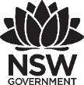
2025 Premier’s Teachers Mutual Bank Aboriginal Education Scholarship

Teaching care(fully) on Country
  - Walking Country: Bringing Indigenous wisdom into early learning to reflect the revisions of the EYLF V2.0
Catherine Jones
Goodstart Early Learning, Kurri Kurri
Sponsored by Teachers Mutual Bank
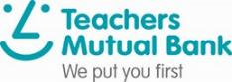

Introduction
The Early Years Learning Framework (EYLF) V2.0 calls teachers to incorporate Aboriginal and Torres Strait Islander knowledges and perspectives across all aspects of children’s education and care practice (Australian Government Department of Education [AGDE], 2022). Key revisions included the addition of two new ‘Principles’ with the focus on the strengthening of Aboriginal and Torres Strait Islander ways of being, knowing and doing, and the broader enactment of sustainability (environmental, social and economic), whilst recognising children’s roles as active and informed citizens.
During the revision, several Practices, notably ‘Partnerships’, ‘Respect for Diversity’, and ‘Learning Environments’ were expanded to emphasise collaboration with diverse families, creation of culturally safe spaces, and stronger connections with child, family and community, and other professionals (AGDE, 2022). ‘Respect for Diversity’ now explicitly values traditional practices, heritage, ancestral knowledge, and deep connections to Country. ‘Learning Environments’ encompass physical, temporal, social, and trauma-informed dimensions. For Aboriginal and Torres Strait Islander families, these expansions facilitate intercultural spaces that integrate both Western and traditional knowledges. Early childhood (EC) teachers and educators must critically reflect on these revisions and adapt their practice accordingly.

Focus of Study
The confidence and competence levels of EC teachers and educators across Australia to authentically reflect the revisions of the EYLF V2.0 considerably vary. However, common findings in the early childhood literature suggest there is a general lack of confidence about 'what to do’, ‘how to do it’, and ‘a fear of being disrespectful' (Townley et al., 2023). I posit this lack of confidence for many teachers (including myself) comes from being socialised within Western worldviews which are in stark contrast to traditional Indigenous worldviews, and a general lack of knowledge of Aboriginal ways of knowing, being and doing.

Significant Learning
This section explores the insights gained over the course of the study tour. Learning included:
- A deeper understanding of Indigenous worldviews is critical for teachers to enact the revisions of the EYLF V2.0.
- The importance of Indigenous language(s) which includes stories passed from generation to generation, as well as single words or phrases, to convey complex cultural concepts. Language impacts identity, well-being and can be an act of decolonisation.
- The efficacy of critical place-based pedagogies in supporting the revisions of the EYLF V2.0, and that learning must extend beyond the classroom, centre or school, and must include meaningful connections with Country and community.
- Positive impacts for early childhood education and care (ECEC) centres and schools in co-developing curriculum and learning experiences with Indigenous communities and families to ensure meaningful cultural identity and relevance to place, thus integrating Indigenous values and supporting intercultural pedagogies.
Throughout this section, each ‘key learning’ will be briefly explained and then illustrated with an example of how teachers and educators can begin to authentically embed the revised Early Years Learning Framework V2.0 with care, love and confidence.

Reflecting on worldviews – and why this is so important for teachers
What may be obvious to others – that the message that Aboriginal spirituality is here for everyone – was something I did not know. However, the generosity shared with me before, during and after the study tour by so many Aboriginal people and my growing spiritual connection to Country showed this to be true. I include this initial insight as it significantly impacted my study tour learning, and my continuing learning. As Uncle Paul Gordon states in The Dreaming Path:
‘Aboriginal spirituality is here for everybody and anybody who wants to be able to connect to their place and to their Mother, the land. If people want to come and connect to Country, Aboriginal people like myself are always willing to share and teach how to.’ (Callaghan & Gordon, 2024, p.27)
Worldviews matter! For non-Indigenous teachers to implement the revisions of the EYLF V2.0, it is vital to develop an understanding of how Indigenous and western worldviews differ fundamentally in terms of humans’ relationship with the natural world, the nature of time, ways of knowing and learning, values, and decision-making. In a Western worldview, humans are the centre of importance, individualism is valued, scientific (and often compartmentalised) knowledge is seen as the only truth, time is structured into hours, days and months, and decision-making is usually based on short term goals. In stark contrast, Indigenous worldviews see humans as just one part of an interconnected web of the natural world. Knowledge is developed more holistically, spiritually, and emphasises experiential learning. Time is cyclical and goes by seasons and natural cycles. Indigenous worldviews value collectivism, and decision-making is based on long-term sustainability.
During my tour, I was told the ‘Jumbal story’ which illustrates the connection to Country for Indigenous Australians. The foundation of this story is recognising that all things embody life and spirit, and that they progressively integrate through the food chain. It is through a deep connection with Country that brings custodianship, and with custodianship comes responsibilities. For Māori people, te ao Māori highlights the significance of the relationships between people and nature. It presents a holistic perspective centered on interconnectedness, rooted in tikanga (customary values and protocols) and mātauranga (knowledge). Practices, values, and principles from te ao Māori have been nurtured around the marae, creating a space where ancestors and communities unite closely with the whenua (land) and taiao (environment).
For teachers and educators wanting to authentically enact the new ‘Sustainability’ Principle into their practice, which includes social and economic as well as environmental sustainability, developing an understanding of Indigenous worldviews, through respect for land, people, and future generations will be of great support.

Language is fundamental for cultural identity, learning, and well-being
Language is fundamentally important to all people because it is the primary means by which humans communicate complex ideas, thoughts, feelings, and experiences. Language builds relationships, community belonging, and allows people to share knowledge. For Indigenous peoples, oral language and stories, have played a crucial role in transmitting cultural knowledge, ecological, astronomical, and moral teachings and function as a way to connect people to their land, culture, and ancestors. Stories are often linked to ceremonial practices, specific times, places, and social contexts, which helps preserve important cultural information (Gwatkin-Higson, 2019; Scalise Sugiyama, 2018).
Over the course of my study tour, I was told many stories which provide the learner with important knowledge and values. For example, a Ngemba story, Thickibilla (also spelled Thigabilla) explains how an ancestral (an Echidna and her babies) shaped the physical environment, and conveyed cultural lore. Baiame is a Wonnarua creation story which tells us how the hills and rivers in the Hunter Valley were created. The Awabakal story Whibayganba also explains the shaping of the physical environment (Nobby’s Head), whilst also providing messages of what happens when you break the law, therefore ensuring social cohesion.
For young children, Australian and international research shows that stories provide meaningful, relatable contexts that prompt children to reflect on ethical behavior and social experiences, helping them internalise values through experiential learning rather than passive reception of information (Gunawardena & Brown, 2021; Nair et. Al., 2014; Yabe et. Al., 2018). To summise, ‘stories stick’!
Living on Wonnarua land, an important story often told to children is of Tiddalik, the greedy frog who drank all the water. This quite well known story is often used with Wonnarua children and when told using Wonnarua language, the story becomes more powerful as language is inextricably linked to cultural identity. This is an example of how Indigenous storytelling (especially local stories- as the rock formation of Tiddalik in on Wonnarua land) enriches understandings of sustainability (environmental, social and economic) through respect for land, people, and future generations. Therefore aligning with the EYLF V2.0’s new Principles of ‘Sustainability’ and ‘Aboriginal and Torres Strait Islander perspectives’ (AGDE, 2022) and highlighting storying as a pedagogical practice.
Language promotes cultural identity and can act as a decolonisation tool. Supporting Indigenous language reclamation and cultural protocols in teaching can create more equitable and self-determined education environments (Harrison, 2021). In our current educational context, when integrated into schools and early education and care centre philosophies, curriculums, and pedagogies, language can improve individual and collective well-being, reinforcing cultural pride and knowledge transmission across generations. During my study tour, the exemplar centres and schools had people in leadership positions who understood that ‘language matters’. Language was embedded in each site, examples included philosophy and values statements, the program or curriculum, pedagogical practices (e.g. storytelling), daily rituals, classroom displays (see Figure 1), and even in teacher reflective sessions.
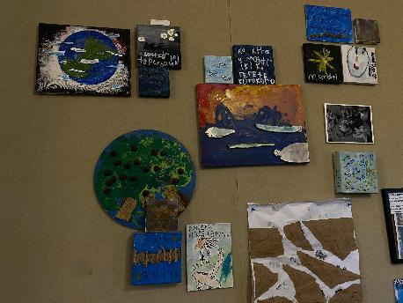
Figure 1: Classroom display at Daisies Early Education and Care Centre
Kids Domain Auckland and Daisies Early Education and Care Centre philosophy statements included the word Kaitiakitanga which is the Māori concept of guardianship, protection, and stewardship, particularly of the natural environment and resources, but also extending to knowledge. Here is an exert from the Kids Domain Auckland philosophy statement,
‘We cultivate a deep sense of place and connection to our local natural environment and encourage children to think and act as guardians and protectors of our planet’
An example of a collegial teacher reflection from Kids’ Domain which illustrates the integration of Māori language (concepts and words) follows:
‘As we reflect on the past few years, journeying through construction, environments, and the richness of our Kids’ Domain conferences, we hold close the wisdom of ‘titiro whakamuri, here ki mua’ honouring the past as we pave the way ahead…we recognize the boundless potential within our team, our space, our tamariki, and our whanau.’
The children, alongside the teachers at Daisies Early Education and Care Centre also created their own treaty (see Figure 2).
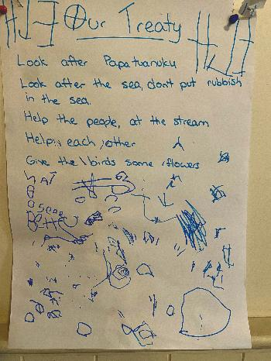
Figure 2: Daisies Early Education and Care Centre children’s treaty
Embedding Indigenous languages strengthen identity, community cohesion, and sustainable land relationships in early education and care centres and their local communities and represent a key aspect of intercultural pedagogy.

The power of critical place-based programs
This section illustrates how ‘critical place-based programs’ have the power to provide early childhood education and care centres to meet the key revisions of the EYLF V2.0. ‘Critical place-based’ pedagogies extend on place-based programs by reflecting an Indigenous epistemology of Country. These pedagogies explicitly address the socio-political context of place, focusing on social justice, decolonisation, and power relations in addition to ecological concerns (Gruenewald, 2003; Karulkiyalu Country et al, 2020; McKnight, 2015; Spillman et al.,2022). To illustrate, I will share an example from the ‘Country as Teacher program (CaT)’ and Kids Domain Auckland.
The CaT program was developed by a research team at the University of Canberra. The program is a strength-based teaching and learning framework aligned with Indigenous ways of knowing, being and doing, and suitable for implementation in mainstream Australian schools and early childhood centres. The program uses a pedagogical framework called the 6Ls, which was gifted to the program by Uncle Paul Gordon. Over the course of my tour, I visited multiple schools enacting the 6Ls.
To illustrate this critical-place based program, I will discuss my time at Jervis Bay School where I spent three days, the majority of which was during various classes on Country learning time which are led by Uncle Matty Simms (Cultural Mentor, Jervis Bay School). My first time on Country was so powerful! Uncle Matty performed a smoking ceremony to welcome me to his Country with a group of Kindergarten children (see Figure 3).
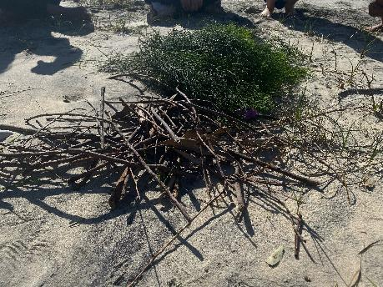
Figure 3: Preparing for a smoking ceremony
Whilst Matty performed the smoking, a large sea eagle flew above us and then perched itself high on a tree and watching us.
During another time on Country, Uncle Matty was very intentional in choosing a headland to tell the story of Bundoola (See Figure 4), shared here as an abridged version of the story. Bundoola is the rain spirit, a significant figure in the Dreaming. Bundoola could shape shift from human form to animal form. He had 12 wives…but he wanted a 13th. The Old people said no, but he took one anyway and there were consequences because he broke the Lore. His 13 wives headed along the South Coast, making up the 13 tribes of Wreck Bay, and they became the original ancestors of the 13 tribal groups. From the headland, the children could see the cliff were Bundoola still resides. Through storying, being on Country, and questioning, Uncle Matty used the 6Ls as the pedagogical tool to support children’s learning.
Uncle Matty asked the children, ‘What have you learnt from the Bundoola story?’ One of the children said ‘Don’t be greedy’, another said ‘You have to listen to the Old People’ and another said ‘Don’t break the Lore. On this headland, there are also shell middens. Matty told the children to come and sit around the midden, to sit as the Old people did many years ago, and reminded them how special this place is and not to move anything, to just Look and Listen. Whilst sitting around the midden, Matty used questioning to reinforce important lessons and concepts. ‘Who knows what these are?’, he asked. ‘Middens’ (said the group of children). ‘That’s right, so what happened here?’ and a few children responded with‘The Old people used to eat here’. ‘That’s right, and what else?’, ‘You only take what you need from Country…you don’t be greedy’ (said a child). ‘That’s right, we only take what we need, you don’t be greedy like Bundoola’ (Learn and Love). During their time on Country, the children are often reminded of these values, particularly respect, reciprocity, and obligation throughout the day, whether the children are in their classroom or on Country. Whilst on Country, Uncle Matty reminded the kindergarten children to ‘be like a family of kangaroos, to look out for each other’ (Lead).
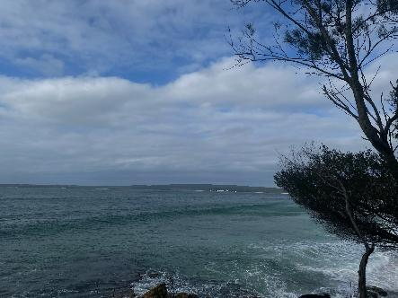
Figure 4: Headland where Uncle Matty told the story of Bundoola
The next example is used to illustrate a centre using critical place-based pedagogies was during my time spent visiting At Kids Domain Auckland. The children at this centre go on regular hīkoi, which is a Māori word for a walk. The teachers and children know this place well and they feel a sense of connection because it is familiar to them. However, one of the educational leaders (who is Māori) realised they didn't know this place’s full history. She organised time with a local Māori expert to take the teachers on a guided walk. By physically walking on the land and listening to the history and stories, the participants came to understand its sad past. They then felt their purpose as leaders was to bring positive energy back into the place alongside the children by retelling the stories, acknowledging the past, and creating new, more positive stories for the children. This example also demonstrates decolonisation practices fostered through critical place-based pedagogies, as well as embodied learning and vulnerability (Harrison, 2021).
Critical place-based pedagogies are vivid enactments of EYLF V2.0’s strengthened commitment to Aboriginal and Torres Strait Islander ways of knowing, being and doing. These pedagogies privilege Indigenous knowledge systems, values, and cultural practices throughout curriculum planning, pedagogy, and community engagement rather than treating these perspectives as supplementary content. Central to critical place-based programs is the cultivation of relational pedagogy, a key update in EYLF V2.0, enabling teachers and children to engage deeply and respectfully with Country and their local community, developing ongoing relationships based on Co-developing curriculum
Co-designing curricula through family and community consultations further exemplify the EYLF V2.0’s principle of collaborative leadership and strengthened partnerships, ensuring these programs are relevant, respectful, and empowering (AGDE, 2022).
At Jervis Bay school, the Principal and her team worked alongside the local community, asking families and community members what they wanted their children to learn by the time they had finished Year 6. Through this collaborative process they developed their ‘Country as Teacher Curriculum Framework’ (see Figure 5) which outlines ‘subject areas’. They then use the 6Ls (Lore, Look/Listen, Learn, Love, and Lead) as their pedagogical framework. This approach places Indigenous voices at the core of decision-making, ensuring culturally relevant and community- driven learning outcomes.
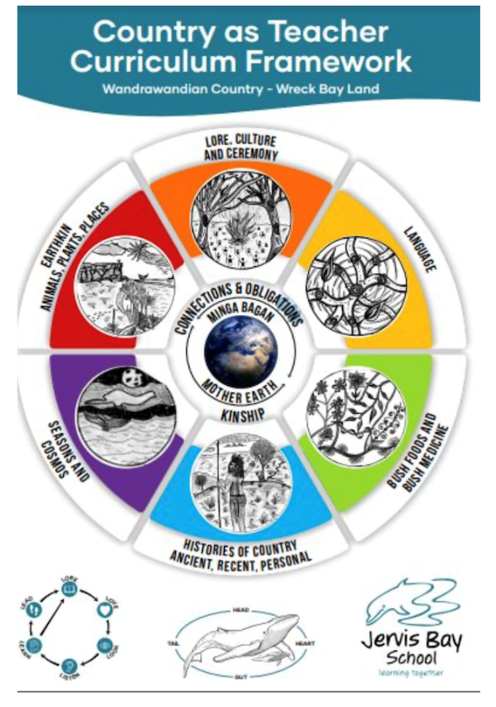
Figure 5: Jervis Bay CaT Curriculum Framework
Listening to the teachers at this school talk about the impact of this program was powerful. The teachers and children have learnt ancestral wisdom, cultural practices, values, lore, and ceremony. One teacher said they barely have any behavioural issues anymore, clearly showing the children’s well-being has dramatically improved.

Conclusion
The knowledge acquired during and after my study tour required me to develop a certain mindset – one of openness, vulnerability and humility. A way of being where I became the listener, not the questioner! Often, the most powerful learning came when I didn’t ask questions but rather listened to people and Country itself.
Given only approximately 2.6% of the ECEC workforce identify as Indigenous (Australian Department of Education, 2024), it is recommended that all teachers and educators require professional development around worldviews and serious critical reflection on personal bias. Understanding Indigenous worldviews and learning more deeply about Aboriginal culture is crucial in shifting common attitudinal and skill challenges when wanting to authentically meet the revisions of the EYLF V2.0. A further recommendation is for individuals to spend time on their own local Country, developing their own deeper connection to Country, and for individuals (or preferably centre teams) to engage in on Country learning beginning with cultural tours.
During this study tour, I determined critical place-based programs can represent a living example of how the EYLF V2.0’s core revisions manifest in practice. These programs empower teachers, educators, children, families, and communities to engage with Country in ways that honor Indigenous sovereignty and uphold social justice. It is recommended that teachers and educators need much more training on how to do this – and my recommendation is to visit exemplar settings when they are doing on Country teaching.
It is hoped these insights illustrate ways in which teachers and educators can authentically embed the revisions of the EYLF V2.0, thus advancing cultural responsiveness, creating culturally safe places, and progressing reconciliation in early childhood education and the broader Australian context.

Acknowledgements
Thank you for the support and collaboration of all who assisted in preparing for and engaging in the study tour, and who contributed to enriching the overall experience. Thank you to Goodsart Early Learning.
Thank you to Teachers Mutual Bank, whose generous funding of this scholarship made the study tour possible.

References
Australian Department of Education. (2024). 2024 National Early Childhood Education and Care workforce census [Data set]. Social Research Centre.
Australian Government Department of Education [AGDE] (2022). Belonging, Being and Becoming: The Early Years Learning Framework for Australia (V2.0). Australian Government Department of Education for the Ministerial Council.
Bishop, M., & Durksen, T. L. (2020). What are the personal attributes a teacher needs to engage Indigenous students effectively in the learning process? Re-viewing the literature. Educational Research, 62(2), 181–198. https://doi.org/10.1080/00131881.2020.1755334
Callaghan, P, & Gordon, P. (2024). The dreaming path- Indigenous thinking to change your life. Neutral Bay, New South Wales, Australia: Pantera Press.
Daisies Early Education & Care Centre website (2025) https://www.daisies.co.nz/
Gruenewald, D. A. (2003). The best of both worlds: A critical pedagogy of place. Educational Researcher, 32(4), 3–12. https://doi.org/10.3102/0013189X032004003
Gunawardena, M., & Brown, B. (2021). Fostering values through authentic storytelling. The Australian Journal of Teacher Education, 46(6), 36–53. https://doi.org/10.14221/ajte.2021v46n6.3
Gwatkin-Higson, P. (2019). What is the role of oral history and testimony in building our understanding of the past. NEW: Emerging Scholars in Australian Indigenous Studies, 4(1), 39-44. https://doi.org/10.5130/nesais.v4i1.1538
Harrison, N. (2021). Learning in the presence of others: Using the body as a resource for teaching. Educational Philosophy and Theory, 53(9), 941–950. https://doi.org/10.1080/00131857.2020.1835645
Jervis Bay School Website (2025). https://www.jbs.act.edu.au/our_curriculum/learning_on_country
Karulkiyalu Country., Gordon, P., Spillman, D., & Wilson, B. (2020). Re-placing schooling in Country: Australian stories of teaching and learning for social and ecological renewal. Australian Aboriginal Studies Journal, 2, 34–44.
Kids Domain Auckland Website (2025) https://kidsdomain.co.nz/
McKnight, A. (2015). Meeting Country and self to initiate an embodiment of knowledge: Embedding a process for Aboriginal perspectives. The Australian Journal of Indigenous Education, 45(1), 11–22. https://doi.org/10.1017/jie.2016.10
Nair, S. M., Yusof, N. M., & Hong, S. C. (2014). Comparing the Effects of the Story Telling Method and the Conventional Method on the Interest, Motivation and Achievement of Chinese Primary School Pupils. Procedia, Social and Behavioral Sciences, 116, 3989–3995. https://doi.org/10.1016/j.sbspro.2014.01.878
Scalise Sugiyama, M. (2017). Oral Storytelling as Evidence of Pedagogy in Forager Societies. Frontiers in Psychology, 8, 471. https://doi.org/10.3389/fpsyg.2017.00471
Spillman, D., Wilson, B., Nixon, M., & McKinnon, K. (2022). Reinvigorating country as teacher in Australian schooling: Beginning with school teacher’s direct experiences, ‘relating with country’. Curriculum Perspectives, 1–11. https://doi.org/10.1007/s41297-022-00176-6
Spillman, D., Wilson, B., Nixon, M. et. al. (2023) ‘New localism’ in Australian schools: Country as Teacher as a critical pedagogy of place. Curriculum Perspectives, 43, 103–114. https://doi.org/10.1007/s41297-023-00201-2
Spillman, D., & Wilson, B. (2024). Decolonising through ReCountrying in teacher education. Curriculum Perspectives. 44. 10.1007/s41297-024-00242-1
Townley, C., Grace, R., Woodrow, C., Baker, E., Staples, K., Locke, M. L., & Kaplun, C. (2023). Educator perspectives on embedding acknowledgement to country practices in early learning centres in Australia. Australasian Journal of Early Childhood, 48(2), 86–98.https://doi.org/10.1177/18369391231173182
Yabe, M., Oshima, S., Eifuku, S., Taira, M., Kobayashi, K., Yabe, H., & Niwa, S. I. (2018). Effects of storytelling on the childhood brain: near-infrared spectroscopic comparison with the effects of picture-book reading. Fukushima journal of medical science, 64(3), 125–132. https://doi.org/10.5387/fms.2018-11

