
2024 Premier’s History Teachers’ Association History Scholarship

Ethical Considerations in Museums
  - What to consider when displaying history and using museums as tools for learning
Simone Etcell
Campbelltown Performing Arts High School
Sponsored by NSW History Teachers’ Association
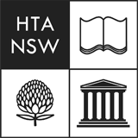

Reader Advised:
This report includes discussions and images of human remains and culturally sensitive content.

Introduction
Museums are universal hubs of culture and history that strive to preserve and educate in ways that are both ethical and accessible—or, at least, they should be. Often used by students as a tool to connect with history on a deeper level, they provide a unique opportunity to explore diverse cultures, engage with primary sources, and develop a more nuanced understanding of the past, fostering critical thinking and a broader perspective on global heritage.
Given their role in imparting invaluable knowledge and shaping young minds, it is crucial to examine the role ethics plays in their exhibits, including whether:
- diverse perspectives and narratives are presented
- the ethical standards for displaying human remains are reviewed and upheld
- the issues surrounding contested artefacts are transparent
- historical and cultural information is appropriate and equitably accessible

Focus of Study
This research addresses the ethical challenges inherent in the representation and display of historical artefacts within major museums, focusing on institutions in Australia, Britain, Denmark, Egypt, Germany, and Greece. Through visits, guided tours, interviews with museum representatives, and an analysis of online resources, this study explores how these institutions manage issues related to cultural representation, the ethical display of human remains, contested ownership, and access to historical information.
The aim of this research is to promote a reliable approach to teaching history by providing educators with insights and a comprehensive resource pack to help them navigate the complexities of exploring historical artefacts. This resource pack combines ethical guidance with practical applications, offering case studies of artefacts and displays from prominent museums that can directly align with the New South Wales Education Standards Authority’s (NESA) Curriculum. The resource pack offers ready-to-use classroom tools, allowing teachers—who often face time constraints—to efficiently foster a learning environment where diverse perspectives are visible and respected, and students are encouraged to critically engage with history, enhancing their ethical understanding and overall academic outcomes in History.
The research directly aligns with multiple History syllabi topics and concepts across the NSW Curriculum, including:
- Stage 6 Ancient History: ‘Investigating Ancient History,’ particularly the options of ‘The Investigation of Ancient Sites and Sources’, ‘The Representation of the Ancient Past’, and ‘Cultural Heritage and the Role of Museums’. Additionally, case studies on ‘Ancient Australia’ and ‘Ancient Egypt’.
- Stage 4 History: Multiple Depth Studies, including ‘Investigating the Ancient Past’ (with a focus on ‘Ancient Australia’), ‘The Mediterranean World’ (with a focus on ‘Egypt’), and ‘Expanding Contacts’ (with a focus on ‘Aboriginal and Indigenous Peoples, Colonisation, and Contact History’).
- History Elective: ‘History, Heritage and Archaeology’, particularly in the sub-topics of ‘Archaeological Sites’, ‘Heritage and Conservation’, ‘History Websites/Online Environments,’ and ‘Museum and/or Archives Studies.’
- Cross-Curriculum Priorities and General Capabilities: Aboriginal and Torres Strait Islander Histories and Cultures, Critical Thinking, Ethical Understanding, Intercultural Understanding, and Difference and Diversity.

Significant Learning

Narratives and Perspectives
UNESCO's International Council of Museums outlines in their Code of Ethics for Museums that displays are to “give appropriate consideration to represented groups or beliefs" (International Council of Museums, 2017). Despite this, it appears that the representation of diverse narratives and perspectives in display, crucial to shaping museum-goers' interpretations, is progressing rather slowly, which is clearly illustrated when comparing two exhibitions during my visit to the Australian Museum in Sydney. Education Project Officer Tim Chuan and First Nations Education Lead Natalie Taylor provided a tour of the First Nations Garrigarrang Gallery, which exemplified an ethically minded approach to curating. Developed with community input, this open-floored gallery includes identified artists, an Acknowledgement of Country, and is managed by First Nations curators. The open space thoughtfully explores and celebrates the rich cultures of Australia’s Salt Water Peoples, ensuring that the perspectives and narratives of First Nations Australians are deeply and respectfully embedded within the displays. In contrast, the 200 Treasures of the Australian Museum exhibition, designed in partnership with the NSW Government and Westpac, displays questionably themed items from around the world in enclosed glass cases. For example, the Ancient Egyptian case features a Theban Mummy and Coffin from the Third Intermediate Period alongside a taxidermied juvenile Ibis bird from Australia. The latter, likely intended to symbolise Thoth, the god of knowledge and writing, underscores a broader issue: the insensitivity of presenting history through a Eurocentric lens that indiscriminately lumps ‘treasures’ together rather than presenting authentic and thoughtful narratives, such as the diverse 3,000 years of Ancient Egyptian History that many museums, including the Egyptian Museum in Cairo, theme more appropriately across multiple time-periods or categorised displays.
Upon visiting international museums, it became evident that many institutions are in a transitional phase, where discussions about diverse representations do not always align with the actual practice of incorporating diverse perspectives into every display. For instance, Mette Boritz, the Manager of Exhibitions at the National Museum of Denmark, mentioned during my tour that they had recently updated the language used in their collection of cold-weather garments from Northern Canada. To more appropriately and accurately reflect cultural identities, the exhibit now specifically identifies particular First Nations communities rather than using the general phrase ‘Inuit Eskimo’. However, in the same museum, an 'Australian' display case featuring weapons, bowls, and woven items lacks informative signs, plaques, or notes regarding the provenance of the items or the First Nations Australian communities from which they might have originated (Figure 1). When I inquired about this, it was explained that storage facilities are often overfilled with artefacts lacking provenance details, and creating new plaques at this time is both costly and not prioritised due to the challenges scholars and communities face in locating and agreeing on accurate information and terminology. While these concerns are valid, it is essential to recognise that these artefacts are still currently displayed as is. Merely arranged decoratively in a manner that reinforces a fictional image of ‘Australia’, it also perpetuates Eurocentric interpretations to viewers and ultimately misses the opportunity to educate and convey their true cultural significance.
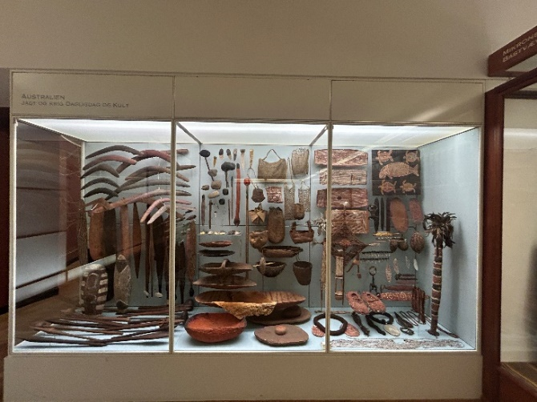
Figure 1: ‘Australian’ display case lacking identifying markers or information cards,
National Museum of Denmark, Denmark (Photo by Simone Etcell)
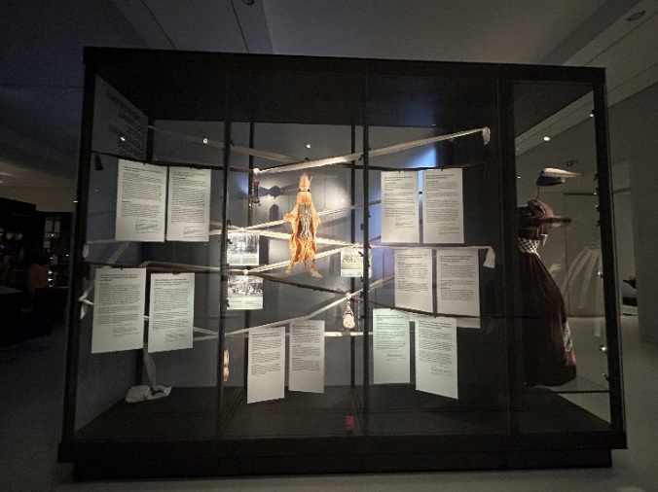
Figure 2: ‘African’ display case with prompting historiographical questions,
Ethnological Museum of Berlin, Germany (Photo by Simone Etcell)
The issue of unavailable provenance, especially in older collections, was also evident during my visit to the Ethnological Museum of Berlin in Germany. However, it was clear that appropriate amendments to displays can be made to educate visitors in a way that is reflective, inclusive, and ethical. Their ‘Africa’ exhibition mirrored the ‘Australian’ display in Denmark: glass cases that decoratively showcase items without informative signs, plaques, or notes. As an update to the colonial-style display, an interactive board was added, digitally cataloguing every item and noting provenance details, where available. Titled ‘Open Storage Africa: Appropriating Objects and Colonial Fictions of Africa,’ it was complemented by modern displays and video exhibits from the communities of origin, highlighting the importance of these artefacts and the socio-cultural practices connected to them. These modern amendments also included signage with historiographical questions (Figure 2), such as “What questions does this display raise?” and “What information is not correct?” positioned near older information sheets. This approach prompts critical thinking and represents a clear effort to decolonise collections and assist in the reconstruction—or revelation—of items’ cultural significance within a museum setting. The exhibition also guides educators and students, encouraging them to be aware of the narratives presented in museum displays so they can have a critical approach to history. It is important to question where other perspectives might be missing or underrepresented, thereby challenging dominant narratives and fostering a more informed and empathetic worldview that encourages students to seek out and value diverse voices in history.

Displaying Human Remains
Human remains are often some of the most popular and highly visited exhibits in museums; however, museums around the world are increasingly reevaluating the ethical implications of displaying these remains, leading to significant changes in how they are presented to the public. The Chau Chak Wing Museum in Australia, for instance, has removed unwrapped mummified body parts from display as they engage with Egyptian communities and authorities to reassess their practices in exhibiting human remains (University of Sydney, 2024). This sentiment is echoed by other museums globally, and while it can be argued that human remains should not be displayed at all, the current discourse largely focuses on establishing and upholding ethical standards for their display.
When visiting Egypt, home to innumerable mummified human remains, it became evident that the standard for displaying these remains varies significantly. At the Luxor Museum, two mummified bodies are each housed behind glass cases in a large, dimly lit room, accompanied by simple signs that indicate their names and a few select items relevant to their lives. Although ethical concerns about their removal from coffins remains, this presentation can be considered one of the more sensitive and respectful ways to display human remains, with a museum representative noting it is to “let them rest”. In stark contrast, the Egyptian Museum in Cairo also displays two mummified bodies, and while the information about their lives is more extensive, their bodies have been removed from their coffin and are exposed to bright lighting, with a large, close-up image of their faces prominently displayed above the entrance (Figure 3). This raises important questions about whether the educational value of such displays outweighs the potential disrespect or dehumanisation of the deceased. Sensationalised presentations risk contributing to a skewed or disrespectful understanding of Ancient Egyptian culture, prioritising shock value over fostering a deeper appreciation of the people and their traditions. At the same time, however, questions about the appropriateness of projecting preferences onto the practices of other countries dually form.
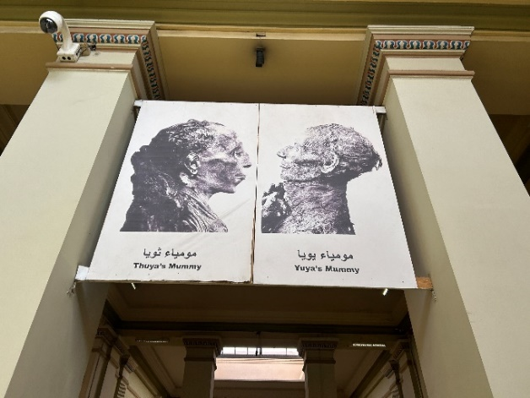
Figure 3: Signage of close-up photographs of the mummified remains of Ancient Egyptians, Thuya and Yuya, Egyptian Museum of Cairo, Egypt (Photo by Simone Etcell)
Exploring the different standards for displaying human remains inevitably leads to further questions. For instance, in the case of Tollund Man at the Museum Silkeborg in Denmark, a clay replica of his body has been created and put on display due to preservation concerns, while some of his actual preserved body parts are also displayed alongside the replica. This approach raises several ethical questions, including whether displaying replicas of human remains is a more appropriate standard and whether there is an ethical difference between the display of real and replicated remains. When I asked Mette Boritz, the Manager of Exhibitions at the National Museum of Denmark, if they received complaints about the display of ‘Bog Bodies’ or requests for a disclaimer at the entrance of exhibits showing human remains, I was informed that this had not been an issue and was what visitors expected at the museum. This response highlights a different perspective on displaying human remains, one that contrasts with the current position in Australia. While projecting national standards onto international institutions and cultures is not appropriate, it does prompt a need for reflection on the implications for Australian educators who may use images of human remains in the classroom. In Australia, a sensitive approach and general disclaimer are often standard practice, and while museums frequently set precedents that guide educational practices, the lack of a global consensus underscores the complexity of this ethical issue and the ongoing debate.

Contested Artefacts
One of the most complex challenges museums face today is the issue of custodianship. Many museum collections were established during the height of colonisation, leading to numerous items with unclear provenance or contentious ownership histories. I interviewed Rodney Kelly, who traces his lineage to the Gweagal warrior Cooman and has tirelessly advocated for the return of the Gweagal Shield. The shield has been the subject of a long-standing repatriation request, and while the British Museum has conducted its own investigations, it remains in their possession. Kelly noted that the bureaucratic hurdles involved in contestations are considerable, a point briefly exemplified by the difficulty I faced in trying to set up an interview with the British Museum to simply discuss the artefact, let alone the possibility of repatriation. Beyond this issue, however, lie deeper questions surrounding the implications of custodianship and what is best for the artefact itself. The British Museum acknowledges on its website that the shield holds deep significance for First Nations Australians and has come to symbolise the ongoing legacy of colonisation (British Museum, 2024). Notably, the shield is currently displayed in their exhibition titled 'Enlightenment: Exploration, Knowledge and Imperialism 1680-1820,' yet it lacks detailed information about its context and the perspectives surrounding its contestation—a position Kelly refers to as “silencing the object” and, in turn, its history. As museums strive for a more ethical approach to displaying artefacts, we must ask not just where contested artefacts hold the most cultural significance, but whether they are currently being appropriately displayed at all.
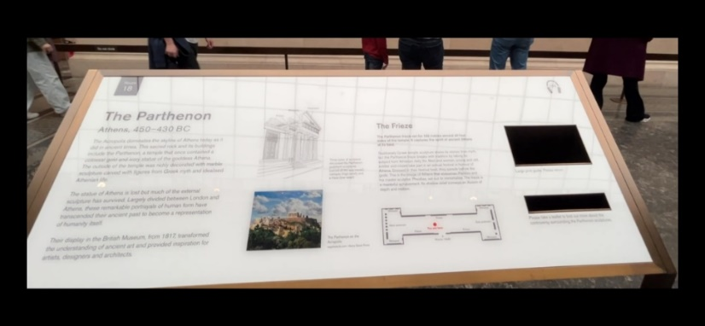
Figure 4: Information board by the Parthenon Marbles with an empty pamphlet space for details on the artefact's controversial contestation, The British Museum, United Kingdom (Photo by Simone Etcell)
This sentiment is echoed in the handling of other contested artefacts worldwide, such as Nefertiti’s Bust at the Neues Museum and the Parthenon Marbles at the British Museum. Despite numerous requests for their return, these items remain in their current locations, yet the information regarding their contested status is often insufficient. For instance, the display for Nefertiti's Bust includes a single, unphotographable sign with minimal details about its history and controversy, a position reflected on the Neues Museum's website (Staatliche Museen zu Berlin, 2024). Similarly, the Parthenon Marbles have an information board with a brief mention of the controversy in pamphlet form. This approach highlights that not only is the information about the controversy often inaccessible—during both of my visits to the British Museum, pamphlets on the topic were unavailable (Figure 4)—but that the controversy itself is considered temporary, deemed worthy only of a paper pamphlet rather than being permanently integrated into the information board. This lack of information about contested artefacts in museums raises significant ethical concerns. Even if these items cannot be returned, the controversies surrounding them are crucial aspects of history that are being deliberately neglected. When viewers and students explore these exhibits without this context, they are deprived of an essential historical perspective, one that: is rooted in critical thought, challenges dominant narratives, and encourages a more nuanced understanding of the past. This omission not only undermines the educational value of these displays but also perpetuates a one-sided view of history that fails to acknowledge the ongoing impact of colonisation, cultural appropriation, and the importance of scrutinising the credibility of historical accounts.
In a positive development, the repatriation of contested artefacts has shown the significant impact such actions can have. The Museum of Archaeology and Anthropology at Cambridge University returned the Gweagal Spears to the La Perouse Aboriginal community in 2024 (Museum of Archaeology and Anthropology, Cambridge, 2024). Currently housed at the Chau Chak Wing Museum until a new visitor centre is built at Kurnell, Kamay, the return of these spears acknowledges the ongoing cultural practices of the Gweagal people, who continue to use multi-pronged fishing spears (National Museum of Australia, 2024). The loan of contemporary spears to Cambridge University underscores the importance of living traditions and challenges museums to reassess their custodianship of culturally significant items (Figure 5). This case exemplifies how the ethical return of artefacts can deepen respect for cultural heritage and strengthen connections between communities and museums. In the classroom, it serves as a powerful reminder that the past remains deeply connected to the present for many cultures, encouraging students to appreciate the ongoing relevance of historical practices and the importance of acknowledging rightful ownership.
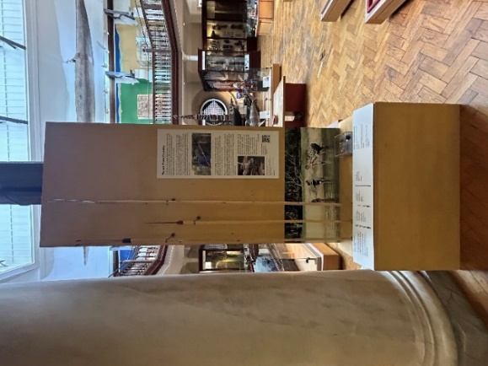
Figure 5: Display of contemporary Gweagal Spears temporarily on loan, Museum of Archaeology and Anthropology, Cambridge University, United Kingdom (Photo by Simone Etcell)

Accessing Information
Museums house a vast array of diverse artefacts and expert knowledge; however, a review of museum websites reveals significant disparities in the quality and accessibility of the information provided, highlighting issues with the inaccessibility of universal information. For example, when exploring the Australian Museum's website, digital collections can be searched, yet the information available is often limited to a brief paragraph or two (Australian Museum, 2024a). This simplified approach is common across many national and international museum websites. During a conversation with Education Project Officer Tim Chum, it was noted that "people won't read it”, reflecting a preference for in-person visits. However, museums are renowned for their primary sources and expertise, and their websites hold the potential to serve as invaluable resources for thousands of students conducting historical research. This is especially important as we move towards a more digital society and consider that students from low socio-economic backgrounds may not always have the means to attend in-person programs that universities and museums offer. Making detailed information more accessible online can bridge this gap, providing equitable access to educational resources for all students, hence this report’s accompanying resource pack.
In addition to accessibility, the language used to describe artefacts must be carefully considered. For instance, the Australian Museum's article 'Conserving an Egyptian Mummy Unwraps a Surprise Discovery' casually refers to ancient remains as 'mummies' and includes a light-hearted implication of 'unwrapping' (Australian Museum, 2024b). This reflects a level of insensitivity that is not typically applied to other ancient human remains and also contrasts with current Australian attitudes towards the respectful display of Ancient Egyptian human remains. Similarly, the British Museum's webpage on the Gweagal Shield labels it as an 'Early Australian Shield' without acknowledging its connection to the community or providing links to relevant articles about its contested status, despite such articles existing and the website featuring a 'Further Reading' section (British Museum, 2024). This careful consideration of language is crucial in classrooms, as it influences how students understand and engage with historical narratives, encouraging them to approach history with respect and cultural sensitivity. On a more positive note, I observed on my study tour that many museums offer information in multiple languages, whether it be through signage, website localisation, or audio tours, which enhances accessibility for diverse audiences.

Conclusion
This study has highlighted significant variations in ethical standards across and within museum institutions. While ethical considerations are increasingly a part of the conversation, the implementation of these standards in practice trails behind, often compromised by sensationalism and the desire to display artefacts without fully considering their cultural significance. Western narratives frequently dominate, even unintentionally, in museum displays, reinforcing a Eurocentric view of history as the default. Contrarily, many museums are developing new displays that are more culturally appropriate and diverse, and rooted in the involvement of community.
Initially, this research was driven by the assumption that there might be a lack of information available to students. However, it became clear that the issue isn't the absence of knowledge—museum programs and tours are rich with information—but rather the difficulty in accessing this knowledge when site visits are not possible. Students who cannot physically visit museums are left relying on websites, which often lack the depth and detail needed. To bridge this gap—and while we wait for museum websites to evolve into more robust resources of valuable information—I have created a Google Sites website (Ethical Considerations in Museums) that delves deeper into the concepts explored in this report, offering detailed case studies of artefacts and displays. The website also includes tasks aligned with these themes and case studies to help teachers and students develop their understanding through critical thinking and empathetic engagement.

Acknowledgments
Having this opportunity to explore a passion so close to my heart is an experience and feeling I will treasure forever. I would like to thank the History Teachers' Association of NSW for generously providing the funds through the Premier's Teachers Scholarship initiative, and, in particular, my Selection Panel Representative, Bernie Howitt, and my Sponsor Representative, Michael Street. Thank you for selecting me!
I would like to recognise all of the people I interviewed throughout my travels, both formally and informally. Thank you for taking the time out of your busy days to give me tours and interviews. You are much appreciated, and I learnt so much from you - what you do is important work! To my School Principal, Leah McKeown, thank you for approving my leave; I quite literally could not have done this without it! And thank you to my husband, Brendan, for supporting me in this entire adventure.

References
Australian Museum, 2024a. Black Cockatoo Shield. [online] Available at: https://australian.museum/learn/first-nations/unsettled/signal-fires/black-cockatoo-shield/ [Accessed 19 Jul. 2024].
Australian Museum, 2024b. Who's your mummy? Conservation makes a surprise discovery. [online] Available at: https://australian.museum/learn/collections/conservation/whos-your-mummy-conservation-makes-a-surprise-discovery/ [Accessed 28 Jul. 2024].
British Museum, 2024. Early shield, Australia. [online] Available at: https://www.britishmuseum.org/about-us/british-museum-story/contested-objects-collection/early-shield-australia [Accessed 11 Jun. 2024].
International Council of Museums (ICOM), 2017. ICOM Code of Ethics for Museums. [online] Available at: https://icom.museum/wp-content/uploads/2018/07/ICOM-code-En-web.pdf [Accessed 3 Aug. 2024].
Museum of Archaeology and Anthropology, Cambridge, 2024. The return of the Gweagal Spears. [online] Available at: https://www.museums.cam.ac.uk/blog/2024/07/01/the-return-of-the-gweagal-spears/ [Accessed 20 Jun. 2024].
National Museum of Australia, 2024. Return of Gweagal Spears to La Perouse community. [online] Available at: https://www.nma.gov.au/about/media/media-releases-listing-by-year/media-releases-2024/return-gweagal-spears-la-perouse-community [Accessed 7 Jul. 2024].
Staatliche Museen zu Berlin. (2024) Bust of Nefertiti. Available at: https://www.smb.museum/en/museums-institutions/aegyptisches-museum-und-papyrussammlung/collection-research/bust-of-nefertiti/ (Accessed: 25 August 2024).
University of Sydney, 2024. Museum removes ancient body parts from display. [online] Available at: https://www.sydney.edu.au/news-opinion/news/2024/04/04/museum-removes-ancient-body-parts-from-display.html [Accessed 30 Jun. 2024].

