
2024 Premier’s Anika Foundation Youth Depression Awareness Scholarship

Creating safe and supportive learning environments for vulnerable and at-risk students
  - An exploration of trauma-informed practice in distance education
Penny Evans
Finigan School of Distance Education
Sponsored by The Anika Foundation


Introduction
Indicators of depression and anxiety in young people have been associated with traumatic events in recent history such as Black Summer and COVID-19 and schools are supporting the learning and wellbeing of an increasing number of students with mental health concerns (Beames, Huckvale, Fujimoto, et al., 2023). Post-COVID, schools have reported increasing rates of school refusal (ASPA, 2022) with anecdotal evidence suggesting that access requests to distance education schools in NSW are increasing for students experiencing trauma and mental health concerns. Distance education for many of these students is a temporary measure before returning to mainstream schooling. The challenge lies with how to re-engage these students in their learning to support a successful transition back to school.
NSW schools rise to the challenge of supporting student mental health and wellbeing with a multifaceted approach including wellbeing programs to assist with prevention and early intervention. One approach is trauma-informed education which encompasses school-wide and classroom strategies that assist with identifying at-risk students so they can be targeted with additional wraparound supports. Trauma-informed education is a holistic approach to supporting student mental health and wellbeing that, when applied school-wide, not only supports the learning of our most vulnerable students, but also lends to positive learning outcomes for all students (Howard, 2021).
Although trauma-informed education has a history of more than 20 years in the USA, the practice is still in its relative infancy in Australian schools and the practical application of trauma-aware education is even less well-known in distance education schools. Observing trauma-informed education in three distance education schools in Australia allowed for the exploration of how the approach can be effectively applied within the specific context of remote learning. Results of the investigation may be used to inform practical strategies to support the learning and social-emotional needs of students in NSW schools, and more specifically within the distance education sector.

Focus of Study
The purpose of the study tour was to develop greater insight into the practical application of trauma-informed education by interviewing experts and observing practice in schools that have demonstrated improved schooling outcomes for students following implementation of trauma-informed education frameworks (Phifer & Hull, 2016). Interviews were also conducted with distance education school leaders and teaching staff within Australia and the United States to gain insight into the range of strategies applied in remote learning to support student sense of belonging and connection. Interviewees were asked to share their experiences including implementation challenges. It is hoped that the sharing of these experiences from schools of diverse geographical, demographical and modes of delivery will benefit schools in NSW that are in the process of developing school-wide implementation of trauma-informed education.
The research aimed to contribute to the growing body of evidence of the efficacy of trauma-informed education and apply the knowledge to the context of distance education. Much of the research into trauma-informed practice in schools is focused on a face-to-face context. This research aimed to address the needs of some of our most vulnerable students, whether it be due to the inequities faced by geographical isolation, or the challenges of chronic physical or mental health concerns that may prevent students from attending a mainstream school. There is a missing link between current research into trauma-informed education and the distance education context. I hope that in addressing this missing link, the research may offer insights that will benefit all students in NSW, with specific recommendations for the implementation of trauma-informed education to support the mental health and wellbeing of distance education students.

Significant Learning

Systemic support for trauma-sensitive schooling
Massachusetts is leading the way in embedding systemic approaches to support improved life outcomes for young people with a background of trauma (CTTF, 2020). The Massachusetts government established the Childhood Trauma Task Force (CTTF) in 2018 with representatives from a broad spectrum of organisations and government departments including juvenile justice, public health, mental health and education. In Massachusetts, the term trauma-sensitive is used to refer to schools that follow a trauma-informed framework. The Trauma and Learning Policy Initiative (TLPI), a partnership between Harvard Law School and Massachusetts Advocates for Children, has been instrumental in the movement toward trauma-sensitive schooling in Massachusetts for many years. The work of the TLPI includes not only supporting schools with training and resources but also advocating for legislative and policy change to support and sustain trauma-sensitive schooling. The TLPI published a landmark report in 2005 that introduced a framework for schools and put forward six recommendations for policy change to support learning success for children impacted by family violence (Cole, Greenwald O’Brien, Geron Gadd, et al., 2005). It was encouraging to meet with Marissa Del Rosario at the TLPI and learn that these recommendations have not gone unheeded with funding continuing to be made available to local schools by the state of Massachusetts to support trauma-sensitive training and resources. Although NSW does not have comparable ongoing funding to support the development of trauma-sensitive schools specifically, fixed-term grant opportunities are occasionally made available, such as the Student Wellbeing Innovation Fund in 2023. The NSW Department of Education recognised the efficacy of trauma-informed practice in supporting student wellbeing when they introduced the pilot course ‘Trauma Informed Practice for Improved Learning and Wellbeing’ in 2019-2020. These modules are available to schools, however schools seeking a more comprehensive framework often turn to external providers such as the Berry Street Education Model or the Australian Childhood Foundation’s Making Space for Learning (Berry Street, 2024; Australian Childhood Foundation, 2010).
I met with Dr Vanja Pejic at Harvard Graduate School of Education to discuss her research and clinical experience working with vulnerable populations with backgrounds of trauma. Dr Pejic spoke of the need to create systems that are culturally responsive and trauma-informed. It was interesting to learn that despite more than 25 years of research highlighting the impact of trauma on brain development and learning (Thomas, Crosby & Vanderhaar, 2019) and almost 20 years since the TLPI published their landmark report, it is still up to individual schools to lead the way toward trauma-sensitive schooling. I learned from my visit to the TLPI that approximately 115 school districts in Massachusetts have applied for the safe and supportive schools grant since its inception in 2004. This equates to approximately 36% of school districts, a promising figure, yet indicates there are still many students that may be getting left behind in educational environments that may not be meeting their learning and social-emotional needs. This trend can also be observed in Australia where general support for trauma-sensitive schools is evident yet it is up to individual schools to lead the way toward trauma-sensitive schooling. Dr Pejic lectures on the impact of trauma on learning at Harvard Graduate School of Education and reported that although welcomed by many pre-service teachers, it is not a compulsory component of initial teacher education in the United States. Australian institutions also vary in the depth and scope of teaching about trauma in initial teacher education (L’Estrange, & Howard, 2022). Systemic support for trauma-sensitive schooling may include universal support for comprehensive education on trauma in all initial teacher education courses to ensure that this understanding is brought into every classroom in Australia, not just in schools that have proactively implemented trauma-informed practice.

Safe and supportive schools – a case study
I visited an elementary school in Massachusetts that started the journey toward trauma-sensitive schooling about ten years ago by applying the TLPI’s Flexible Framework: Making School Environments Trauma-Sensitive. I was fortunate to be invited to join the principal on her morning rounds of classrooms before interviewing the principal about the school’s experience of becoming trauma-sensitive. The principal reported that it took three years to comprehensively embed the practice, and they are now in a period of successfully sustaining the practice. All school staff, including teachers, office staff, cafeteria staff, and the custodians undertook training in trauma, and this is evident in the positive relationships observed between students and staff throughout the school. The school has implemented routines throughout the day that emphasise positive relationships and consistent, predictable routines, from when the students first arrive at school in the morning, to the routine of entering the classroom and starting lessons. The school explicitly teaches self-regulation and uses the Zones of Regulation as a common language between students and staff. The school is a model for the efficacy of trauma-informed practice to support positive schooling outcomes with a reduction in student behavioural incidents and office referrals and improved staff morale and cohesion (Atallah, Koslouski, Perkins, et al., 2019). The process of change was not without its challenges and although the majority of staff were committed to the cause, it was reported that initially there were some small pockets of resistance. The principal emphasised that the key to success was intentionality and consistency. Staff were supported throughout the process with appropriate training and mentoring and were empowered by being given the tools to build genuine teacher-student connections that supported the learning process. The school continues to successfully sustain the practice by equipping new staff with training, resources and mentoring. A steering committee comprised of teachers and school leaders meet monthly to review the school’s practices and propose new initiatives.
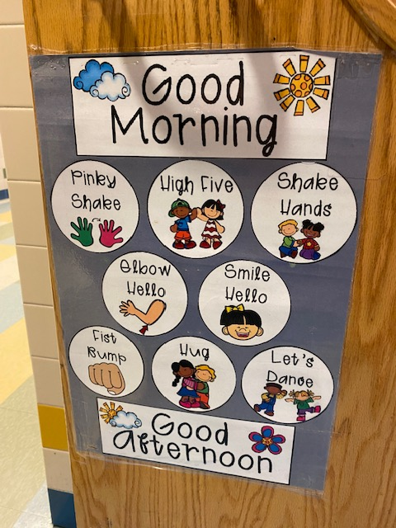
Figure 1: Classroom door poster displaying student choice board for greeting between teacher and student on entering the classroom (Photo by Penny Evans)
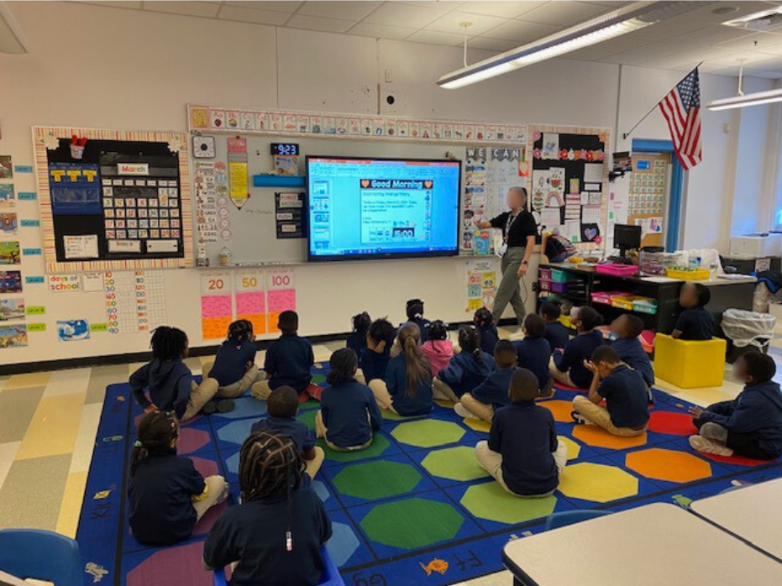
Figure 2: Morning routine in the classroom (Photo by Penny Evans)

Trauma-informed practice in distance education
The study tour allowed for the opportunity to observe trauma-informed practice in three different distance education schools across three different states of Australia. Two of the schools, School A and School B, are implementing the Berry Street Education Model (BSEM) while School C is applying the Australian Childhood Foundation’s Making Space for Learning Framework. All three schools have large numbers of students enrolled under the mental health category indicating high levels of vulnerability within the student population. Learning disengagement is also reported to be high across all three schools, a factor reported by both School A and School C as contributing to the decision to make the shift toward trauma-sensitive schooling as it was recognised that a different approach was needed to meet the needs of these students.
The core principles of trauma-informed education, such as positive relationships, consistent predictable routines and explicit teaching of social-emotional skills, are evident in the range of strategies being applied across all three schools. Distance education poses significant challenges in building connections between students and school, especially when students come from a place of long-term disengagement with their schooling and at times school-associated trauma. It is heartening to see educators in these contexts thinking outside the box to adapt strategies originally designed for a face-to-face classroom, to forge connections with their students and create a digital space for learning that is psychologically safe. Some of the strategies observed include a daily morning check-in between students and their wellbeing coach (School A), checking students’ readiness to learn at the beginning of online lessons (all three schools), use of positive primers and brain breaks in online lessons (School A and School B), explicit teaching of self-regulation skills (School A and School B) and weekly lessons dedicated to increasing students’ psychological resources (all three schools). Further wraparound support is evident in all three schools with a team around the learner approach to case management that brings together learning advisors/wellbeing leaders, teachers and learning support staff to discuss and plan for individual student support needs.
In addition to the complexity of forging connections between students and teachers in the distance education context, some further reported challenges included compliance from all staff with allocating lesson time to positive primers and brain breaks (School A and School B) and the vicarious, or personal, trauma amongst the staff (School C). One teacher spoke of the adjustment period being difficult for some staff but that consistency across the school, including school leaders embedding positive primers into all staff meetings, helped to keep the momentum going. This is similar to the experience reported by the elementary school visited in Massachusetts, so provides reassurance that despite the challenges faced in the early stages of implementation, a consistent approach with quality delivery of ongoing professional learning and support can mitigate some of the impact of these challenges and help to ensure success with sustaining practice. Research that has examined the role of school leaders in effectively implementing and sustaining trauma-informed education has found that leadership of teacher professional learning beyond the initial content delivery is effective in supporting teachers to embed new practices (Stokes, 2022). The active engagement of senior school leadership in the initial training of trauma-informed education and ongoing professional learning was noted by all schools observed in this study.
The school leaders interviewed all said that their foremost advice for implementing and sustaining practice was having a team with a range of teacher expertise to drive the practice. Two schools from the study have a team that meet two or three times each school term to review progress and identify areas for improvement. Further suggestions included informal audits of classroom practice, which can take the form of self-feedback of recorded lessons, to identify areas where further support or professional learning is required. School leaders expressed the importance of not only providing ongoing support and professional learning for current staff but also the need to upskill new staff with appropriate training and mentoring. School B has all new staff participate in BSEM training, with the first two days completed in the first year, then the next two days completed in their second year at the school. Teachers at School B embed BSEM strategies into their quality differentiated teaching practice and all full-time teachers have a care group that they meet with once per week to deliver social-emotional learning that includes teaching self-regulation skills and bolstering psychological resources using BSEM elements such as character strengths and learning stamina. School C provides all new staff with a comprehensive induction package that includes trauma-informed education modules and mentoring by a learning specialist. All teaching staff at School C participate in ongoing professional learning within small collaborative learning teams using an inquiry-based model. Similar to School B, School C also requires all teaching staff to deliver a social-emotional learning program in a weekly online lesson. This approach to having all teaching staff involved in the delivery of these lessons means that trauma-informed education is deeply embedded as a whole-school approach. It not only enhances the development of the teacher-student relationship but also emphasises that active participation in initiatives to support student mental health and wellbeing is essential for all teachers and not just the domain of a wellbeing team. School A is still in the early stages of training all staff in the Berry Street Education Model so yet to formulate a plan for upskilling new staff into the future.
All three distance education schools are still in the implementation stage, so they report that it is difficult to reliably assess the impact of trauma-informed practice on student wellbeing and learning outcomes. Despite the lack of significant data at this early stage, all three schools report that they are confident the practice will lead to positive outcomes. There were reports of anecdotal evidence of improvements in learning engagement such as one teacher remarking that while writing end of term reports recently, he observed that only a few students demonstrated low engagement compared to most of the class when reporting in the year prior. Another school reported an increase in online lesson attendance, submission of work, and a decline in the percentage of students with very low engagement as measured by work return rates from 2022 to 2023. Key BSEM strategies including morning check-in and explicit teaching of self-regulation commenced at the school in Term 1 2023.

School A - Learning engagement data 2022 and 2023
 | Year 9 2022 | Year 10 2023
Student work return rates | 51% | 60.5%
Live lesson attendance | 43% | 47%
High level disengagement* | 43% | 30%
*Percentage of students with work return rates <50%

Both School A and School B indicated that other initiatives that have recently been implemented at the school may also be a causal factor such as a pedagogical change to explicit teaching and a team around the learner approach. However, as one school leader said, at the very least they are confident it is having some degree of positive impact. It would be interesting to observe impact again after the schools have reached a period of sustaining practice.

Conclusion
The study tour highlighted the dedication of teachers in meeting the learning and social-emotional needs of their students and their unwavering commitment to professional learning to support pedagogical change. Many schools across NSW are recognising that a trauma-informed approach aligns with best practice in the classroom. When it comes to providing educational opportunities, there is movement toward acknowledging that curriculum provision alone is not enough in distance education. The explicit teaching of social-emotional learning, including self-regulation, is essential for all young people to equip them with the skills needed to face the challenges life throws at them. The opportunity to be supported by a trauma-informed approach is even more crucial for young people struggling to process the impact of trauma and poor mental health.
This research stemmed from the recognition that there are distance education schools around Australia working diligently to adapt trauma-informed frameworks designed for face-to-face classrooms. It is hoped that sharing this information with the educational community will benefit other schools that are supporting the remote learning of students including mainstream schools grappling with school refusal. Strategies to assist students in maintaining a connection with the school may support transition back to the classroom.

Acknowledgments
I would like to express my sincere gratitude to the Anika Foundation for providing the opportunity for the study tour. I would like to acknowledge the school leaders, teachers, staff and students who welcomed me into their schools and classrooms. I would also like to acknowledge the academics and other experts who shared their knowledge with me.
A special thank you to Prof Therese Cumming, Marissa Del Rosario, Terri Grey, Malcolm McIver, Vanja Pejic, Natalie Pohl, Prof Helen Stokes, Gabriele Turci, Dr Michelle Tye, Zena Wotton.

References
Atallah, D. G., Koslouski, J. B., Perkins, K. N., Marsico, C., and Porche, M. V., (2019). An Evaluation of Trauma and Learning Policy Initiative’s (TLPI) Inquiry-Based Process: Year Three. Boston, MA: Boston University, Wheelock College of Education and Human Development.
Australian Childhood Foundation, 2010. Making Space for Learning: Trauma Informed Practice in Schools. https://professionals.childhood.org.au/
Australian Secondary Principals’ Association (ASPA), 2022. National Trend of School Refusal and Related Matters. Submission to Senate Inquiry. https://www.aph.gov.au/DocumentStore.ashx?id=f529094d-d9b6-4b83-b3fc-356f13ce7917&subId=727746
Beames, J.R., Huckvale, K., Fujimoto, H., Maston, K, Batterham, P.J., Calear, A.L., Mackinnon, A., Werner-Seidler, A. and Christensen, H., 2023. The impact of COVID-19 and bushfires on the mental health of Australian adolescents: a cross-sectional study. Child and Adolescent Psychiatry and Mental Health, 17, 34. https://doi.org/10.1186/s13034-023-00583-1
Berry Street, 2024. Berry Street Education Model. [online] Available at: https://www.berrystreet.org.au/learning-and-resources/berry-street-education-model [Accessed 22 April 2024].
Childhood Trauma Task Force (CTTF), 2020. Framework for trauma informed and responsive organizations in Massachusetts. https://www.mass.gov/lists/framework-for-trauma-informed-and-responsive-tir-organizations
Cole, S., Greenwald O’Brien, J., Geron Gadd, M., Ristuccia, J., Luray Wallace, D. and Gregory, M., 2005. Helping Traumatized Children Learn. ed.1. Boston: Massachusetts Advocates for Children.
Howard, J., 2021. National Guidelines for Trauma-Aware Education, QUT and Australian Childhood Foundation. https://eprints.qut.edu.au/207800/
L’Estrange, L. and Howard, J., 2022. Trauma-Informed Initial Teacher Education Training: A Necessary Step in a System-Wide Response to Addressing Childhood Trauma. Frontiers in Education, 7, article number: 929582. https://doi.org/10.3389/feduc.2022.929582
Phifer, L.W., and Hull, R., 2016. Helping Students Heal: Observations of Trauma-Informed Practices in the Schools. School Mental Health, 8, 201–205. https://doi.org/10.1007/s12310-016-9183-2
Stokes, H., 2022. Leading Trauma-Informed Practice as an Instructional Model for Teaching and Learning. Frontiers in Education, 7, article number: 911328. https://www.frontiersin.org/articles/10.3389/feduc.2022.911328/full
Thomas, M.S., Crosby, S. and Vanderhaar, J., 2019. Trauma-Informed Practices in Schools Across Two Decades: An Interdisciplinary Review of Research. Review of Research in Education, 43, 422-452.

