
2020 Premier’s Anika Foundation Youth Depression Awareness Scholarship

The Heart of Education
  - Compassion-based approaches to emotional health in schools
Tiffany Barreca
Child Wellbeing & Mental Health Services Unit
Based at Belmore Boys High School
Sponsored by
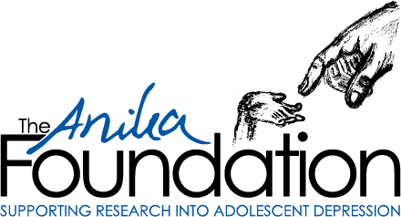

Introduction
The highest aim of education is to prepare students to live a meaningful and rewarding life as engaged citizens in a complex and dynamic society. The students of today live in a world increasingly defined by unprecedented interconnectedness and with it, global challenges and existential threats such as escalating geopolitical tensions, rising inequality, climate change, and the rapid encroachment of Artificial Intelligence (AI). For students to navigate this brave new world, education must prioritise the cultivation of one of our defining human qualities – our capacity for compassion.
Considered a virtue in almost all societies throughout history, compassion concerns the direct engagement with and alleviation of suffering. Unfortunately, the psychological suffering of Australia’s young people has steadily deteriorated despite increasing awareness and investment in mental health programs. In NSW, one in three adolescents report significant levels of psychological distress, which is associated with an increased risk of mental illness, citing the environment, discrimination, and mental health as their top concerns (Mission Australia 2023). The rates of mental illness have surged to 39% and suicide remains the leading cause of death in this age group (ABS 2023; AIHW 2023). These distressing statistics are exacerbated in more vulnerable student groups, including First Nations and LGBTIQA+ youth. As up to 50% of first episodes of mental health concerns occur before age 14, schools have a powerful potential to either exacerbate or reduce distress in young people (Kessler et al. 2005).
However, addressing youth mental health presents a wicked problem. Mental health is a highly heterogeneous, multifactorial, and dynamic phenomenon arising from complex interactions between various biological, psychological, social, and environmental vulnerabilities and protective factors. Thus, we need innovative, collaborative, and multi-level student-centred compassionate responses, as recommended by the National Mental Health Commission (UNE & Everymind 2023). Although not a panacea, when compassion is the heart of education, we can collectively face the complex difficulties of life, without being overwhelmed by them, and work toward alleviating and preventing distress in all its guises.

Focus of Study
The focus of my study tour was threefold:
- To deepen my understanding of why compassion cultivation is effective in addressing psychological distress and improving the wellbeing of students.
- To enrich my knowledge of how compassion can be cultivated in schools and the wider education system, including expanding my repertoire of compassion-based approaches and strategies.
- To gain insight into what is required to translate this learning into the context of the NSW education system, by navigating potential implementation challenges, while leveraging effective existing practices.

Significant Learning

The Dialectics of Compassion
Throughout my study tour, the transdisciplinary nature of compassion research was repeatedly emphasised, so I have organised my significant learning into five key themes I call the Dialectics of Compassion. Broadly, from a dialectical stance, progress and shared understanding emerges from the synthesis of internal tensions and seemingly opposing perspectives. Excessive focus on any single dimension, or one pole of a particular dimension, can lead to oversimplified and reductionist approaches to youth mental health that fail to handle the complexity of the issue. I believe compassionate educational systems emerge from a synthesis of the dialectical tensions described below. When compassion is the heart of education, all actors within the system can thrive, with wide-reaching benefits for youth mental health and broader society.

Compassion is innate and cultivated
Compassion is an innate human capacity hard-wired into our neurobiology from the evolutionary advantages it confers, ensuring the survival of our offspring and kin. However, it is also highly cultivable. Throughout my study tour, from encountering varying definitions of compassion, I have come to understand it as: “a sensitive awareness of, concern for, and motivation to alleviate and prevent the suffering of others (including ‘other’ parts of oneself)” (Gilbert 2009; Jazaieri 2018). Compassion comprises five elements, which I have linked to specific competencies (Strauss et al. 2016):
- Recognition of suffering (mindful awareness)
- Understanding the universality of human suffering (cognitive understanding)
- Connecting emotionally with the distress of the person suffering (affective resonance)
- Tolerating uncomfortable feelings whilst remaining open to the sufferer (distress tolerance)
- A motivation / acting to alleviate suffering (intentional action)
Compassion is often conflated with a range of closely related, yet conceptually different, constructs including kindness, altruism, love, and empathy. A recurring theme in my study tour was the critical importance of differentiating compassion from empathy, which have distinct patterns of brain activity and different neural correlates (Novak et al. 2022). Empathy involves sensing and feeling various emotions of others, while compassion engages unpleasant emotional states. Unlike empathy, compassion emphasises action without the internalisation of other’s emotions. This distinction highlights drawbacks to empathy, such as reacting to our own emotions in response to others’ suffering, rather than helping (Chierchia & Singer 2017).
Compassion Focused Therapy (CFT) frames compassion as ‘wise courage’ (Gilbert 2009). Courage empowers us to confront suffering, but wisdom is required to guide action. Rushing to save someone from danger displays courage yet can be imprudent if lacking the necessary skills. Conversely, without courage we may hesitate to act, for instance when a student or colleague returns to school following a significant loss, such as the death of a loved one. Despite the genuine desire to offer support or comfort, individuals may find themselves overwhelmed by the fear of saying or doing the wrong thing and as a result, avoid interacting with the grieving person. This avoidance stems from empathy but ironically isolates the bereaved.
Our ability to respond compassionately in situations is shaped by both personal factors (e.g. life experiences, attachment style, beliefs, culture, and skillset) and situational factors (e.g. time pressure, distraction, and neurophysiological state) (Kirby, Day & Sagar 2019). Importantly, compassionate action is not focused on changing unpleasant emotions and may mean being present with or validating someone in distress, which is therapeutic despite not seeming an active intervention (Kuo et al. 2022). Cultivating compassion involves honing various skills and capabilities, such as mindfulness, emotion regulation, distress tolerance and communication, which vary among individuals and across situations. Compassion training involves strengthening and generalising these skills, and acquiring strategies for managing internal and external inhibitors, with the goal of developing episodic compassion into a more stable trait.

Compassion integrates mind and body
Compassion cultivation is a praxis that integrates mind and body, requiring both cognitive understanding and ongoing practise to build the required skills and competencies. The Three Circle Model of CFT provides a simple way to understand the integration of mind and body via three continually active emotional regulation systems, which contribute to our survival and wellbeing (Gilbert 2009). Firstly, the Threat-Defence System ensures our safety in response to perceived threat, quickly activating our physiological stress response and fight-flight-freeze behaviours. While aiming to protect us, when overly active, it may contribute to excessive anxiety, anger, or sadness. The Drive System motivates us to actively seek out resources to fulfil our needs via dopaminergic reward pathways. However, over activation contributes to addictive behaviours. Finally, the Soothing System leads to feelings of safety and calm, which promote affiliative behaviours and social bonding. It is hypothesised that psychological distress emerges from an imbalance of these three systems. Compassion cultivation aims to strengthen the Soothing System, which can often be less developed due to the competitive motives underlying many aspects of modern life, so we can moderate the overactivation of the Drive and Threat-Defence systems.
Figure 1. The Three Emotional Regulation Systems (Source: Kirby et al. 2023)
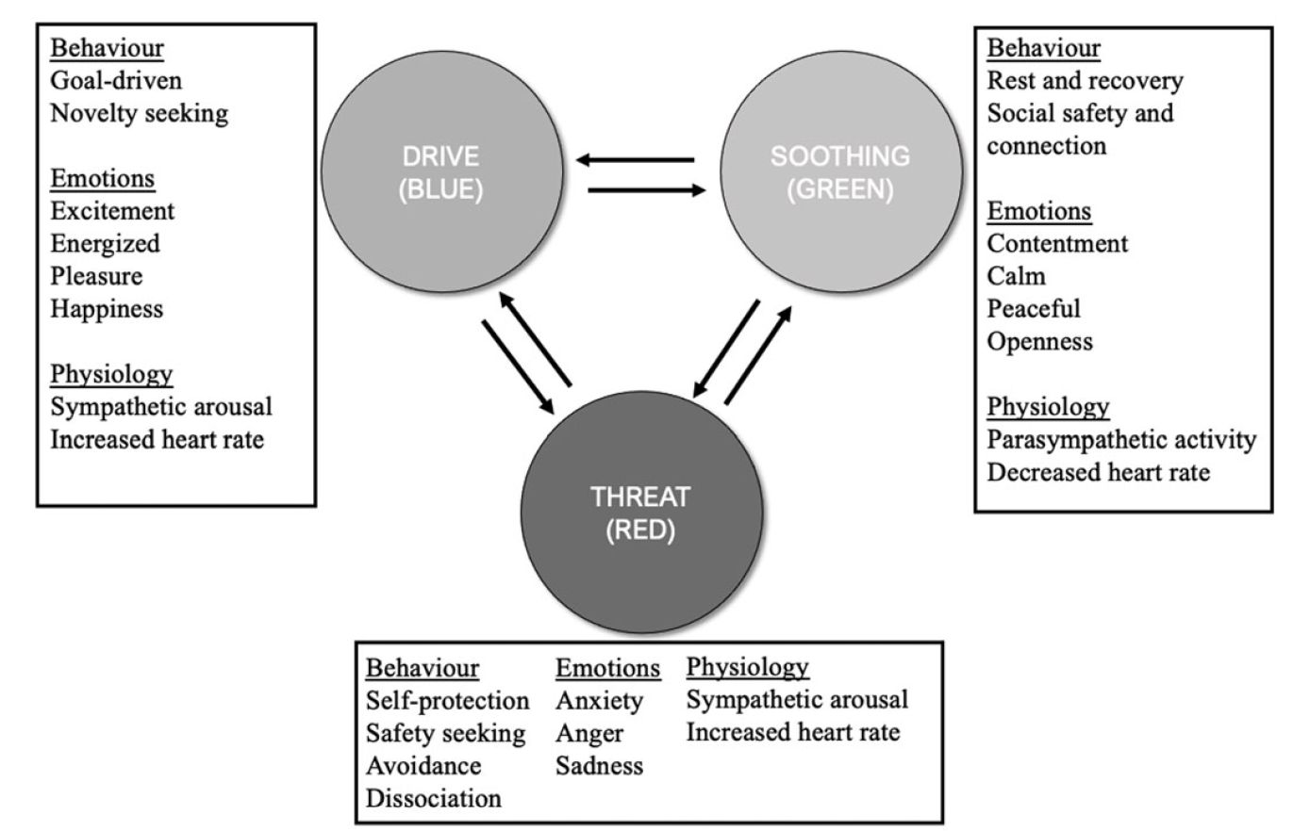
Compassion can arise automatically via affective pathways in response to distress signals, like crying. However, our innate evolutionary bias makes it easier to feel compassion for familiar and likable individuals than those we may feel aversion towards, like difficult colleagues or violent offenders. Deliberative compassion, a more effortful cognitive process, is crucial for expanding our circle of concern. As groups grow larger, the affective pathway to compassion becomes more difficult, so developing our cognitive pathways are critical, particularly in leadership, to counter emotional in-group biases (Kirby 2022).
Compassionate states shift individuals toward increased parasympathetic response (i.e. the Soothing System), which calms our stress responses by lowering heart rate and modulating inflammation. Compassion training has been demonstrated to reduce overall threat sensitivity, lower cortisol levels, increase heart rate variability (an indicator of resilience) and promote feelings of safety and trust (Kim et al. 2020). Compassion cultivation also reduces stress, shame, and self-criticism, which are associated with common adolescent mental health issues, including eating disorders, depressive and anxiety disorders, problematic perfectionism, self-harm, and suicidality (Furukawa & Kessler 2019; Kirby, Tellegen & Steindl 2017). Thus, through practise, compassion cultivation strengthens the neural pathways of the Soothing System, making compassionate responses easier and more automatic.

Compassion encompasses self and system
The essence of compassion is the fundamental truth of the interconnectedness and interdependence of all life including the shared human experience of all people past, present, and future. The Compassionate Systems Framework in Schools (CSF), developed by Dr Boell and Dr Senge from MIT, has been implemented in schools internationally including in Australia, Singapore, and Canada. The framework, inspired by ways of being from Indigenous cultures, considers compassion a systemic property of mind, arising from ‘an ever-unfolding awareness of interconnectedness’, cultivated through the synthesis of an intellectual appreciation of the systemic forces that influence people’s actions, and the felt sense of what it is like to be an actor in the system (Senge et al. 2019, p. 2).
The framework posits that humans are continually shaped internally and externally by systems, from our personal biological and psychological systems (referred to as the mind-heart-body system), to family and social institutions like schools, and the larger social, economic, and natural systems around us. CSF considers all interactions as existing in a relational space called a social field. How each of us shows up in this field directly impacts its nature and tone. We want to nurture generative social fields, which allow individuals to flourish, foster creativity, and promote learning. Thus, personal wellbeing is considered the foundation, or the quality of the soil, from which our patterns of relating to others grow. By developing the competencies required for compassion, we contribute to the greater generative social field that in turn, via feedback loops, further fosters compassion.
Research overwhelmingly demonstrates that our capacity for compassion is contagious and continuously expands. Receiving, feeling, or even just witnessing compassion increases our propensity to act compassionately and reduces our inclination to punish others (Kirby 2022). In an educational context, for example, feeling compassion towards a colleague makes us more able to respond compassionately to challenging student interactions. However, across my study tour, working skilfully with the dialectical tension between Self and System was universally emphasised as many existing approaches overly-focus on individual responsibility. Subsequently, compassionate systems, and compassionate leadership, must involve courageously examining and addressing broader systemic influences beyond any individual’s control. CSF offers an innovative approach here in recommending the application of pre-existing systems-thinking tools to engage with complex dynamics without being overwhelmed by them.

Compassion includes staff and students
Compassion cultivation in schooling systems needs to involve all stakeholders, encapsulated by CSF's 'Wellbeing at Every Level' principle. This principle underscores how all students, staff, and leaders engage in interactions that determine the social field. Combined with the three interactive flows of compassion from the CFT model, we can better grasp the complex dynamics from which compassionate cultures, institutions and organisations emerge, as depicted in Figure 2 (Gilbert 2009).
Figure 2. The Interactive Flows of Compassion (Source: Adapted from Gilbert 2009)
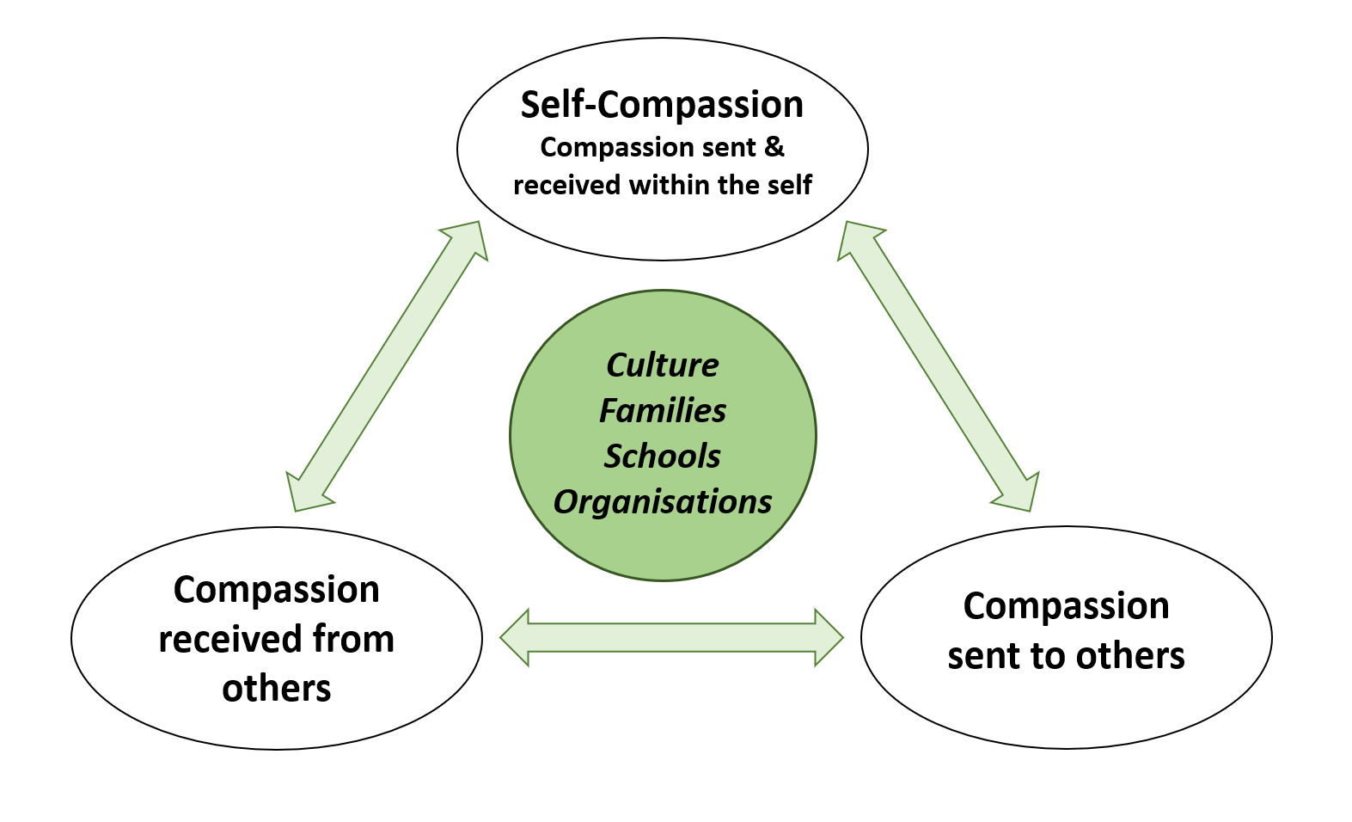
Staff wellbeing was consistently emphasised as an urgent priority, as it directly impacts student achievement, the efficacy of social-emotional learning initiatives, and stress levels of both students and staff (Madigan & Kim 2021; Oberle & Schonert-Reichl 2016; Thierry, Vincent & Norris 2020). Importantly, the term “compassion-fatigue” is a widespread misnomer more accurately described as “empathic distress fatigue”, with different biopsychological pathways shown in Figure 3 (Hofmeyer, Kennedy & Taylor 2019). Empathic distress activates neurological pain networks, leading to increased stress and burnout. In contrast, compassion actually protects against burnout, lowers markers associated with the harmful effects of stress, and increases job satisfaction (Jennings & Min 2023). Translating research from the healthcare sector is invaluable for educational contexts due to analogous challenges, including chronic staff shortages, increasingly complex and unsustainable workloads, and high rates of burnout and attrition. This has led to the development of courses such as Monash University’s Compassion Training for Educators, which aims to teach participants how to transform empathy into compassion (Ling, Olver & Petrakis 2018).
Figure 3. The Pathways to Empathic Distress or Compassion (Source: Adapted from Chierchia & Singer 2017)
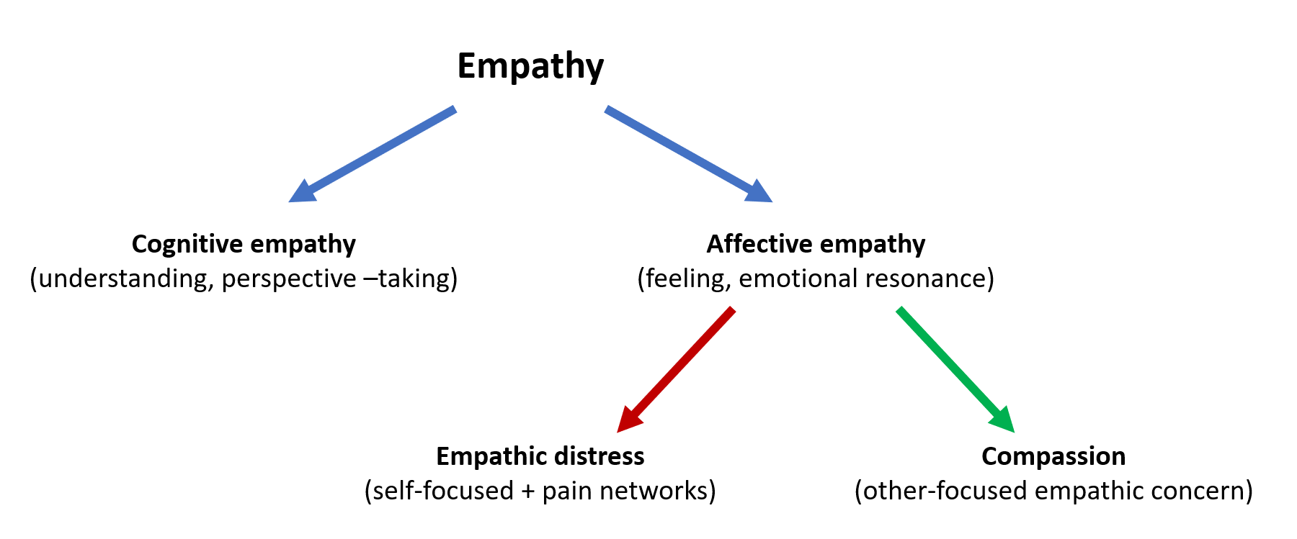
During my study tour, I engaged with an international team of CFT researchers, who have drawn on therapeutic techniques to develop universal Compassionate Mind Training programs (CMT) for teachers, pupils, and parents. CMT-Pupils had significant impacts on student’s levels of anxiety and self-criticism, improved classroom behavioural and emotional regulation, and protected against deteriorations in mental health (Maratos et al. 2024). Similarly, CMT-Teachers significantly decreased levels of depression, stress, and fears of compassion from others, while significantly increasing self-compassion (Matos et al. 2022). The emotional regulation capacities of both students and adults determines the nature of the social field, such as in a classroom system, demonstrated in Figure 4 (Kirby et al. 2023). In schools, the Drive System is often overly activated and regulated by the Threat-Defence System due to comparison and competition where achievement feels linked to self-worth. However, through co-regulation, a teacher’s compassionate Soothing System can foster environments more conducive to learning and creativity. This means compassion cultivation can enhance the efficacy of current wellbeing approaches in NSW schools including positive behaviour for learning, trauma-informed practice, growth mindsets, and restorative practices.
Figure 4. Emotional Regulation in Competitive and Compassionate Classroom Systems Source: (Kirby et al. 2023)
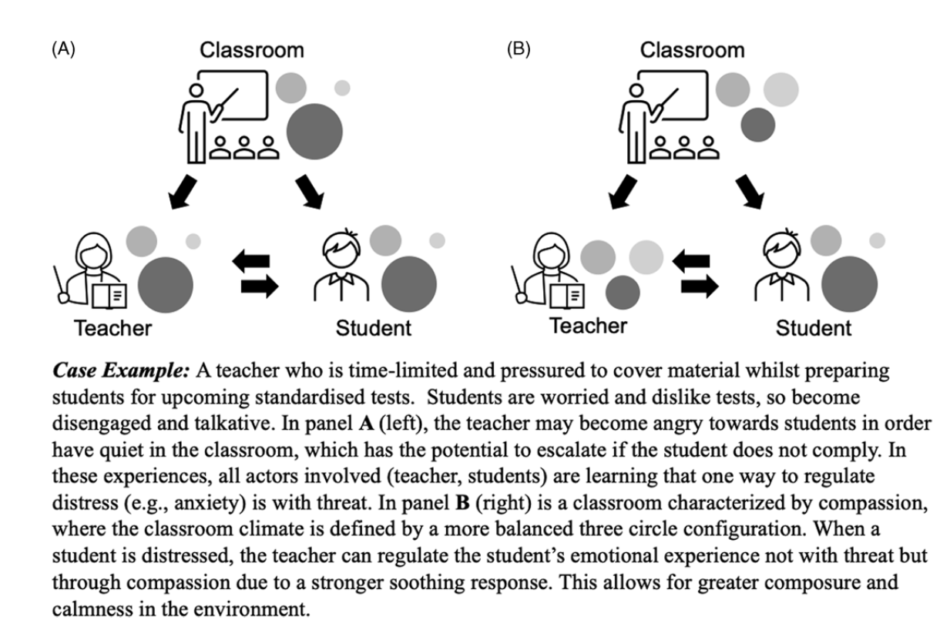
My study tour also enabled me to extend my repertoire of compassionate educational approaches via professional learning through UC Berkeley’s Greater Good Science Centre, Emory University’s SEE Learning and from generously shared resources such as the Flourish Curriculum from the Compassionate Schools Project (CSP), the most comprehensive modern study of wellbeing in schools (awaiting publication).

Compassion grows intentionally and organically
Embedding compassion in educational systems is akin to tending a garden, involving universal challenges, contextual nuances, and responsiveness to changing conditions. Like plants, compassion flourishes naturally when provided with the right conditions, time, and space. Initial steps include assessing the underlying conditions and doing the groundwork so that planted seeds can develop deep roots and thrive to produce desired outcomes. Like seedlings, in the early stages, compassion cultivation demands higher levels of investment and attention. Psychoeducation, working gently with fears of compassion, seeking to listen to all, and developing a shared language are essential for increasing individuals’ willingness to engage in systems change. Our capacity for compassion is easily disrupted by situational factors like stress, distraction, cognitive overload, time pressure, challenging interactions, and competition (Ling, Olver & Petrakis 2018). Therefore, we must intentionally construct environments embedded with nudges, primes, and light-touch interventions that foster compassion. This is essential for developing more sustainable, perennial systems, where all individuals cannot help but be positively shaped by the system (Di Bello et al. 2020).
Just as monoculture makes gardens susceptible to disease, diversity strengthens systems and enhances resilience. Dr Serebin, from the University of Manitoba's Faculty of Education, explained that reimagining more diverse and compassionate educational paradigms involves intentionally and courageously confronting cultural, colonialist, gendered, and heteronormative hegemonic legacies entrenched in Western educational structures. In the UK, compassionate and distributive leadership is being used to radically transform the culture of the National Health Service. Compassionate leadership involves the courage to listen deeply to truth-telling and allowing one's interpretations to be questioned, leading to a shared understanding of challenges and more effective solutions. Distributive leadership fosters collective responsibility for nurturing compassionate cultures of learning and innovation by valuing diverse knowledge, skills, and perspectives, thereby improving system outcomes (West, Bailey & Williams, 2020). This translates to educational settings, where embodied compassionate leadership significantly predicted the effectiveness of interventions like CMT and the CSP.
As change unfolds gradually and is challenging to perceive, reflective practices are vital for tracking progress and maintaining momentum. However, every little step or short burst towards more compassionate institutions is win-win. Cultivating compassion means valuing processes over outcomes and appreciating that progress emerges from the synthesis of acceptance and change. Although compassion cultivation, like gardening, is never truly complete, the perpetual evolution of any system provides infinite opportunities for renewal and transformation.

Conclusion
Compassionate educational systems embrace the entire spectrum of our shared humanity, where the inevitable challenges of life are met with care and concern. They are spaces where the holistic wellbeing of every individual is honoured, in an environment where open-hearted listening enables authentic and honest expression, which drives collaborative transformational innovation. This vision necessitates working at the individual, relational and systemic level, integrating everyday practices with concerted efforts to acknowledge and dismantle barriers to compassion. By fearlessly addressing the roots of suffering, compassionate schools can mitigate the biopsychosocial and environmental factors that contribute to adolescent distress and mental health issues. Compassionate schools emerge by synthesising the dialectics of compassion – the innate and the cultivated, mind and body, the self and system, staff and students, the intentional and organic.
Over the unprecedented five years of this project, and the incredible change that accompanied it, I have continually adapted and explored new opportunities for the dissemination of my findings. I am continuing to work within my base school to cultivate a departmental compassion hub and will be presenting to the NSW Selective School Network conference in June. Through my current role in the Child Wellbeing & Mental Health Services unit, I am collaborating to disseminate my learning through the Trauma-Informed Practice team of 100+ trainers who deliver professional learning to schools across NSW. I am also currently developing professional learning options for targeted groups such as school-based learning and wellbeing teams, the student support officer network, the school counsellor and psychologist workforce, and presentations for Director and Principal network meetings.
Throughout my scholarship journey, I've often questioned my credibility to study compassion considering my many failures to act compassionately. In facing this very struggle, I am reminded that cultivating compassion is not about eradicating our fallibilities but embracing our humanness. Compassion gives us the courage to turn toward and radically accept pain and suffering in ourselves and others, so that we can work towards meaningfully alleviating and preventing it. This is the heart of education.

Acknowledgments
Firstly, I acknowledge and pay respect to the Traditional Owners of Country on whose lands I worked and travelled as part of this project, including the Arakwal, Awabakal, Bidjigal, Bundjalung, Bunurong, Gadigal, Kabi Kabi, Turrbal, and Wurundjeri peoples. I extend this to all Indigenous peoples of the world whose traditions, ways of being, and wisdom of the interconnectedness of all life, offer much to learn about compassion.
I am sincerely grateful to the many researchers, schools, staff, students, and leaders who made themselves available to meet and speak with me, and generously shared their work, insights, and lived experience. I would also like to thank the Anika Foundation for their interest in this project and unwavering support since the unprecedented year of 2020.
Finally, I express my profound gratitude to the people in my personal and professional life, living and in memory, whose compassion nurtured me along this journey.

References
ABS – see Australian Bureau of Statistics
Australian Bureau of Statistics 2023, National Study of Mental Health and Wellbeing 2022-2023, ABS, viewed 05 May 2023, https://www.abs.gov.au/statistics/health/mental-health/national-study-mental-health-and-wellbeing/2020-2022#media-releases
AIHW – see Australian Institute for Health and Welfare
Australian Institute for Health and Welfare 2023, Deaths by Suicide Among Young People 2022, AIHW, viewed 05 May 2023, https://www.aihw.gov.au/suicide-self-harm-monitoring/data/populations-age-groups/suicide-among-young-people
Chierchia, G & Singer, T 2017, ‘The neuroscience of compassion and empathy and their link to prosocial motivation and behavior’, Decision Neuroscience, pp. 247–257, https://doi.org/10.1016/B978-0-12-805308-9.00020-8
Di Bello, M, Carnevali, L, Petrocchi, N, Thayer, JF, Gilbert, P & Ottaviani, C 2020, ‘The compassionate vagus: A meta-analysis on the connection between compassion and heart rate variability’, Neuroscience & Biobehavioral Reviews, vol. 116, pp. 21–30, https://doi.org/10.1016/j.neubiorev.2020.06.016
Furukawa, TA & Kessler, RC 2019, ‘Why has prevalence of mental disorders not decreased as treatment has increased?’, Australian & New Zealand Journal of Psychiatry, vol. 53, no. 12, pp. 1143–1144, ‌https://doi.org/10.1177/0004867419886652
‌Gilbert, P 2009, The Compassionate Mind: A New Approach to Life’s Challenges, Robinson, London.
‌Hofmeyer, A, Kennedy, K & Taylor, R 2019, ‘Contesting the term “compassion fatigue”: Integrating findings from social neuroscience and self-care research’, Collegian, vol. 27, no. 2, https://doi.org/10.1016/j.colegn.2019.07.001
Jazaieri, H 2018, ‘Compassionate education from preschool to graduate school’, Journal of Research in Innovative Teaching & Learning, vol. 11, no. 1, pp. 22–66, https://doi.org/10.1108/jrit-08-2017-0017
Jennings, PA & Min, HH 2023, ‘Transforming empathy-based stress to compassion: Skillful means to preventing teacher burnout’, Mindfulness, vol. 14, pp. 2311–2322, https://doi.org/10.1007/s12671-023-02115-6
Kessler, RC, Berglund, P, Demler, O, Jin, R, Merikangas, KR & Walters, EE 2005, ‘Lifetime prevalence and age-of-onset distributions of DSM-IV disorders in the national comorbidity survey replication’, Archives of General Psychiatry, vol. 62, no. 6, pp. 593–602, https://doi.org.au/10.1001/archpsyc.62.6.593
Kim, JJ, Parker, SL, Doty, JR, Cunnington, R, Gilbert, P & Kirby, JN 2020, ‘Neurophysiological and behavioural markers of compassion’, Scientific Reports, vol. 10, 6789, https://doi.org/10.1038/s41598-020-63846-3
Kirby, JN, Tellegen, CL & Steindl, SR 2017, ‘A meta-analysis of compassion-based interventions: Current state of knowledge and future directions’, Behavior Therapy, vol. 48, no. 6, pp. 778–792, ‌https://doi.org/10.1016/j.beth.2017.06.003
Kirby, JN, Day, J & Sagar, V 2019, ‘The “flow” of compassion: A meta-analysis of the fears of compassion scales and psychological functioning’, Clinical Psychology Review, vol. 70, pp. 26–39, https://doi.org/10.1016/j.cpr.2019.03.001
Kirby, J 2022, Choose Compassion, University of Queensland Press, Australia.
‌Kirby, JN, Sherwell, C, Lynn, S & Moloney-Gibb, D 2023, ‘Compassion as a framework for creating individual and group-level wellbeing in the classroom: New directions’, Journal of Psychologists and Counsellors in Schools, pp. 1–11, https://doi.org/10.1017/jgc.2023.5
Kuo, JR, Fitzpatrick, S, Ip, J & Uliaszek, A 2022, ‘The who and what of validation: an experimental examination of validation and invalidation of specific emotions and the moderating effect of emotion dysregulation’, Borderline Personality Disorder and Emotion Dysregulation, vol. 9, no. 1, https://doi.org/10.1186/s40479-022-00185-x
Ling, D, Olver, J & Petrakis, M 2018, 'Outcomes from a compassion training intervention for health care workers', Czech and Slovak Social Work, vol. 18, no. 4, pp. 88-96.
Madigan, DJ & Kim, LE 2021, ‘Does teacher burnout affect students? A systematic review of its association with academic achievement and student-reported outcomes’, International Journal of Educational Research, vol. 105, no. 101714, ‌https://doi.org.au/10.1016/j.ijer.2020.101714
Maratos, FA, Wood, W, Cahill, R, Tronco, A, Matos, M & Gilbert, P 2024, ‘A mixed-methods study of Compassionate Mind Training for pupils (CMT-Pupils) as a school-based wellbeing intervention’, Mindfulness, vol. 15, pp. 459–478, https://doi/org/10.1007/s12671-024-02303-y
Matos, M, Albuquerque, I, Galhardo, A, Cunha, M, Pedroso Lima, M, Palmeira, L, Petrocchi, N, McEwan, K, Maratos, FA & Gilbert, P 2022, ‘Nurturing compassion in schools: A randomized controlled trial of the effectiveness of a Compassionate Mind Training program for teachers’, PLoS ONE, vol. 17, no. 3, e0263480, https://doi.org/10.1371/journal.pone.0263480
Mission Australia 2023, Youth Survey Report 2023, Mission Australia, viewed 01 December 2023, https://www.missionaustralia.com.au/publications/youth-survey/3019-youth-survey-report-2023/file
Novak, L, Malinakova, K, Mikoska, P, van Dijk, JP & Tavel, P 2022, ‘Neural correlates of compassion – An integrative systematic review’, International Journal of Psychophysiology, vol. 172, pp. 46–59, https://doi.org/10.1016/j.ijpsycho.2021.12.004
Oberle, E & Schonert-Reichl, KA 2016, ‘Stress contagion in the classroom? The link between classroom teacher burnout and morning cortisol in elementary school students’, Social Science & Medicine, vol. 159, pp. 30–37, https://doi.org/10.1016/j.socscimed.2016.04.031
Senge P, Boelle M, Cook L, Martin J, Lynn K, Haygaru T, Gruen S & Urrea C 2019, Introduction to Compassionate Systems Framework in Schools¸ Abdul Latif Jameel World Education Lab, The Center for Systems Awareness, Massachusetts Institute of Technology, viewed 04 April 2023 https://systemsawareness.org/wp-content/uploads/2019/06/Intro-CompassionateSystemsFramework-March-2019.pdf
Strauss, C, Lever Taylor, B, Gu, J, Kuyken, W, Baer, R, Jones, F & Cavanagh, K 2016, ‘What is compassion and how can we measure it? A review of definitions and measures’, Clinical Psychology Review, vol. 47, pp. 15–27, https://doi.org/10.1016/j.cpr.2016.05.004
Thierry, KL, Vincent, RL & Norris, K 2020, ‘Teacher-level predictors of the fidelity of implementation of a social-emotional learning curriculum’, Early Education and Development, vol. 33, no. 1, pp. 1–15, https://doi.org/10.1080/10409289.2020.1849896
UNE – see University of New England
University of New England & Everymind 2023, Curiosity, Compassion and Care: Designing and delivering community-based supports drawing on people’s lived experience of distress and mental ill-health in Australia, National Mental Health Commission, Sydney, viewed 1 December 2023, https://www.mentalhealthcommission.gov.au/publications/curiosity-compassion-and-care
West M, Bailey S & Williams E 2020, The Courage of Compassion, The RCN Foundation & The King’s Fund, viewed 02 April 2023, https://assets.kingsfund.org.uk/f/256914/x/a8048c1365/courage_of_compassion_2020.pdf

