
2020 Premier’s Early Childhood Education Scholarship

Putting Play at the Centre of Learning in Primary Schools
  - How we best support young minds to become critical, collaborative, and creative global citizens through integrating playful learning in Primary Schools.
Kate Maslowski
Helensburgh Public School
Sponsored by


Introduction
‘Why should children play at school?’ The answer is simple: play supports learning (Mardell et al. 2023). Research shows that play is an integral part of fostering a holistic approach to a child’s education. It not only enhances learning across all developmental domains, including physical, social, emotional, cognitive, and language aspects but also supports academic growth (Taylor & Boyer, 2020). However, despite decades of research demonstrating the benefits of playful learning as age-appropriate pedagogy (Pyle & Danniels, 2017), the growing pressure placed on educators and students to improve academic results has taken precedence over a focus on developing the whole child.
The world is rapidly changing, and it is imperative that our education system remains adaptable and evolves with these transformations. The recent introduction of revised NSW syllabuses and updates to the curriculum presents an opportune moment for educational professionals to reassess their pedagogical practices. Educators are tasked with the responsibility of carefully considering the instructional methods that will most effectively equip their students with the requisite knowledge and skills, both in the present and for the future. Among these essential skills are critical thinking, creativity, collaboration, and communication, all of which can be best taught and fostered through purposefully designed playful learning experiences. It is paramount to shift the focus from a wide breadth of knowledge to a deeper understanding. An integrated playful learning approach is vital in preparing students for a lifetime of learning and for assuming meaningful and effective roles as future citizens (NESA, 2020).
Extensive research underpins play as a pedagogical approach and its benefits are well-documented. Therefore, this report will not primarily aim to persuade the reader of the advantages of play. Instead, it will delve into the more challenging component of putting play at the centre of learning in primary school settings. The focus here is on the 'how' – the strategies and methods required to make play a focal point in the learning process.

Focus of Study
Through continuous research into international education systems and conducting site visits across Queensland, Victoria, New South Wales, and South Australia, three key guiding questions have been examined:
- How can schools establish a collaborative culture conducive to supporting a playful pedagogy?
- In what ways can educators seamlessly integrate playful learning with curricula to cater to the diverse needs of all students?
- How can educators effectively plan, program, and assess playful learning experiences?

There are different terms used across Australia when referring to year/grade levels. The terms used throughout this report such as Prep, Foundation and Kindergarten may differ, however, all refer to the year that formal schooling commences.

Significant Learning
This experience enabled a deeper insight into the various practical approaches for implementing playful learning in primary school across Kindergarten to Grade 6. During site visits, recurring patterns and themes emerged, highlighting the necessary steps and procedures that schools must undertake to establish successful and embedded playful learning programs.

Creating collaborative cultures for playful learning
For playful learning to succeed, schools must focus on working with all stakeholders to develop a collective understanding, responsibility, and commitment to integrating playful learning experiences.

Trust and support from leadership teams
Whilst it is possible for any teacher to integrate the characteristics of playful learning into classrooms – for example, learning experiences that are actively engaging, joyful and meaningful (The LEGO Foundation, 2023) – strong, strategic, and effective leadership is paramount to creating an embedded whole school approach that is self-sustaining and self-improving (NSW Department of Education, 2017). During site visits, it was clear, regardless of the school's initial approach or timeline in adopting playful learning, that the active involvement and support of the principal and the leadership team proved to be a highly necessary factor in establishing whole-school playful learning practices that were successful and long-lasting.

Starting with a deep understanding of playful learning
A key component to implementing and sustaining playful learning practices is establishing a deep understanding of the “why.” Why should playful learning be regarded as an essential pedagogical approach? In their book 'Let the Children Play,' authors Pasi Sahlberg and William Doyle draw on research, case studies, and global examples to construct a compelling argument for the importance of play in children’s learning and development. It is essential for schools to invest ample time in examining the evidence and building a comprehensive understanding of the advantages of play in child development along with how playful learning experiences can positively impact students within their specific educational context (Sahlberg & Doyle, 2019). Educators need to believe in the purpose of play as a pedagogy, as the absence of individual and collective motivation makes improvement unattainable (Fullan, 2007).

Regularly seeking out and participating in professional learning
Once educators have established a solid foundation of understanding the "why," they can shift their attention to the critical “how.” How can theory be effectively translated into practice? Participants at various sites emphasised the importance of gaining an in-depth comprehension of the curriculum and various forms of play to seamlessly incorporate both into educational experiences. A notable challenge encountered by many schools was the lack of professional learning opportunities available to support this integration.
Much like the significance of students having regular chances to revisit and solidify their prior learning, educators also need these opportunities. It is crucial for staff members to regularly participate in professional learning to enhance their knowledge, skills, and effectiveness as educators, ultimately contributing to the improvement of student learning and well-being (NSW Department of Education, 2023a). Schools can facilitate this by establishing recurring discussions on play research, planning, and practices, incorporating them into stage and staff meetings, as well as staff development days.

Engaging the Parent Community
Research shows that when parents and carers are given opportunities to engage in their child's education at school, better educational and wellbeing outcomes are achieved (Evidence for Learning, 2021). During site visits, parents and carers were invited into the classroom regularly to participate in playful learning experiences with their children. Nundah State School's Prep classes open their doors at 8:30am, providing parents and caregivers the opportunity to engage in playful activities, read with children, and explore student-shared artifacts. At St. James Parish School, the last 30 minutes of the Prep Day includes shared reading and singing, where parents can read to the class and sing educational songs with their children.
When school principals were asked about their support from the parent community, a recurring pattern emerged with two consistent responses. The positive community response is primarily attributed to the following factors:
- Clear articulation during transitions: This pedagogical approach is effectively conveyed to families during pivotal transitional periods, such as the transition from Preschool to Kindergarten or when students transfer from a previous school. This communication ensures that parents grasp the significance and advantages of the approach.
- Visible benefits: The community witnesses the advantages of playful learning firsthand. This is evident through students' enthusiasm for school, observations made when parents are invited into classrooms, and the sharing of photos and videos on various online platforms.
- Parent/carer workshops: Organising parent/carer workshops and seminars on playful learning as a pedagogical approach serves as a valuable means to foster a shared vision among all stakeholders.

A connected curriculum
Many classroom teachers in NSW face the challenge of designing timetables that accommodate daily playful learning experiences while adhering to the time allocation requirements set forth by the NSW Education Standards Authority (NESA, n.d.).
An effective strategy to address this obstacle involves creating integrated units of work and ensuring that playful learning experiences are seamlessly linked to Key Learning Areas (KLAs). The advantages of a connected curriculum have been shown to lead to deeper learning, increased student motivation and engagement, improved academic performance and provide opportunities for educators to impart the knowledge and skills necessary for students to thrive as successful 21st-century citizens (Drake & Reid, 2018).

Connecting Curriculum through Narrative and Storyboards
At St James Parish School in Victoria, teachers Foundation to Year 6 intertwine curricula through narrative and the use of three-dimensional, interactive storyboards.
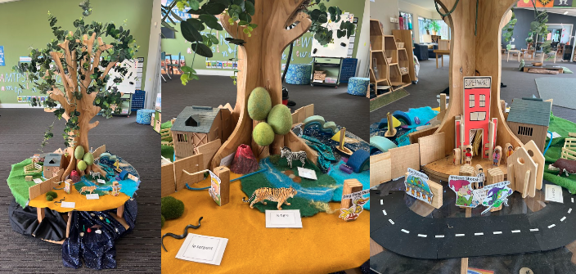
Figure 1: St James Parish School Foundation classroom, Term 2 storyboard. The storyboard integrated Science, Digital Technologies, English, History and the school’s Specialised Language Program.
Storyboards are imaginary worlds that mirror real world issues (Reus, 2023). They are created by teaching teams each term and become the bases for learning. Storyboards are aligned with the curriculum and integrate learning from a range of Key Learning Areas. For two to three sessions per week, students immerse themselves in a learning narrative guided by the teacher, where they encounter challenges requiring problem-solving. The necessary knowledge and skills for responding within the narrative are purposefully planned and cultivated through playful learning experiences. For example, Foundation students at St. James Parish School needed an understanding of communication forms from different time periods to address a narrative challenge. In the lead-up to this situation, play stations like post offices, letter writing, string telephones, and cardboard models illustrating interconnected telecommunication networks were introduced, explicitly taught, and discussed during playful investigations.

Connecting Curriculum through Investigation Stations
Schools trained in the Walker Learning Approach (WLA) K-2, provide students with regular opportunities to participate in purposefully planned playful learning experiences, referred to as investigations, that focus on learning and development objectives (Walker, 2011).
At Kidman Park Public School in South Australia, students in Foundation to Year Two participate in investigations three to four times per week. Investigations align with student interests, developmental domains, and curriculum outcomes. Learning intentions are displayed on interactive whiteboards (IWB) and are referenced before, during, and after student investigations. In Figure 2, the top right image depicts a construction investigation tied to mathematics, involving position and location descriptions. The bottom right image portrays a collage investigation linked to science, focusing on materials and properties.
Integrating play experiences with the curriculum empowers teachers to foster students' cross-disciplinary connections, reinforce learning, and facilitate deeper conceptual understanding throughout the learning sequences.
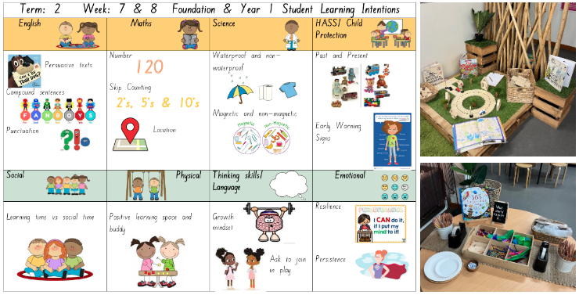
Figure 2: Kidman Park Public School, SA, Foundation/Year 1. Fortnightly learning intentions and focus areas (left) and two examples of investigation stations linking to Mathematics (top right) and Science (bottom right). (Document provided by Vanessa Bottroff)

Developing General Capabilities: One School’s SECRET Powers
At Prospect North Public School, the planning of play experiences and personal investigations revolves around cultivating students' general capabilities, aligning with the school-wide emphasis on developing SECRET powers. Students from Reception to Year Six are actively involved in goal setting to enhance their abilities as self-managers, engaged citizens, creative and critical thinkers, reflective learners, explorers, and team players, aligning with the broader objective of preparing young Australians for success in both their lives and careers in the 21st century (ACARA, n.d).

Planning, Programming and Assessing Play
Planning and assessment are interrelated; one does not exist without the other (MacDonald, 2018). Planning for play requires much of the same process as planning for any teaching and learning. Teachers follow a cyclical framework that includes analysing student current understanding, deciding learning objectives, planning activities that will develop the essential skills and knowledge, and employing a range of mechanisms to formatively assess student understanding and achievement (NSW Department of Education, 2023b).

Well Thought Learning Intentions and a Clear Purpose
The teacher who plans for play has well-thought learning intentions and a clear purpose for initiating play experiences (Mardell et al. 2023). This planning process is both rigorous and dynamic as teachers take into consideration not only learning intentions, but also student needs and interests (Walker, 2011).
Although the duration of units of work varies across site schools implementing the WLA, the process of planning and assessing for play remains consistent. It commences with the identification of learning and development intentions, coupled with the collection of evidence regarding student understanding and interests. The documentation is adaptable and responsive to emerging student needs, interests, skills, and knowledge.

Recording and Documenting Learning
Documenting both the process and product of playful learning experiences through videos, audio, written notes, photographs, and student work samples, is a way to ensure learning is visible through all stages of the learning process. Documentation is important for accountability, but more importantly, revisiting documentation guides decision making for future learning (Mardell et al. 2023).
Assessment of student learning and development occurs consistently and employs a variety of methods. One effective strategy employed by teachers is to choose 2-3 focus students daily to document observational notes, capture photographs, and record videos during playful learning experiences. To streamline this process, K-2 teachers at Middle Harbour Public School were experimenting with individualised student QR codes that connect directly to student profiles and online platforms for sharing learning progress with parents and caregivers.
In some schools, focus students chose their activities, while in others, teachers used this as an opportunity to work with students on individualised learning or developmental goals. Student roles like ‘reporter’ and ‘photographer’ were also employed during playful learning activities to document student progress. These photographs and records were later used for whole-class reflection or in subsequent lessons. For instance, at Middle Harbour Public School, 1/2J reporters created safety rules for an upcoming Athletics carnival, while photographers collected visual evidence for a Mathematics task later in the session.

A Framework for Assessing Pretend Play
Research shows that children who can spontaneously initiate pretend play, demonstrate higher competence in oral language, are able to better self-regulate and have greater socioemotional skills and understanding (Stagnitti & Paatsch 2018). At St James Parish School in Victoria, student pretend play skills are assessed 2-3 times annually using the Child-Initiated Pretend Play Assessment-2 KIT and Pretend Play Checklist for Teachers (PPC-T), which evaluates five pretend play skills. Teachers use the PPC-T Assessment Scoring Form to determine a student’s proficiency level in pretend play skills, ranging from students that need substantial support to proficient players who benefit from advanced play scenarios.

Indicators of Playful Learning
To plan for, implement, and assess play, schools and staff need to decide on what playful learning looks like and feels like in their specific context. The Indicators of Playful Learning is a valuable tool designed to assist schools in developing a pedagogy centred around playful teaching and learning, that is shaped by school culture and beliefs. Once established, school teams can rely on this framework as a reference point for planning and assessing playful learning experiences (Mardell et al. 2023).
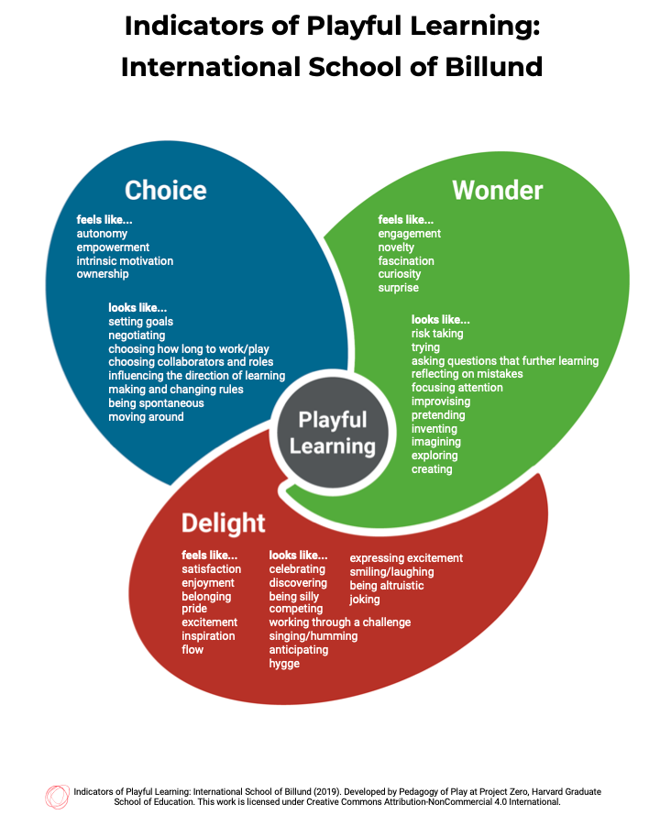
Figure 3: Indicators of Playful Learning. (Pedagogy of Play at Project Zero, Harvard Graduate School of Education, 2019)

Commitment to Regular Collaboration
In a review of achieving educational excellence in Australia schools, collaboration emerged as an important factor in improving teaching and learning, as well as supporting school improvement (Centre for Education Statistics and Evaluation, 2020). To facilitate this, schools should establish a conducive culture and environment for productive collaboration, where educators collaborate to design high-quality lessons, engage in peer observations, offer effective feedback, and have dedicated time for reflective professional discussions.
At St. James Parish School, stage teams collaboratively plan storyboards during staff development days. They draw upon both internal resources, including teacher expertise, and external resources such as the online platform MAPPEN to create engaging and meaningful learning experiences. While all classes work toward the same outcomes, they may progress differently based on students' interests, comprehension levels, and progress. Teachers formatively assess students' responses, allowing for real-time adjustments to the narrative as they interact with their students. Additionally, stage teams receive dedicated release time each week from face-to-face teaching to discuss and respond to learners' needs, adapting the narrative and play experiences as required.
High quality playful learning experiences require regular and ongoing collaboration. Schools should allocate dedicated time on each staff development day and during weekly stage meetings to collectively plan, reflect upon, and refine play programs.

Conclusion
Playful learning as a pedagogical approach is a dynamic and transformative force in education. It empowers students to engage actively with their learning, fostering holistic development across various domains while enhancing academic growth. However, its effective implementation relies on careful planning, ongoing collaboration, and a profound understanding of its purpose and potential.
The integration of playful learning into the curriculum facilitates cross-disciplinary connections, enriching students' educational experiences and promoting deeper comprehension of concepts. By aligning playful learning with learning intentions and developmental goals, educators can create a meaningful and impactful learning environment.
Assessment in playful learning is not only a measure of students' progress but also a tool for refining and personalising the learning experience. Regular assessment, documentation, and reflection are essential components in ensuring the continuous improvement of playful programs.
To succeed in incorporating playful learning, schools must invest in creating a supportive culture that values and embraces the approach. This includes providing educators with the time, resources, and professional development opportunities needed to plan, assess, and adapt playful learning experiences effectively.
Collaboration among educators is paramount. Schools that foster a culture of collaboration, where teachers work together to design engaging lessons, observe, and provide feedback, and reflect on their practice, are best equipped to unleash the full potential of playful learning.
Playful learning prepares students for success in the ever-evolving landscape of the twenty-first century. As educators, schools, and policymakers continue to explore and refine this pedagogical approach, they contribute to a brighter and more engaging future for students and the education system as a whole.

Further Considerations
While not directly linked to the study's key focus areas, several common themes surfaced across each site school and during ongoing personal research on play in primary schools.
A Balance of Pedagogical Approaches – Playful learning experiences or investigations are not intended to replace explicit teaching; instead, they complement and enhance it by fostering deeper connections in students' understanding of challenging concepts. Therefore, in the daily educational routine, students should actively engage in both formal instruction and intentionally planned playful learning experiences.
Setting Up a Playful Environment – The conditions in which playful learning can thrive in the classroom require careful consideration (Mardell et al. 2023). The way that the physical environment is organised, the materials used and resources available are important factors in nurturing a sense of wonder and engaging students in purposeful and meaningful learning (Walker, 2011).
Play in Upper Primary – Just as learners themselves change and grow, playful learning experiences also evolve over time. Promoting playful integrated pedagogies and granting students choice and voice in their learning, particularly in upper primary, can be an effective approach to increasing student motivation, engagement, and wellbeing.

Acknowledgments
I would like to extend my sincere gratitude and acknowledgement to all the principals who graciously permitted me to visit their schools, allocated time for interviews, and granted me the opportunity to shadow their classroom teachers. To the dedicated educators who welcomed me into their classrooms, generously shared their expertise, and provided invaluable support throughout the scholarship study tour and research process, I extend my heartfelt thanks. Your unwavering advocacy for play in education is truly commendable. A special thank you goes to the schools which I visited:
- Kate, Leah and Maree, Nundah State School, Queensland
- Claire, Sandringham East Primary School, Victoria
- Peter, Jacqui and Courtney St James Parish School, Victoria
- Carole and Jen, Middle Harbour Public School, New South Wales
- Liz, Arncliffe Public School, New South Wales
- Melissa and Daniela, Cecil Hills Public School, New South Wales
- John, Vanessa and Patrick, Kidman Park Primary School, South Australia
- Marg, Danni, Emily and Karen, Prospect North Public School, South Australia.
I would also like to express my appreciation to Principal Paul McGillicuddy of Ruse Public School, NSW, for his initial encouragement and endorsement of this scholarship. Additionally, I extend my gratitude to Principal Ewen Neild of Helensburgh Public School, NSW, for his ongoing support throughout this endeavour. Finally, I want to acknowledge Warren Marks from Leading Educators Around the Planet (LEAP) for his instrumental role in facilitating connections with educators both within Australia and across the globe. Your collective support and contributions have been invaluable to this research.

References
ACARA (Australian Curriculum, Assessment and Reporting Authority) (n.d.) General capabilities (Version 8.4), ACARA, viewed 23 June 2023, <https://www.australiancurriculum.edu.au/f-10-curriculum/general-capabilities/>.
AITSL (Australian Institute for Teaching and School Leadership), 2017, Australian Professional Standards for Teachers, viewed 23 June 2023, <https://www.aitsl.edu.au/standards>.
Centre for Education Statistics and Evaluation 2020, What works best: 2020 update, NSW Department of Education, viewed 22 June 2023, <cese.nsw.gov.au>.
Drake, S & Reid, J 2018 ‘Integrated curriculum as an effective way to teach 21st century capabilities’, Asia Pacific Journal of Educational Research, vol. 1, pp. 31-50.
Evidence for Learning, 2021. Parent Engagement: Moderate impact for very low cost based on extensive evidence, Evidence for Learning, viewed 23 June 2023, <https://evidenceforlearning.org.au/education-evidence/teaching-learning-toolkit/parental-engagement>.
Fullan, M 2007. Change theory as a force for school improvement. Intelligent leadership: Constructs for thinking education leaders (pp. 27-39).
MacDonald, A 2018, Mathematics in Early Childhood Education. Oxford University Press, Victoria, Australia.
Mardell, B, Ryan, J, Krechevsky, M, Baker, M, Schulz, S & Lui Constant, Y 2023, A Pedagogy of Play: Supporting playful learning in classrooms and schools, Project Zero, Harvard Graduate School of Education, Cambridge, MA.
NESA (NSW Education Standards Authority), 2020, Nurturing wonder and igniting passion. designs for a new school curriculum: NSW Curriculum Review, NSW Education Standards Authority, Sydney, Australia.
NESA (NSW Education Standards Authority) (n.d.) K– 6 Curriculum requirements, NESA, viewed 23 June 2023, <https://educationstandards.nsw.edu.au/wps/portal/nesa/k-10/understanding-the-curriculum/k-6-curriculum-requirements>.
NSW Department of Education and Communities, 2015, The Wellbeing Framework for Schools, viewed 23 June 2023, <https://education.nsw.gov.au/student-wellbeing/whole-school-approach/wellbeing-framework-for-schools>
NSW Department of Education, 2017. School Excellence Framework: version 2, NSW Department of Education, viewed 23 June 2023, <https://education.nsw.gov.au/content/dam/main-education/teaching-and-learning/school-excellence-and-accountability/media/documents/SEF_Document_Version_2_2017_AA.pdf>.
NSW Department of Education, 2022. Engaging our parents and carers, viewed 22 June 2023, <education.nsw.gov.au>.
NSW Department of Education, 2023a. Professional Learning for Teachers and School Staff, viewed 23 June 2023, <https://education.nsw.gov.au/policy-library/policies/pd-2004-0017>.
NSW Department of Education, 2023b. Teaching and learning cycle, viewed 23 June 2023, <https://education.nsw.gov.au/teaching-and-learning/curriculum/planning-programming-and-assessing-k-12/teaching-and-learning-cycle>.
Pedagogy of Play at Project Zero, Harvard Graduate School of Education, 2019, Indicators of Playful Learning: International School of Billund, viewed 22 June 2023, <https://pz.harvard.edu/sites/default/files/ISB%20indicators_2-pager_color.pdf>
Pyle, A & Danniels, E 2017, ‘A Continuum of Play-Based Learning: The Role of the Teacher in Play-Based Pedagogy and the Fear of Hijacking Play’, Early Education and Development, vol. 28, no. 3, pp. 274- 289.
Queensland Government Department of Education, 2016, Age-appropriate pedagogies for the early years of school: Foundation paper summary, Queensland Government, viewed 23 June 2023, <https://earlychildhood.qld.gov.au/earlyYears/Documents/foundation-paper-summary.pdf>
Reus, M 2023, Story Boards at St James', online video, viewed 23 June 2023, viewed 23 June 2023, <https://www.youtube.com/watch?v=fVSkPoXK7Rg>.
Sahlberg, P & Doyle, W 2019, Let the Children Play: Why More Play Will Save Our Schools and Help Children Thrive, Oxford University Press, New York, United States of America.
Stagnitti, K 2023. Learn to Play, KBB Digital, viewed 22 June 2023, <https://www.learntoplayevents.com/for-teachers/>.
Stagnitti, K & Paatsch, L 2018, Pretend Play Checklist for Teachers, Learn to Play.
Taylor, M & Boyer, W 2020, ‘Play‑Based Learning: Evidence‑Based Research to Improve Children’s Learning Experiences in the Kindergarten Classroom’, Early Childhood Education Journal, vol. 48, no. 2, pp. 127–133.
The LEGO Foundation, 2023. Learning through play: what the science says, The LEGO Foundation, viewed 22 June 2023, <https://learningthroughplay.com/explore-the-research/the-scientific-case-for-learning-through-play>.
Visible Learning Limited Partnership and Cognition Education Group, 2017, Visible Learning plus: 250+ Influences on Student Achievement, viewed 23 June 2023, <https://visible-learning.org/wp-content/uploads/2018/03/VLPLUS-252-Influences-Hattie-ranking-DEC-2017.pdf>.
Walker, K 2011, Play Matters: Investigative learning for preschool to Grade 2, ACER Press, Victoria, Australia.

