
Premier’s Language Teacher Scholarship

Innovative technologies for language learning.

Shanelle Ingram
Hunter Sports High School
Sponsored by


Introduction
The world has changed and as language teachers, we need to navigate these changing times. Technology has changed the way we teach languages and the way students learn languages. Studying a language via a textbook and dictionary alone is long gone. Teachers are using technology in one way or another each and every day. With new and innovative technologies being developed and utilised across many learning areas in schools, knowing how to effectively implement these in the language classroom to maximise student engagement and motivation is relatively unknown.
There are new Chinese, French, German, Indonesian, Italian, Japanese, Korean and Spanish K–10 syllabuses within the Languages K–10 Key Learning Area in NSW which started being taught in 2019 in K-6, Years 7 and Year 9. Within these syllabuses, there is a more specific focus on the use of language in authentic ways. With limited opportunities to travel to the target language country, creating authentic learning experiences can occur with innovative technologies. In the new syllabuses, there are more significant opportunities for the use of digital technologies for communication purposes in a range of contexts. The new syllabuses are inclusive of the learning needs of all students. It is essential we develop an understanding of how innovative technologies can support students to learn at their own speed and cater for their individual needs.
School landscapes are shifting with many schools implementing future-focused learning and teaching preparing students to thrive in a rapidly changing and interconnected world. It is crucial that language teachers are future-focused teachers who not only know their students but are flexible and implement effective teaching strategies.
One of the current priorities for The NSW Department of Education is “Education for A Changing World” where the department examines how advances in technologies will affect education. In languages, not only can we prepare young people for the future, but we can incorporate these technologies right here right now into the classroom to enhance language teaching and develop students’ 21st-century skills in our students.

Focus of Study
Language teachers in 2019 are faced with many options for using technology in language lessons. For teachers who are inclined to experiment with emerging technologies, it can be challenging to identify which tools may best suit a lesson, activity or goal. The focus of this study was to investigate which technologies are being used in classrooms for language learning in South Korea and Japan. I also wanted to address the extent to which cutting-edge technologies can be implemented to benefit students as well as how we can utilise these technologies in learning experiences in ways that will enhance teaching and learning.
Various learning areas across schools are using these technologies to some extent, but this research will dispel the idea that these technologies cannot be used in the language classroom. I wanted to research that these technologies can not only be incorporated into language lessons but are in fact ideal for language learners through increased engagement and enhanced language learning experiences. I see these technologies as providing opportunities in language for augmenting input, providing opportunities for language practice and serving as a platform for interaction, collaboration and task-based learning activities. These technologies also facilitate opportunities for accessing authentic environments which students may not otherwise have a chance to access.

Significant Learning

Virtual Reality
With limited opportunities to travel abroad, creating authentic learning experiences in the classroom can occur with innovative technologies. The use of Virtual Reality (VR) in a variety of formats in school was shown to increase the use of the target language (TL) and enhance student engagement.
In both South Korea and Japan, the most common use of VR in the classroom was to take virtual field trips to places all over the world while simultaneously learning about the chosen location in the TL. Teachers of English, Spanish, Mandarin and Italian reported that the implications for the use of VR for language learning were linked to student motivation, memory and knowledge retention. Students expressed that they enjoyed using VR technology to learn, were inspired by the places they were virtually visiting, and felt they were retaining more knowledge through VR. Students left the classroom enthused, speaking in the TL and keen for the next lesson. The multi-sensory experience provided through VR enriched learning experiences. Taking virtual field trips would benefit language learners in NSW who otherwise may not have an opportunity to travel.
With the increasing popularity of gamification in education, VR games which were very popular in both Japan and South Korea would have a place in language classrooms across NSW as they allow immersion into realistic virtual scenarios. With VR, you can be immediately transported to a new reality. Users can move between centuries providing immersive experiences from historical settings through to futuristic settings. An example was Ninja VR which together with intensive education in the TL on the history of ninja and key language, had participants feeling like they were in a setting hundreds of years old. Other VR games ranged from battling robots through to snowball fights with friends. In many of the settings, the game was projected onto screens so everyone can watch the action live as it happens.
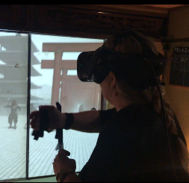
Figure 1: Demonstration of Ninja VR, Kyoto (Photo by Satoru Fukuzawa)
There were many hands-on opportunities to try both VR and augmented reality (AR) in South Korea, including in showrooms, museums, department stores, virtual reality game centres and palaces. SK Telecom, a South Korean wireless telecommunications operator, has its own experiential, interactive technology museum, T.um. In the Connected Shop, I completed a VR shopping experience where I was able to move through the shop, select items I liked to pick up and inspect while wearing a VR headset. Although the use of language was not required in this setting, the experience in a shop in the country of the TL, with labels and prices in the TL or with associated activities to complete would be beneficial to language learners.
Through my research, I also came across ImmerseMe, VR based software, introducing learners to authentic and interactive language learning to improve listening, speaking, reading, fluency and confidence in the TL. ImmerseMe has over 3,000 interactive scenarios across nine languages: German, Spanish, French, English, Japanese, Chinese, Italian, Greek and Indonesian. Using ImmerseMe students practise the language in virtual scenarios that mimic real-life interactions preparing learners for similar situations they will encounter in the real world including ordering a baguette in Paris, buying a bento box in Tokyo or trying tapas at a Spanish restaurant. ImmerseMe also offers self-conscious learners who are hesitant to engage in conversations with native speakers a safe space to use the language in a virtual environment until they have built up their confidence. This software creates a contextualised environment where learners can enhance their language skills through three differentiated levels: beginner, intermediate and advanced. learners are progressed through four scaffolded learning modes: pronunciation, dictation, translation and immersion.
VR reproduces the world that is difficult to experience in real life. Through VR, students can visit museums, wander streets, play games, order food, buy tickets and more.
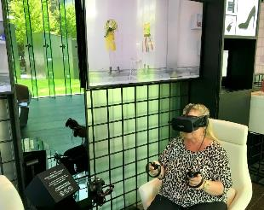
Figure 2: Demonstration of the Connected Shop (VR shopping) at T.um, Seoul (Photo by Sang-hoon Kim)

Robots
The use of robots in classrooms is an area that is slowly emerging in language education. At this stage, robots are not used to replace human teachers but to supplement teaching and to learn in the languages classroom.
Musio is an artificial intelligence (A.I.) robot that is used as a learning tool for children due to its interactive nature. Musio is a social robot for educational purposes, specifically to help people who wish to improve their English speaking abilities. Musio is becoming increasingly popular for use in Japanese middle and high schools, as well as education companies, to help with English teaching curricula. Musio converses with people, recognises objects and also understands people's facial expressions. Musio’s popularity in classrooms is evident as students are always wanting to engage with the robot. As Musio has its own emotional engine, this lets it display facial expressions when conversing with someone. Different sounds and facial colours are shown with animations. With the help of a WI-FI connection, Musio can talk freely about different subjects with people. A whole range of questions can be asked and also with the inference abilities, Musio can even know what a person is talking about as well as remember past questions. Apart from trivial matters, a natural fluid conversation can also be carried out.
Mr Takashi Tanda at Doshisha Junior High School in Kyoto was the first teacher in Japan to implement the AI robot into English classes. Mr Tanda reflected on the enormous potential of Musio in English education with various features from reviews to adaptive learning. He stated that increased ratios of Musio per student in the classroom has allowed for a more dynamic learning experience for students. In Kotogawa Junior High School in Ube, there was just one Musio in the school. It was clear that students enjoyed talking with Musio and every time Musio was in the classroom, students would gather around and start asking questions in English. Students who struggled to speak during regular English class activities lost their inhibitions and were more at ease speaking with Musio. English teachers noted an increased knowledge of vocabulary and full sentences amongst students since Musio has been adopted into their lessons. The use of Musio to assist in English language classes in Japan shows opportunities of similar artificial intelligence robots in other languages in the future.
Pepper is a semi-humanoid robot manufactured by SoftBank Robotics that has been designed to recognise faces and basic human emotions. Pepper was optimised for social interaction and is able to engage with people through conversation, and the touch screen on his chest displays content, highlights messages and supports speech. It also mimics human behaviours such as following the conversation around by looking at whoever is talking. Pepper is not only used in schools but also banks, restaurants, hotels and other places throughout Japan. This technology has also been adopted by companies around the world in settings such as an assistant to welcome, inform and guide visitors in an innovative way.
It is easy to see the benefits of Pepper in education. Standing at 120cm tall, Pepper is a friendly robot that engages all who see him. He has the ability to provide real-time feedback. He has no trouble in perceiving his environment and entering into a conversation when he sees a person. The use of Pepper in education is not to replace the teacher, but as a learning tool to enhance student engagement in the classroom as well as assist students with their learning. One benefit is that Pepper does not tire of repeated questions or correcting mistakes. Pepper easily creates an empathetic link with students by their eye-catching appearances, moderate size and humanoid behaviours.
Meeting with the president of Tokyo Robotics, Mr Yoshihiro Sakamoto, we discussed advances and applications of robotics in education. The core business of Tokyo Robotics is the development, production, and selling of robotic systems with a vision to achieve a productive society through the use of robotics. The company has Torobo (a humanoid research platform) and Torobo arm (an arm research platform) which have been developed to accelerate their research and development for their clients. Mr Sakamoto spoke of the increasing amount of companies now researching AI and the applications including having robots make bento lunchboxes, doing semi-automatic police patrols and completing bomb disposals. He reflected on the robots that are being used in the classrooms in Japan having the ability to provide information but not having the ability to move much, if at all. We discussed the use of another popular robot in education, Nao. Nao is a small autonomous programmable humanoid robot (58cm tall) that had been introduced to young children learning English. Nao can be programmed to intentionally make mistakes in English so that the children could correct the errors as part of their learning. Students also taught Nao how to write which was a learning strategy implemented actually to improve the children’s own poor writing. The thought of NAO being programmed in different languages would open up opportunities for students learning languages. Both Pepper and NAO are versatile and high-performing robots that are advanced platforms for the in-depth study such as human-machine interaction, cognitive computing, autonomous navigation and more.
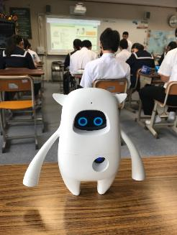
Figure 3: Musio at Kotogawa Junior High School, Japan (Photo by Shanelle Ingram)
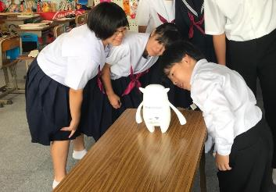
Figure 4: Students conversing with Musio at Kotogawa Junior High School, Japan. (Photo by Shanelle Ingram)
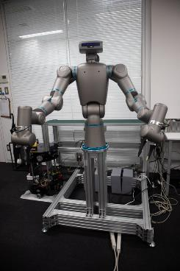
Figure 5: Torobo at Tokyo Robotics, Tokyo (Photo by Shanelle Ingram)
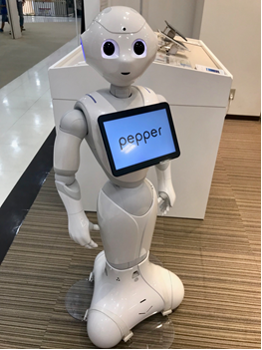
Figure 6: Pepper in Ube, Japan (Photo by Shanelle Ingram)

Online Speaking Training
Online Speaking Training, also known as OST, is the use of Skype, Zoom or other telecommunication applications for students to engage in English conversation with native speakers abroad. OST is especially popular amongst private schools in Japan. Classroom teachers organise regular lessons for their students with English speakers in the Philippines. The English speakers work either individually or with small groups of students engaging them in conversation based on topics that had been pre-organised by the classroom teacher. The English speakers assist with correct word order, pronunciation and intonation. OST is an excellent way for students to engage with a native speaker (mainly when the language teacher is not a native speaker) and all students have access to individual speaking training throughout the sessions. OST is convenient but comes at a cost which could be prohibitable for many schools. Watching OST in action, it was evident that in addition to the language learning, it also provides students with opportunities to practise other forms of communication such as nodding, eye contact, gestures and different non-verbal reactions. Students were excited when the English speakers appeared on the screen, greeting them with waves and cheers.
During OST, students received instant gratification like a thumbs-up signal or words of encouragement. Whilst all students participated in the lessons, students who used headphones on a 1-1 ratio had less trouble than students completing OST in small groups without headphones as the noise was at times distracting to some. There were also issues of lagging with internet connections which impacted on students with the visual transmissions not matching the audio communications. In these instances, some students found it very confusing to follow. Issues aside, OST was an effective way for language learners to communicate with speakers of the language they are learning, making the learning process more dynamic and allowing for effective and instant feedback.
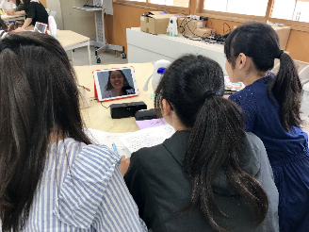
Figure 7: Students completing OST at Doshisha Junior High School, Japan (Photo by Shanelle Ingram)
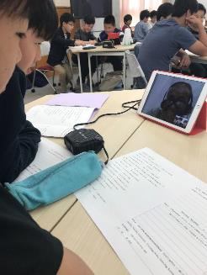
Figure 8: Students completing OST at Doshisha Junior High School, Japan (Photo by Shanelle Ingram)
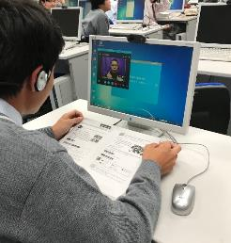
Figure 9: A student completing OST independently at Keishin Junior High School, Japan (Photo by Shanelle Ingram)

3D Printing
Schools abroad are recognising the opportunities of 3D printing by incorporating the use of 3D printing into their programs. They are seen as a way to engage students, as well as an educational tool to prepare students for future technical employment. Students are developing skills in creating three-dimensional objects from digital files that can be customised or produced on demand.
The most common use of 3D printing was for students to create realia for presentations and for teachers to 3D print objects to support learning and teaching. The use of 3D printing to create objects such as items from the country of the TL or labels in the TL for the classroom/school was found in both South Korean and Japanese schools. Although 3D printing was not used in language lessons during my visit, I was able to spend time with students working on 3D printing projects and talk about the uses. Students previously have had to create and print a real or imagined pet for an English project. They had also used 3D printing to create signs in the languages they were learning. In some schools, students had to learn two foreign languages and had made signage across those languages plus their native language.

Other Learning
Through my research, in both South Korea and Japan, I was introduced to many new technologies. In many cases, I was able to experience first-hand what would be applicable to not only language learning but many other learning areas. Hologram conferencing, voice-recognising AI , AR , video conferencing, network robots, mixed reality, large-formatted multilingual pop-up books using a mix of analog and digital technology, chatbots, virtual drones, digital art, interactive flip boards and touchscreen tables are just some of the technologies that schools and companies are experimenting with.
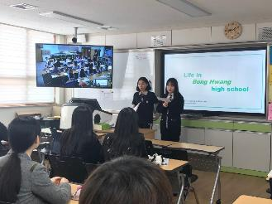
Figure 10: English class at Bonghwang Junior High School in South Korea videoconferencing with an English class at a neighbouring school (Photo by Shanelle Ingram)

Conclusion
My research found that new technologies are not just limited to use in other learning areas but can benefit language teaching and learning. These technologies can be adapted to cater for personalised education for students at a range of levels of linguistic competency, therefore, optimising the effectiveness of language learning in the classroom. These technologies improve student access to interactional opportunities. Students are increasingly willing to participate in lessons as the technologies create exciting and new experiences. The ability for technologies to provide various kinds of formative and corrective automated feedback is also beneficial to learning languages.
The use of VR in the classroom provides students with a more realistic learning experience, and the physical classroom space is enhanced with simulations of TL landscapes and cultures. Robots in class are not replacing teachers, but assisting teachers in improving student understanding and increasing student knowledge. The non- judgemental, gentle nature of robots provides students with a safe and neutral learning environment where students can feel comfortable to participate and repeat questions as required for understanding.
Technological innovations influence enhanced individualised experiences, social activity and access to data. The use of these technologies in the languages classroom is a relevant and meaningful resource and not merely a distraction to language learning in school.
By visiting schools and seeing these technologies in action, I witnessed first-hand student engagement, confidence and enthusiasm, which would benefit language learners in NSW schools. New technologies will create new opportunities for learning in languages in schools across NSW and language teachers should embrace a continuously evolving role to develop new and exciting language learning experiences in the 21st century by exploring these technologies to transform the educational landscape in their language classrooms. I will share my knowledge of innovative technologies for language learning through teacher networks and presenting at language conferences.

