
Premier’s History Teachers Association History Scholarship

Historians and witches unveiled
  - A historiographical survey of the Salem Witch Trials since 2000
Michael Street
Green Point Christian College

Sponsored by


Introduction
The history of witchcraft is a topic that seems to skirt on the edges of what history, as a discipline, is equipped to explore. History is bound by the naturalistic foundations of evidence, theory and hypothesis testing. However, witchcraft is what Malcolm Gaskill has described as ‘liminal’ (Gaskill, 2008a, 2008b). Witchcraft exists in a space between empiricism and private religious belief, a space which history, with its reliance on physical source material, struggles to access. This unique cocktail of methodological and epistemological constraints makes witchcraft history a dynamic and, at times, convoluted field of study.
In 2017, The New South Wales Education Standards Authority (NESA) released the updated HSC History Extension syllabus (NESA, 2017). Therein is a collection of new case studies for students to explore. One of the studies, titled Witch Hunts and Witch Trials, encourages teachers and students to examine:
- the origins, causes and nature of witch hunts and witch trials
- gender and persecution
- the decline of witch hunts and witch trials.
In the case study, teachers are given the option to explore witch hunts and witch trials in the New England Colony and or Early Modern Europe. Additionally, there is flexibility in the case study to explore a narrow geographical space or particular witch hunt, if teachers found it appropriate.
As a convoluted area of study and a topic which was entirely new to NSW history teaching, resources were few and far between, and expertise in these fields was even harder to find. This NSW Premier’s History Teachers Association History Scholarship tour was designed to rectify both of these issues by facilitating the creation of resources and the formation of expertise.

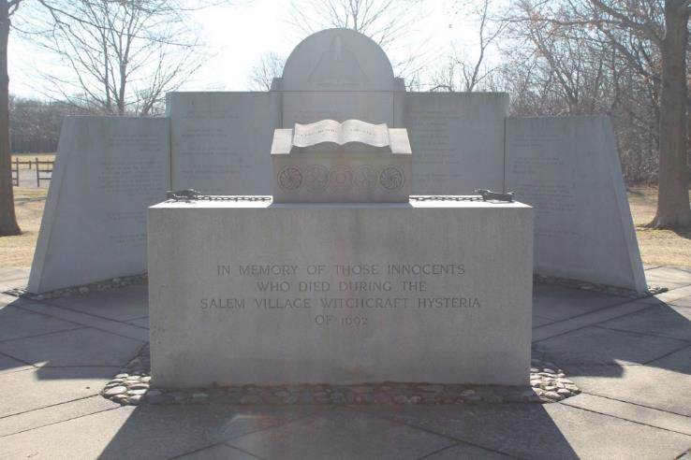
Figure 1: The Salem Witch Trials Memorial, Danvers, MA (photo taken by Michael Street)

Focus of Study
Unlike other case study options in HSC History Extension, the evolution of academic discourse associated with the history of Witch Hunts and Witch Trials in Early Modern Europe and the New England Colony tends to resist stratification. After the Second World War, the field of witchcraft histories branched out into often competing, rarely dialogical threads of historical inquiry. This has been exacerbated by a lack of interest in comparative witchcraft studies from scholars on either side of the Atlantic, Wolfgang Behringer’s (2004) history of global witch hunts being a significant exception. There has been some work completed examining the historiographical contours of witchcraft studies in the USA, UK, and continental Europe in recent decades. However, the last significant synthesis of Salem Witch Trials historiography in the USA is the now out-of-date Salem Witch Trials Reader (Hill, 2000). Emerson Baker’s (2016) A Storm of Witchcraft has rectified this issue to an extent, however Baker’s efforts were restricted to a chapter at the conclusion of the text.
Syntheses of British witchcraft historiography have fared much better, under the curation and care of historians like Malcolm Gaskill and Owen Davies. Unlike historians in the USA, who have struggled to walk the fine line between media sensationalism and dry academia (see: Carlson, 1999), Gaskill and Davies have contributed significantly to measured and historically conscious explanations of the historiographical contours of their field in both public (Gaskill, 2010) and academic (Barry & Davies, 2007; Gaskill, 2008a) spaces. In light of these disparities and issues associated with the synthesis and dissemination of historiographical information associated with Witch Hunts and Witch Trials, I sought to interview historians of the Salem Witch Trials in the USA, and historians of British and European witchcraft in the UK. The results of these interviews were designed to facilitate the creation of resources and support documents that would help teachers throughout NSW teach the History Extension case study.
In addition to these interviews, I visited significant locations associated with witch hunts and witch trials, including museums, cemeteries, archives, and memorials. All of these extra activities were completed with the goal of collecting and creating resources that could be used to engage students and support teachers. There was also some focus given to the development of resources for the delivery of a witchcraft unit in History Elective.

Significant Learning
The two most significant examples of witchcraft in literature, and therefore the most pertinent in the public imagination, are Arthur Miller’s (1996) The Crucible and William Shakespeare’s (2008) Macbeth. Both of these texts were created in a period of significant change, Miller during the Cold War and Shakespeare after the transition from Elizabethan to Jacobean reign. One key feature across the field of witchcraft history is that witch hunts and witch trials tend to take place in moments of transition and political instability. They tend to take on the character of a mass catharsis that relaxes the tension and frustration caused by these periods of uncertainty. Uncertainty and change are the most basic prerequisites of a witch hunt. All of the historians interviewed for this study grew up in and were influenced by the social revolutions, existential weariness and political climate of the Cold War. Even though the era of witch hunts and witch trials in the USA and the UK are over, the current generation of witchcraft historians have experienced many of the same uncertainties that dominated the lives of 16th-18th century Christians during the “witch craze” (Roper, 2004). They have seen rights given and taken away from particular groups, they have seen the criminalisation and demonisation of supposedly deviant ideologies, and many were trained to recognise the ordinary and the small in the social history movement. These accumulated experiences have led historians to construct the past in deeply personal and empathetic ways.
Places also construct the past in various ways that both contend with and support historical perspectives on Witch Hunts and Witch Trials. Salem is a city in tension, finding ways to honour its historical past while also encouraging a popular, ahistorical economy that relies on it. Salem is tacky and rich. It is historically conscious and forever in a process of forgetting. The United Kingdom, however, does not have a strong historical consciousness associated with witchcraft histories that goes beyond Monty Python and the Holy Grail or Michael Reeves’ (1968) violent and sexualised cult classic, Witchfinder General. Consequently, infamous individuals from British witch hunts, like Matthew Hopkins, are currently buried in unmarked graves. The experience of place, in many ways, had a greater impact on my perception and understanding of witch hunts than the historians I interviewed.

The United States of America

Place
The target location for the initial part of my study tour was Salem, Massachusetts. However, prior to my arrival in Salem, I ensured to visit locations of colonial significance in New York City and Boston. There were many examples of engaging source material in New York City, especially in the New York Historical Society Museum, where I found George Henry Boughton’s (1867) painting, Pilgrims Going to Church. The painting captures the fear and insecurity that motivated witch hunts on the New England frontier at the end of the 17th century, the same fear and insecurity examined in Mary Beth Norton’s (2002) In The Devil’s Snare.
My first encounter with a figure who was personally involved in the Salem Witch Trials was at the Mather family crypt in Copp’s Hill Burying Ground, Boston, MA. Cotton Mather and Increase Mather were outspoken ministers during the trials, Cotton being a supporter of the trials, while Increase an opponent. The Mather family crypt has been refurbished in the last decade and the commemorative epitaph has also been updated. Neither Cotton nor Increase’s involvement in the development of a feverish culture of witchcraft paranoia throughout the second half of the 17th century are discussed. Rather, their achievements as leaders of the New England colony are exclusively portrayed. This intentional forgetting was a common part of the post-Salem Witch Trial era and clearly still continues to this day for some descendants who do not wish to be on the wrong side of history.
After exploring Boston, I travelled to Salem, MA. When one arrives in Salem, they are confronted by a borderline absurdity in the central square; a statue of Samantha Stephens from Bewitched (figure 2). All of the contradictions associated with Salem are encompassed by this statue. Erected in 2005, the statue commemorates a television show which has no historical relationship with the Salem Witch Trials. However, in one episode of the television show, Samantha visited Salem. This episode was very much the beginning of Salem’s tourist culture, culminating today with Salem’s place as the Halloween capital of the USA. In contrast, the Salem Witch Trials Memorial (figure 3) is a quiet, contemplative place, devoid of all religious imagery. Opened by Elie Wiesel in 1992, the Salem Witch Trials Memorial was designed to commemorate a historical tragedy, sharing similar yet smaller features with the Holocaust. Samantha Stephens and the Salem Witch Trials Memorial are a mere five minute walk apart, revealing the divide between tourism dollars and history, while also revealing their tacky, distasteful closeness in that city. Correlating with this trend, descendants of executed witches living in Salem and Danvers are proud of their heritage and frequently share their family stories with anyone who will listen.
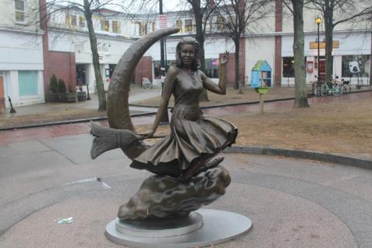  Figure 2: Statue of Samantha Stephens from Bewitched, Salem, MA (photo taken by Michael Street) | 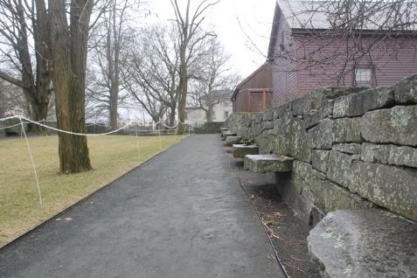  Figure 3: Salem Witch Trials Memorial, Salem, MA (Photo taken by Michael Street)
In contrast, the memorial at Proctor’s Ledge (figure 4 and 5), a slope at the base of gallows hill where the accused witches were hanged, is much more reserved and sombre. This area was acknowledged as the place of execution in 2015 and is not a frequently visited part of the region. Additionally, the small town of Danvers, where Salem Village resided and the accusations began, is difficult for tourists to travel through without prior knowledge of the area. The archaeological site for the Salem Village Parsonage is poorly marked. The Nurse homestead was closed and required some creative traversing to get into. While walking through Danvers and visiting the original homes and locations of these historically maligned individuals, I was struck by the distances required to reach them. It is understandable that many of these people will have felt paranoid, walking distances of three hours or more to travel from one side of the village to the other, with the real threat of Native American attacks and poorly maintained roads. My day walking through Danvers in the snow at -15 degrees Celsius allowed me to empathise with the original inhabitants of the village in ways I simply couldn’t through a book.
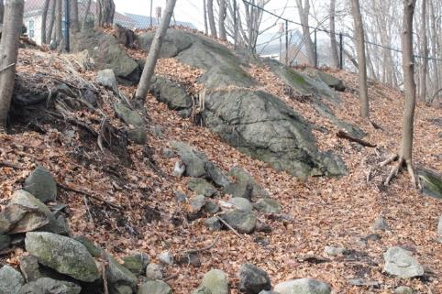  Figure 4: The execution site above the Proctor's Ledge Memorial, Salem, MA (photo taken by Michael Street) | 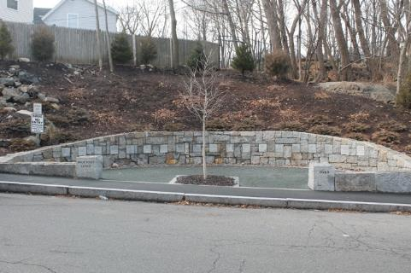  Figure 5: The Proctor's Ledge Memorial, Salem, MA (photo taken by Michael Street)
Throughout January 2019, the United States Government was forced to shut down, resulting in the closure of all federally funded buildings and museums for the duration of my time in the country. The Smithsonian Institute in Washington DC was closed, as were all state archives, like the Massachusetts archive, which contains most of the primary sources associated with the Salem Witch Trials. I was able to visit the Museum of the Bible in Washington DC, which like the Mather Tomb, omitted any of the negative aspects of British colonisation and Christianity in the New England Colony. The closure of the government and all federally funded buildings was an endless frustration throughout my travels and undermined many of my plans.

Historians
While in Salem, I interviewed Professor Emerson Baker, Marilynne K. Roach and Richard Trask. My initial intention for the interview with Baker was to discuss his process and methodology while writing A Storm of Witchcraft. However, the interview resulted in a two and a half hour discussion about the historiographical contours of Salem witchcraft histories and how one could develop a concise unit of coursework that would give students a good understanding of the topic. This interview formed the backbone for the program and resources I would end up developing in the months after the study tour. Marilynne K. Roach, who wrote a brilliant day-by-day chronicle of the Salem Witch Trials, provided me with a deeper understanding about the difficulties and processes behind the collection and synthesis of primary sources. Richard Trask is the Danvers historical archivist who contributed to the creation of the Witch Trial Memorials in both Salem and Danvers. A significant point that I learned was that, for Roach and Trask, the Salem Witch Trials were a part of local history and therefore open to inquiry from all of the people who have personal links back to the trials. Unlike many other areas of American colonial history, the Salem Witch Trials is not an area of exclusively academic inquiry.
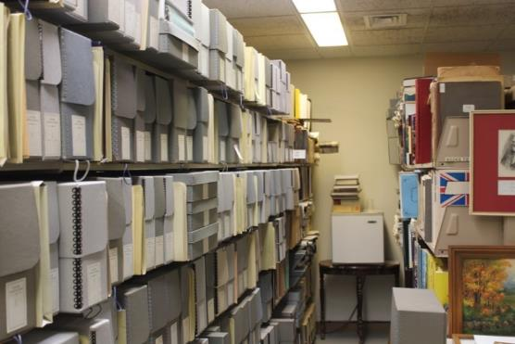
Figure 6: The Danvers Historical Archive, Danvers, MA. The archive contains many written and archaeological primary sources from the examinations and trials. (photo taken by Michael Street)
I interviewed Stephen Nissenbaum in his hometown of Burlington, Vermont. Stephen Nissenbaum’s (1974) Salem Possessed was a major contribution to the field of witchcraft history. Despite being retired, Nissenbaum was charitable with his time and spent the day talking to me about his career and the process of writing Salem Possessed. The findings from my interview with Nissenbaum will be shared with the History Extension community in a separate essay.
My final interview in the United States was with Professor Mary Beth Norton of Cornell University. Norton’s (2002) In the Devil’s Snare is the most comprehensive history of the trials, bringing in many new sources. My interview with Norton revealed the process she undertook when exploring and synthesising sources. She initially set out to write a history of the Salem Witch Trials through a gendered lens. However, the sources indicated that the Native American Wars were a greater antecedent for the trials than gender relations. Consequently, she was forced to shift the entire focus of her investigation so that it would account for the influence of these wars. I have written a short explanation of Norton’s thesis and use of evidence on my scholarship blog, to be consumed by the wider History Extension teaching community.
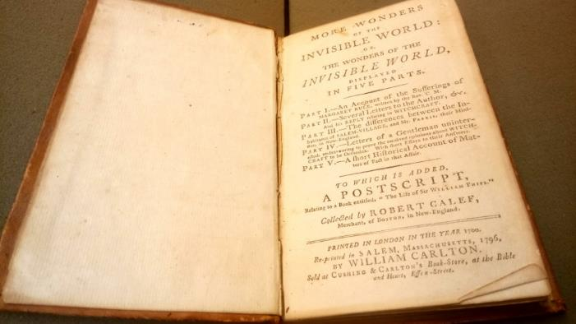
Figure 7: A 1796 printing of Robert Calef More Wonders of the Invisible World. Mary Beth Norton gave me access to Cornell University's Witchcraft Collection (photo taken by Michael Street)

The United Kingdom

Place
As discussed above, many people in the United Kingdom imagine the British witch trials through the media they have consumed, rather than historically. Not long after arriving in the UK, I visited Colchester, so that I could see the ways that the Essex witch hunts of the 1640s were memorialised. There was very little. Colchester Castle was famously where Matthew Hopkins imprisoned many accused witches during the British Civil War. However, when on a tour of the foundations under Colchester Castle, the tour guide emphasised the Roman origins of the foundations and gave a throwaway line about women who thought for themselves being thrown into prison. Matthew Hopkins is now buried in an unmarked grave outside of Manningtree. I would not have been able to find it without the directions of Malcolm Gaskill during my interview with him earlier that week.
Despite the absence of public knowledge about the English witch hunts, the museums in England’s university towns were indispensable. The Ashmolean and Pitt Rivers Museums in Oxford collected witchcraft artefacts from across the world and placed them together. These museum experiences emphasised for me the universality of both witchcraft beliefs across the world and the frenzies that result in witches. The Fitzwilliam Museum in Cambridge gave me access to many examples of medieval and early modern European witchcraft artefacts. One surprise for me was a group of apotropaic markings above a fireplace in the Loch Fyne restaurant in Cambridge, an example of everyday white magic from the 17th-18th century.
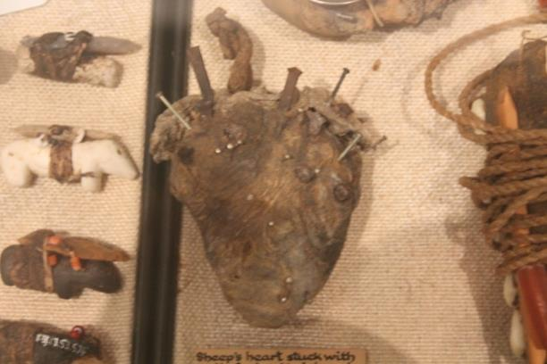
Figure 8: A desiccated sheep’s heart run through with nails, Pitt Rivers Museum, Oxford, UK. It is unknown what this spell was used for, but it does give an indication of the imagination and worldview of the spell caster. (Photo taken by Michael Street)

Historians
My interviews with Malcolm Gaskill, Robert Poole, Owen Davies and Lyndal Roper revealed a trend in UK witchcraft history scholarship that was not evident in the USA. The UK historians I interviewed were far more explicitly influenced by the Marxian social history movement than historians trained in the United States. Witchcraft is therefore usually constructed by these historians through the lens of society, gender and psychoanalysis. Lyndal Roper saw her experiences as a feminist completing a PhD in the UK during the 1970s as a formative experience for the ways she would interpret the German witch hunts. In my interview with Malcolm Gaskill, he argued that witchcraft histories are some of the only spaces where one can complete genuine social history in Early Modern Europe. While there is a tendency towards sensationalism and schism in the construction of witchcraft histories in the USA, UK historians were much more united around the tenets of social history.

Conclusion
In this study, I sought to collect the information necessary to develop resources that could support the instruction of the Witch Hunts and Witch Trials case study option in HSC History Extension, with a focus on historiographical content after 2000. Through my interviews and visits to museums and places of historical significance, I believe I have well and truly achieved this. My interviews gave me the data I needed to develop material that could enable students to explore the historiographical features of historical works and how they relate to the overarching narrative of Salem Witch Trial histories from 2000, and well before. Despite these developments, it is clear to me that, even with these resources, this will be a challenging case study for those teachers who wish to teach it. However, with this challenge comes great reward, as it is also clear that this is an incredibly rich and fertile space for our students to test out the historiographical skills they will have learned throughout HSC History Extension.
This study tour also provided many opportunities to think about and develop resources for those teachers seeking to teach the Salem Witch Trials in Stage 5 History Elective. After having explored many tactile and written sources alike, the Salem Witch Trials and witchcraft culture in general, are excellent frames for young burgeoning historians to learn how to inquire into the past.
I plan on disseminating my findings through three pathways: programs , resources and seminars. I have written a detailed program for the HSC History Extension case study and have shared it for free with the history teaching community. If there is demand for it, I will also write a program for Stage 5 History Elective, focussing on inquiry methods and historical writing. I have been steadily writing essays and developing resources that will help teachers take their students through the HSC History Extension case study. I have already presented at three HTA conferences on the case study and will continue to present at conferences to give support to teachers in both HSC History Extension and Stage 5 History Elective. It is my intention to take this scholarship, an enormous gift given to me at an early point in my career by a wonderful community of practitioners and use it to help others become the best educators they can possibly be.

Acknowledgements
I would like to recognise all of the people I interviewed throughout my travels. In the USA, I interviewed Emerson Baker of Salem State University, Marilynne K. Roach, Rachel Christ of the Salem Witch Museum, Richard Trask, Stephen Nissenbaum of University of Massachusetts Amherst and Mary Beth Norton of Cornell University. In the UK, I interviewed Malcolm Gaskill of University of East Anglia, Robert Poole of University of Central Lancashire, Arthur Chapman of University College London, Owen Davies of University of Hertfordshire, and Lyndal Roper of University of Oxford.
I must honour and thank the History Teachers’ Association NSW for funding and supporting me as I went on this journey. This scholarship has enabled me to expand my knowledge and practice in ways I could not have imagined earlier in my career. I am very much looking forward to working with the HTA for many years to come.
I would like to thank the leaders of Covenant Christian School, who happily gave me time and space to undertake this endeavour. I must thank my wife, Richelle, who cared for our five children on her own for the entire month that I was away. I could not have done this without her commitment to support me throughout the process.

References
Baker, E. W. (2016). A Storm of Witchcraft: The Salem Trials and the American Experience. New York: Oxford University Press.
Barry, J., & Davies, O. (2007). Palgrave advances in witchcraft historiography. New York: Springer.
Behringer, W. (2004). Witches and witch-hunts: A global history. Cambridge: Polity.
Boughton, G. H. (1867). Pilgrims Going to Church. In New York City, NY: New-York Historical Society Museum.
Boyer, P., & Nissenbaum, S. (1974). Salem Possessed: The Social Origins of Witchcraft. Cambridge, MA: Harvard University Press.
Carlson, L. W. (1999). A fever in Salem: a new interpretation of the New England witch trials. Lanham: Rowman and Littlefield.
Carr, E. H. (2008). What is History? Camberwell, Victoria: Penguin Group (Australia).
Gaskill, M. (2008a). The Pursuit of Reality: Recent Research into the History of Witchcraft. The Historical Journal, 51(4), 1069-1088. doi:10.1017/S0018246X0800719X
Gaskill, M. (2008b). Witchcraft and Evidence in Early Modern England. Past and Present, 198, 33-70. doi:10.1093/pastj/gtm048
Gaskill, M. (2010). Witchcraft: A very short introduction (Vol. 228). Oxford: Oxford University Press.
Gilliam, T., & Jones, T. (Writers). (1975). Monty Python and the Holy Grail. Python Pictures.
Hill, F. (2000). The Salem Witch Trials Reader: New York: Da Capo Press.
Miller, A. (1996). The Crucible: Revised Edition. London: Penguin.
NESA. (2017). History Extension: Stage 6 Syllabus. Sydney, NSW: NESA.
Norton, M. B. (2002). In The Devil's Snare: The Salem Witchcraft Crisis of 1692. New York: Vintage.
Reeves, M. (Writer). (1968). Witchfinder general. Tigon British Film Productions.
Roach, M. K. (2004). The Salem Witch Trials: A Day-By-Day Chronicle Of A Community Under Siege: Taylor Trade Publications.
Roper, L. (2004). Witch craze: Terror and fantasy in Baroque Germany. New Haven: Yale University Press.
Shakespeare, W. (2008). The Tragedy of Macbeth. Oxford: Oxford University Press.

