
Premier’s IOOF Centre for Educational and Medical Research Itinerant Support Teacher (Hearing) Scholarship

The educational impact of Conductive Hearing Loss in school aged students
Jacqualine Aczel
St Clair Public School
Sponsored by


Introduction
Conductive Hearing Loss (CHL) is a fluctuating type of hearing loss that is associated with the middle and middle to inner ear. As this type of loss fluctuates, students may have the capacity to hear in class on some days but may have severe hearing impairment on other occasions (such as when they have a cold or other infection).
This type of hearing loss can result in limited language development in young children and can impact on their capacity to develop speech, vocabulary and auditory memory. Students who experience reoccurring and fluctuating middle ear conditions and CHL have limited access to language in the classroom and classroom instruction. They often misinterpret peers and teacher instructions, and this can have impact on their social development. These students often have limited vocabulary, reduced auditory processing skills and limited expressive and receptive language. As middle ear conditions are more common in children and young adults, this can impact on their ability to learn at stage appropriate levels. This type of loss can have a lifelong impact, as it often occurs during the vital language acquisition years.
CHL is particularly prevalent in Australian Indigenous student populations. On any day up to 90% of Indigenous students in rural areas and 50% of Indigenous students in non-rural areas will experience levels of CHL (Interview Denyse Bainbridge and Tammy Simmons NT Education May.2019). Up to 30% of students from other backgrounds can experience CHL on any day. As the condition fluctuates, students can experience regular bouts of hearing loss.
‘Most notably, hearing health must be treated as a national health priority and we must do so much more to respond to Indigenous hearing health. It is no exaggeration to describe Indigenous hearing health as at a crisis’ (Still Waiting to be Heard 2017, Report on the Inquiry into the Hearing Health and Wellbeing; House of Representatives Standing Committee on Health, Aged Care and Sport).
To understand the effects of hearing loss it is important to recognise the importance of good hearing. Good hearing is essential for the development of communication and language. Even a mildly fluctuating CHL can have a negative effect on the language and learning for many children. If a child has hearing loss it can cause limitations in the development of various skills. The amount it will impact on development is dependent on two main aspects of the hearing loss:
- the age of onset- the earlier in the child’s life, the greater these skills are impacted
- the degree of hearing loss- the greater the loss, the greater these skills are affected.
(Aboriginal Ear Health Manual 2012 p.10)
All children who suffer from regular CHL and middle ear disease face difficulties with learning. In the case of Indigenous children, learning may be further complicated by:
- English being a second language
- English being the language for instruction in the classroom.
(Aboriginal Ear Health Manual 2012 p.34)

Focus of Study
The focus of this study was to examine the educational impact of CHL in both urban and regional school settings and to further enhance CHL programs throughout both remote and urban Australia. As an Assistant Principal Hearing, I currently work in the Mount Druitt/Blacktown area. Part of our program is providing education regarding CHL and basic screening for Indigenous students. Mount Druitt/Blacktown area currently has the highest urban Indigenous population in Australia (WENTWEST Health Report 2017). Improving the capacity of our program in Western Sydney would allow more students to be identified with CHL and referred to specialist resources in a reasonable timeframe.
A number of programs to educate, screen and prevent middle ear conditions are currently in place in rural and regional areas throughout Australia that have high Indigenous populations. These programs have shown great success in reducing the number of permanent hearing losses, increasing hearing screening and medical specialist services, which provide students, teachers and parents with education in how to identify and prevent reoccurring middle ear conditions.
For this reason, I chose to visit rural Australian settings to experience the exemplary CHL programs that support both students and teachers and allow students with CHL to have enhanced access to education. I visited both Dubbo and regional NSW and Northern Territory to view the exemplary CHL programs currently in place and discuss future directions in education and prevention of CHL conditions.

Significant Learning

Dubbo and regional NSW
The first part of my study tour involved working with the Department of Education Itinerant Hearing Teachers based at Dubbo Public School. This team of teachers works with students who have both Conductive and Sensorineural hearing loss throughout regional and rural Western NSW. The team also is involved in the Department of Education CHL program that involves education and prevention of middle ear conditions for staff, students and parents/carers.
The Dubbo Hearing Team is closely affiliated with the Hear Our Heart Ear Bus Project which was established by the Dubbo Deaf Club in 2017 and is a not for profit organisation. The ear bus is based in Dubbo and visits a range of communities including Nyngan, Trangie, Warren, Gilgandra, Wellington, Yeoval and Narromine. The aim of the project is to provide health education, targeted hearing testing and free access to ear specialists. The ear bus contains a soundproof booth which allows for regular hearing screening as well as ear health checks and clinical testing. The Hear Our Heart bus targets all students from preschool to Year 12, regardless of their background. They focus on preschool and primary school students so that hearing loss and middle ear conditions are identified early.
Three tests are performed on students to check their general ear health:
- Otoscopy: Visual examination of the ear canal and ear drum to check for signs of inflammation, wax build up, fluid, perforation or foreign objects.
- Tympanometry: A test to check the movement of the ear drum and ear pressure (often indicates if there is fluid behind the ear drum)
- Audiology: A listening test that is conducted through headphones, where the student listens to different sounds in frequencies and intensity and responds when they hear a sound. The results are graphed on an audiogram to determine the level of hearing loss and at what frequencies and decibels loss is detected.
These three tests give an overall report of the student’s ear health and hearing levels. These results are stored at school, sent home to parents with advice letters and are followed up by the Hear Our Heart team who arrange Ear Nose and Throat Specialist (ENT) appointments and follow up screening. Students who are targeted as a concern are tested a number of times each year.
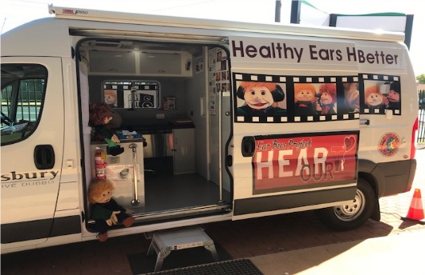
Figure 1: Hear Our Heart Ear Bus (Photo taken by Jackie Aczel)

ENT Clinics
Students who are a concern are referred to the ENT specialist and there is a monthly clinic where ENT specialists further assess these students and refer them for surgery or follow up if required. Families who live in remote areas have their travel subsidised to visit these clinics and the clinics are bulk-billed.
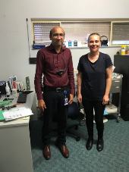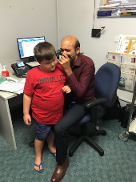
Figure 2: Dr Sirigiry (ENT) and J. Aczel. (Photo taken by Rachel Mills)
Figure 3: ENT specialist Dr Sigigiry testing referred students (Photo taken by Jackie Aczel)

Department of Education CHL Program
The Dubbo Itinerant Hearing Team are also responsible for delivering ear health lessons in schools. These lessons involve nose blowing, understanding how our ears work, and promoting ear health. Various lessons have been designed to cater for students aged from preschool to Year 12. Ear health lessons for younger students involve a puppet show where students learn about their ears and practise blowing their noses. Older primary and high school student lessons focus on the parts of the ear and are more technical. They also focus on the permanent hearing damage that excessive noise exposure can cause. These lessons aim to make students more aware of their ear health and the importance of good hearing. It is important for children to learn how to blow their nose correctly in order to reduce blockage in the Eustachian Tube (tube running from the ear to the nose) and reduce pressure on the ear drum. Nose blowing is difficult for young students and it is important for them to practise this skill daily. Classroom teachers in this area are committed to delivering daily nose blowing sessions with students and this practice has become a part of daily classroom routine.
Staff meetings and parent information sessions are also part of this program which extends throughout regional NSW.
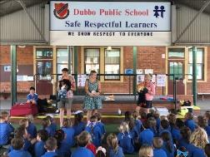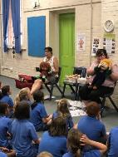
Figure 3: Ear Health Lessons: Dubbo PS (Photo taken by Jackie Aczel)

Sound field systems and classroom acoustics
Many schools in regional and rural NSW schools with high Indigenous enrolments have installed sound field systems and made physical improvements to classroom environments to ensure they are acoustically appropriate. Sound field systems are speaker systems which can be fitted or portable. They amplify the teacher’s voice through a body worn microphone so that students have access to instruction. These systems can be fitted or portable and there are a number of options available depending on the classroom setting and the needs of students. Many schools in Western NSW have installed sound field systems in all classrooms and this has proven to be beneficial to both teachers and students. Students with CHL are generally not fitted with hearing aids as their loss is fluctuating so the use of amplification systems such as sound fields is a proactive way of ensuring all students have equitable access to education.
Acoustic absorption tiling and physical adaptations to learning environments also improve the capacity for students to have access to education. A number of schools have also designed newly built or refurbished classrooms to ensure they are acoustically acceptable for student learning.
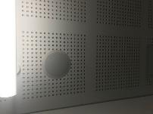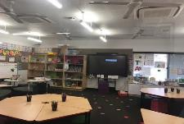
Figure 4: Modified classroom and acoustic tiling with speaker systems installed – Dubbo West Public School. (Photo taken By Jackie Aczel)

Darwin and Northern Territory
My experiences in Darwin involved working with Northern Territory hearing advisors. The Northern Territory hearing team consist of five specialist hearing teachers including one state advisor. The team cover the entire state and works with students with permanent and fluctuating. There is a high Indigenous population in schools throughout the Northern Territory, with some schools in remote or Indigenous communities consisting of 90-100 per cent Indigenous enrolments.
The team makes regular visits to remote communities to build the capacity of teachers, liaise with Aboriginal Elders within each community. They promote ear health, provide ear health and nose blowing lessons to students, support the National Consistent Collection of Data (NCCD) and advise how adaptations can support students with CHL. They also support schools in obtaining sound field equipment and assess classroom acoustics, advising on physical changes to the classroom that can improve the acoustic environment. They liaise with students, staff and communities in remote settings through video conferencing on a regular basis to ensure all remote communities are supporting children with middle ear conditions.
The Northern Territory team have further developed the NCCD to include levels of support for students with a hearing loss (both sensorineural and conductive). This framework has enhanced teacher understanding of the types of hearing loss and how to accommodate and adjust the curriculum and classroom environment to enhance every student’s access to education. They meet regularly with Northern Territory teaching staff in open forums and school staff meetings to reflect on the NCCD and how individual students can be supported on a case to case basis.
The Catholic school system in Northern Territory have committed to ensuring every classroom in a Catholic school will be fitted with sound field amplification by 2020. Many Northern Territory government schools are currently funding this equipment and the Northern Territory hearing team provides loan equipment to schools who have not purchased amplification devices or are interested in trialling equipment prior to purchase.

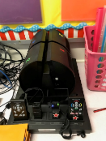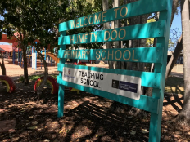
Figure 5: Sound field speaker system: Humpty Doo Public School. (Photo taken by Jackie Aczel)

Families as First Teachers (FaFT) Program
The Families as First Teachers (FaFT) Program is an early learning and family support program for remote Indigenous families with children prior to school entry (0-3 years). The program aims to develop play-based programs to engage families and communities in giving their children the best start in life. The program acknowledges the important role families have as first teachers of their children; helping to develop family knowledge of child development and providing active engagement in quality early childhood education. The program aims to enhance parental knowledge of early childhood learning and development, health, hygiene, parenting skills and nutrition.
The program is based on five key messages:
- families who understand how their children learn and develop are able to support them now and, in the future
- healthy children have a better chance to grow up strong and succeed in life
- early learning experiences impact on life outcomes
- building on community strengths will empower families and support them to give their children the best start in life
- parental literacy and numeracy skills help to support their children’s success at school.
(Howard, 2012)
The program has proven to be successful in developing the skills of families to support the growth and development of their children.
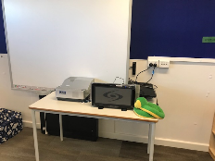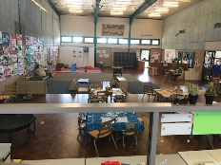
Figures 6 and 7: FaFT Preschool Mimik-Ga Centre, N.T, Sound Field System in FaFt Preschool. (Photo taken by J Aczel)

Hearing for Learning Initiative:
The Hearing for Learning Initiative July 2018 – June 2023 is a $7.9m community-based service enhancement program which aims to integrate locally-based ear health project officers into existing services for Aboriginal and Torres Strait Islander children with ear and hearing problems.
The goal of the initiative is to work with communities to establish reliable, sustainable, culturally appropriate services that ensure every ear of every child is healthy and hearing every day.
This initiative will employ and train a community member as an Ear and Hearing Clinical and Education Support Officer to:
- provide culturally appropriate, safe, reliable clinical and education services for children who have ear conditions and hearing loss
- provide education on how hearing loss can impact on behaviour, social interactions, listening, talking and learning
- explain how to detect, treat and manage ear health conditions
- link families with services such as health clinics and specialists.
(Menzies school of health research; Hearing for Learning Initiative Project Summary p1-2 2018)
The initiative is expected to reach 5000 children, with a focus on children under three, in order to increase early detection and intervention. The project commenced in 2019 in four remote communities and is expected to be rolled out in up to 20 communities in the Northern Territory.
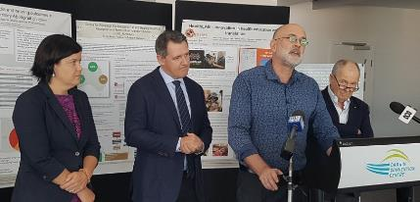
Figure 1: Hearing for Learning Initiative Launch: 2018. NT Health Minister Natasha Fyles, NT Chief Minister Michael Gunner, Neil Balnaves AO and Professor Alan Cass. (Photo Taken by N.T News)

Conclusion
There are extensive programs throughout regional NSW and Northern Territory aiming to reduce the prevalence of middle ear conditions in children and young adults. Education and prevention are essential to ensure that children have optimal access to learning. Sound field systems and classroom acoustic planning improve classroom environments and cater for fluctuating hearing loss. Encouraging schools to install this equipment and make modifications to learning environments enhances access to education and is beneficial for both students and teaching staff.
The Development of a ‘NCCD Considerations for Students with a Hearing Loss’ matrix (Northern Territory Government, 2018) allows teachers to understand the level of adjustments to make based on the types and levels of hearing loss in students. Further development of this document on a national level will provide consistent support Australia- wide and will provide educators with a further understanding of all types of hearing loss.
Ear health lessons and education for staff and parents are essential and have proved to be successful in these areas. The resources teams have shared will enhance the Western Sydney CHL program and further develop relationships with other hearing teams nationally.
The World Health organisation defines a four% prevalence rate of CHL conditions such as Otitis Media as being a major public health problem. The current rate in some Indigenous communities is up to 35%. The effect of up to 32 months of CHL in childhood has a life-long impact on the child’s speech and language development and future educational and vocational outcomes (Aboriginal Ear Health Manual 2012). It is in light of these concerns that a number of public health initiatives to improve the health of Aboriginal communities by improving access to housing, clean water and medical attention have been advocated. Continuing to advocate for improved services in Western Sydney will improve detection, prevention and intervention regarding CHL, Otitis Media and other middle ear conditions.
Students from all backgrounds can be impacted by CHL and early detection, education and prevention of these conditions ensures all students have access to education and instruction. Developing the CHL program to screen and educate all students targeted for hearing and medical screening will ensure all students have access to the curriculum.
The study tour has allowed me to further develop my understanding of rural and regional CHL support and develop relationships with other experts which will continue to enhance our local program. It has also allowed access to shared resources between other teams with CHL programs subsequently improving our program in Western Sydney.

Acknowledgements
I would like to thank the following people and organisations for supporting my study tour:
- IOOF Centre for Educational and Medical Research
- NSW Department of Education Itinerant Hearing Team: Dubbo NSW
- Donna Rees: Assistant Principal Hearing: Base School Dubbo Public School
- Rachel Mills: CHL Coordinator, Western NSW
- Dr Sirigiri ENT: Dubbo Hospital
- Dubbo West Public School
- Hear our Heart Ear Bus Project: Dubbo NSW
- Northern Territory Government
- Northern Territory Department of Education Hearing Team: Base office Mimik-Ga Centre, N.T
- Denyse Bainbridge: NT State Hearing Advisor
- Tammy Simmons: NT CHL coordinator
- FaFT teachers: Mimik-Ga Centre, N.T

References
Australian Bureau of Statistics, Australian Institute of Health and Welfare (2005) The health and welfare of Australia's Aboriginal and Torres Strait Islander peoples. Canberra: Australian Institute of Health and Welfare and the Australian Bureau of Statistics.
Australian Indigenous Health InfoNet (2004) Review of ear health and hearing among Indigenous peoples. Retrieved 06/07/2019 from http://www.healthinfonet.ecu.edu.au/other-health-conditions/ear/reviews/our-review
Crandell, C., Smaldino, J., & Flexer, C. (1995). Sound Field FM Amplification: Theory and Practical Applications. Singular Press: Los Angeles, CA.
Howard D (1994) Culturally responsive classrooms: a way to assist Aboriginal students with hearing loss in urban schools. In: Harris S, Malin M, eds. Aboriginal kids in urban classrooms. Wentworth Falls: Social Science Press: 37-50.
Howard D (2007) Intercultural Communication and Conductive Hearing Loss. First Peoples Child and Family Review; 3 (1): 96-105.
Howard D (2012) Families as First Teachers (FaFT) Hearing Loss Literature Review: 3-4.
Menzies School of Health Research (2001) Recommendations for clinical care guidelines on the management of otitis media in Aboriginal and Torres Strait Islander populations. Canberra: Commonwealth Department of Health and Aged Care.

