Premier’s IOOF Centre for Educational and Medical Research Itinerant Support Teacher (Vision) Scholarship

Tactile Graphics
Galiema Gool
Corrimal Public School
Sponsored by
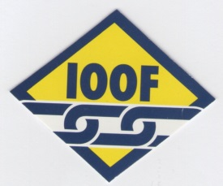

Our Vision sense allows us to gather information quickly, incidentally, holistically and at a distance, we integrate the information with our other senses to understand the world. Tactile readers absorbs information in the reverse order, they scan the parts of a tactile graphic to create a mental picture of the whole.
— Marek, 2011, Roundtable
We live in an overloaded visual information-rich world, where visual media is used to convey messages in all areas of life. We are doing our vision-impaired students a great disservice if we do not provide them with tactile graphics to develop concepts. Demands and challenges on students with vision impairment have increased because all curriculum areas are saturated with graphics.

Overview
My research investigated the tactile graphic skills required of 21st century learners with vision impairment to participate successfully in all areas of the curriculum. The research focused on various tactile graphic programs used across Australia and New Zealand to address the skills required of students. In particular, my search was for a scaffolded systematic tactile graphic program that addresses or can be adjusted to address all stages of school life.
My qualitative research method was interview using a questionnaire. I had a list of questions for production staff and a list of questions for educators, and on six occasions specialist educators and students answered a questionnaire together. I explored alternative production and educational perspectives; however, my focus was the educational perspective. I interviewed five alternative format producers and 25 specialist educators.
I travelled to Auckland and all capital cities in Australia (apart from Hobart) in a five week period to complete my face-to-face qualitative research.
Because each state had its own terminology for vision support teachers, including ‘itinerant support teacher vision’, ‘resource teacher vision’ and ‘visiting teacher’, for ease of writing this report I am using the term ‘specialist teacher’.

What is a Tactile Graphic?
A tactile graphic is an image that uses raised surfaces in order for a person with a vision impairment to touch and feel the image. A tactile graphic is not an exact reproduction of a print graphic.

Methods of production
- Collage uses textured craft items for early reader picture books.
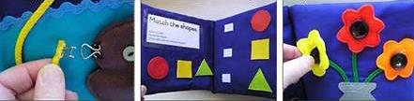
- Thermoform uses a vacuum form process called thermoform to produce a master graphic to produce a collage. Thermoform is a time consuming process and only master copies are produced. It is mainly used in textbooks.
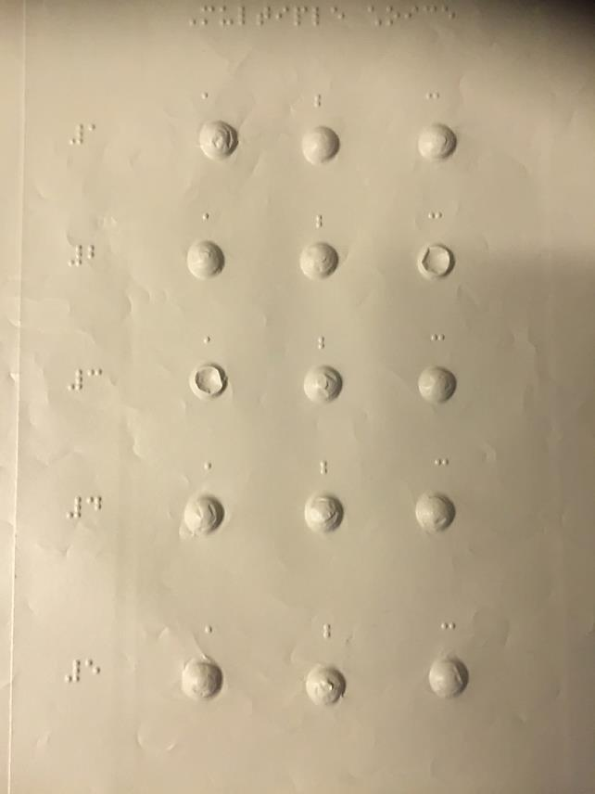
- Swell paper and Piaf (Pictures in a Flash) are quick production methods. A diagram is transferred to swell paper and put through the PIAF machine.

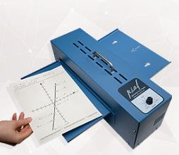 | 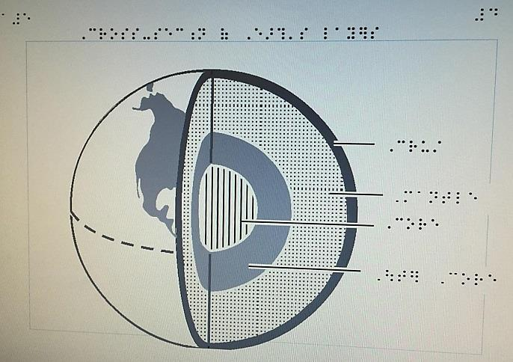

Interview Questions

Questions for educators/students
- Which tactile graphic skills do you focus on in your tactile graphic programs?
- Which tactile graphic teaching programs do you use?
- Which textures do your students prefer?
- Are there any impediments to teaching tactile graphics?
- Do you have any concerns regarding the teaching and learning of tactile graphics?
- Do you have any advice to share?

Questions for production staff
- How do you decide which medium to use for a graphic?
- Which considerations do you have when preparing a graphic?
- What choices do you make when it comes to textures – labelling, keys, numbers?
- Do you close your eyes and do a touch test?

Questions and answers from educators / students
- Which tactile graphic skills do you focus on in your tactile graphic programs?
  - perspective skills (aerial view, side view)
  - understanding of the language of lines
  - body awareness – haptic skills, spatial awareness, tactile memory, concept of scale, tracing and tracking skills, tactile perception skills
  - kinesthetic learning skills
  - concept development
  - positional language
  - various hand scanning techniques, horizontal, vertical, circular
  - use of both hands to get the gestalt, thereafter using systematic search patterns
  - use of reference points
- Which tactile graphic programs do you use?
Tactile Graphic Teaching Programs
Hungry Fingers | Lublin, Poland  Hungry Fingers Educational Tools for Young Learners with Special Needs
Setting the Stage for Tactile Understanding | American Printing House for the Blind
Picture Maker Tactile Diagramming Kit | American Printing House for the Blind
What is it Communication Game | American Printing House for the Blind
Teaching Touch | American Printing House for the Blind
Ozzie Dots | Deb Lewis and Gillian Gale  Statewide Vision Resource Centre, Victoria
Building on Patterns | American Printing House for the Blind
Mangold | American Printing House for the Blind
Picture Braille | Pentronics, 27 Birkdale Circuit, Glenmore Park, NSW, 2745
“I read with my hands” Tactile Books | Lynette Rudman  South Africa  Tactile Books
Feelix Library | Vision Australia, Victoria
Reach and Match | Mandy Lau  Reach and Match Keeping in touch
Chang Tactile Diagram Kit | American Printing House for the Blind
Little Paths | American Printing House for the Blind
- Which textures do you prefer? Your students prefer?
  - swell paper and soft textures
  - a student commented that with repeated rubbing thermoform gives an ‘electric shock’ (static electricity). Baby powder combats it (T.d’Apice)
  - a student commented on how they dislike the experience of being pricked by textures when exploring a graphic (collage)
  - ‘collage with no pipe cleaners’, a student mentioned. Use crocodile tweezers to fold edge in neatly (T.d’Apice)
- Are there any impediments to teaching tactile graphics?
  - time restraints
  - access to quality tactile resources
  - teacher knowledge and understanding
  - lack of structure and sequential development of the required skill set
  - crowded curriculum
  - tactile defensive student
  - looking pretty doesn’t equal ‘feeling real’
  - lack of pedagogy on how to teach tactile graphics
  - programs vary depending on the skill set they focus on, but there are no sequential programs with checklist to measure progress or concepts
  - class teachers are not giving sufficient notice to specialist teachers to produce tactile graphic, especially for tests and exam
  - parents’ capacity, prior to school tactile experiences
- Do you have any concerns regarding the teaching and learning of tactile graphics?
  - lack of systematic teaching approach and programs
  - lack of awareness that tactile graphics is core to the expanded core curriculum, access to curriculum, orientation and mobility
  - specialist teachers are too literacy focused
  - later aversion of students to engage with tactile graphics due to lack of exposure
  - students being unable to transition to the complex graphics that are part of technical subjects because no solid foundation or scaffolding has taken place
  - lack of knowledge / untrained specialist staff
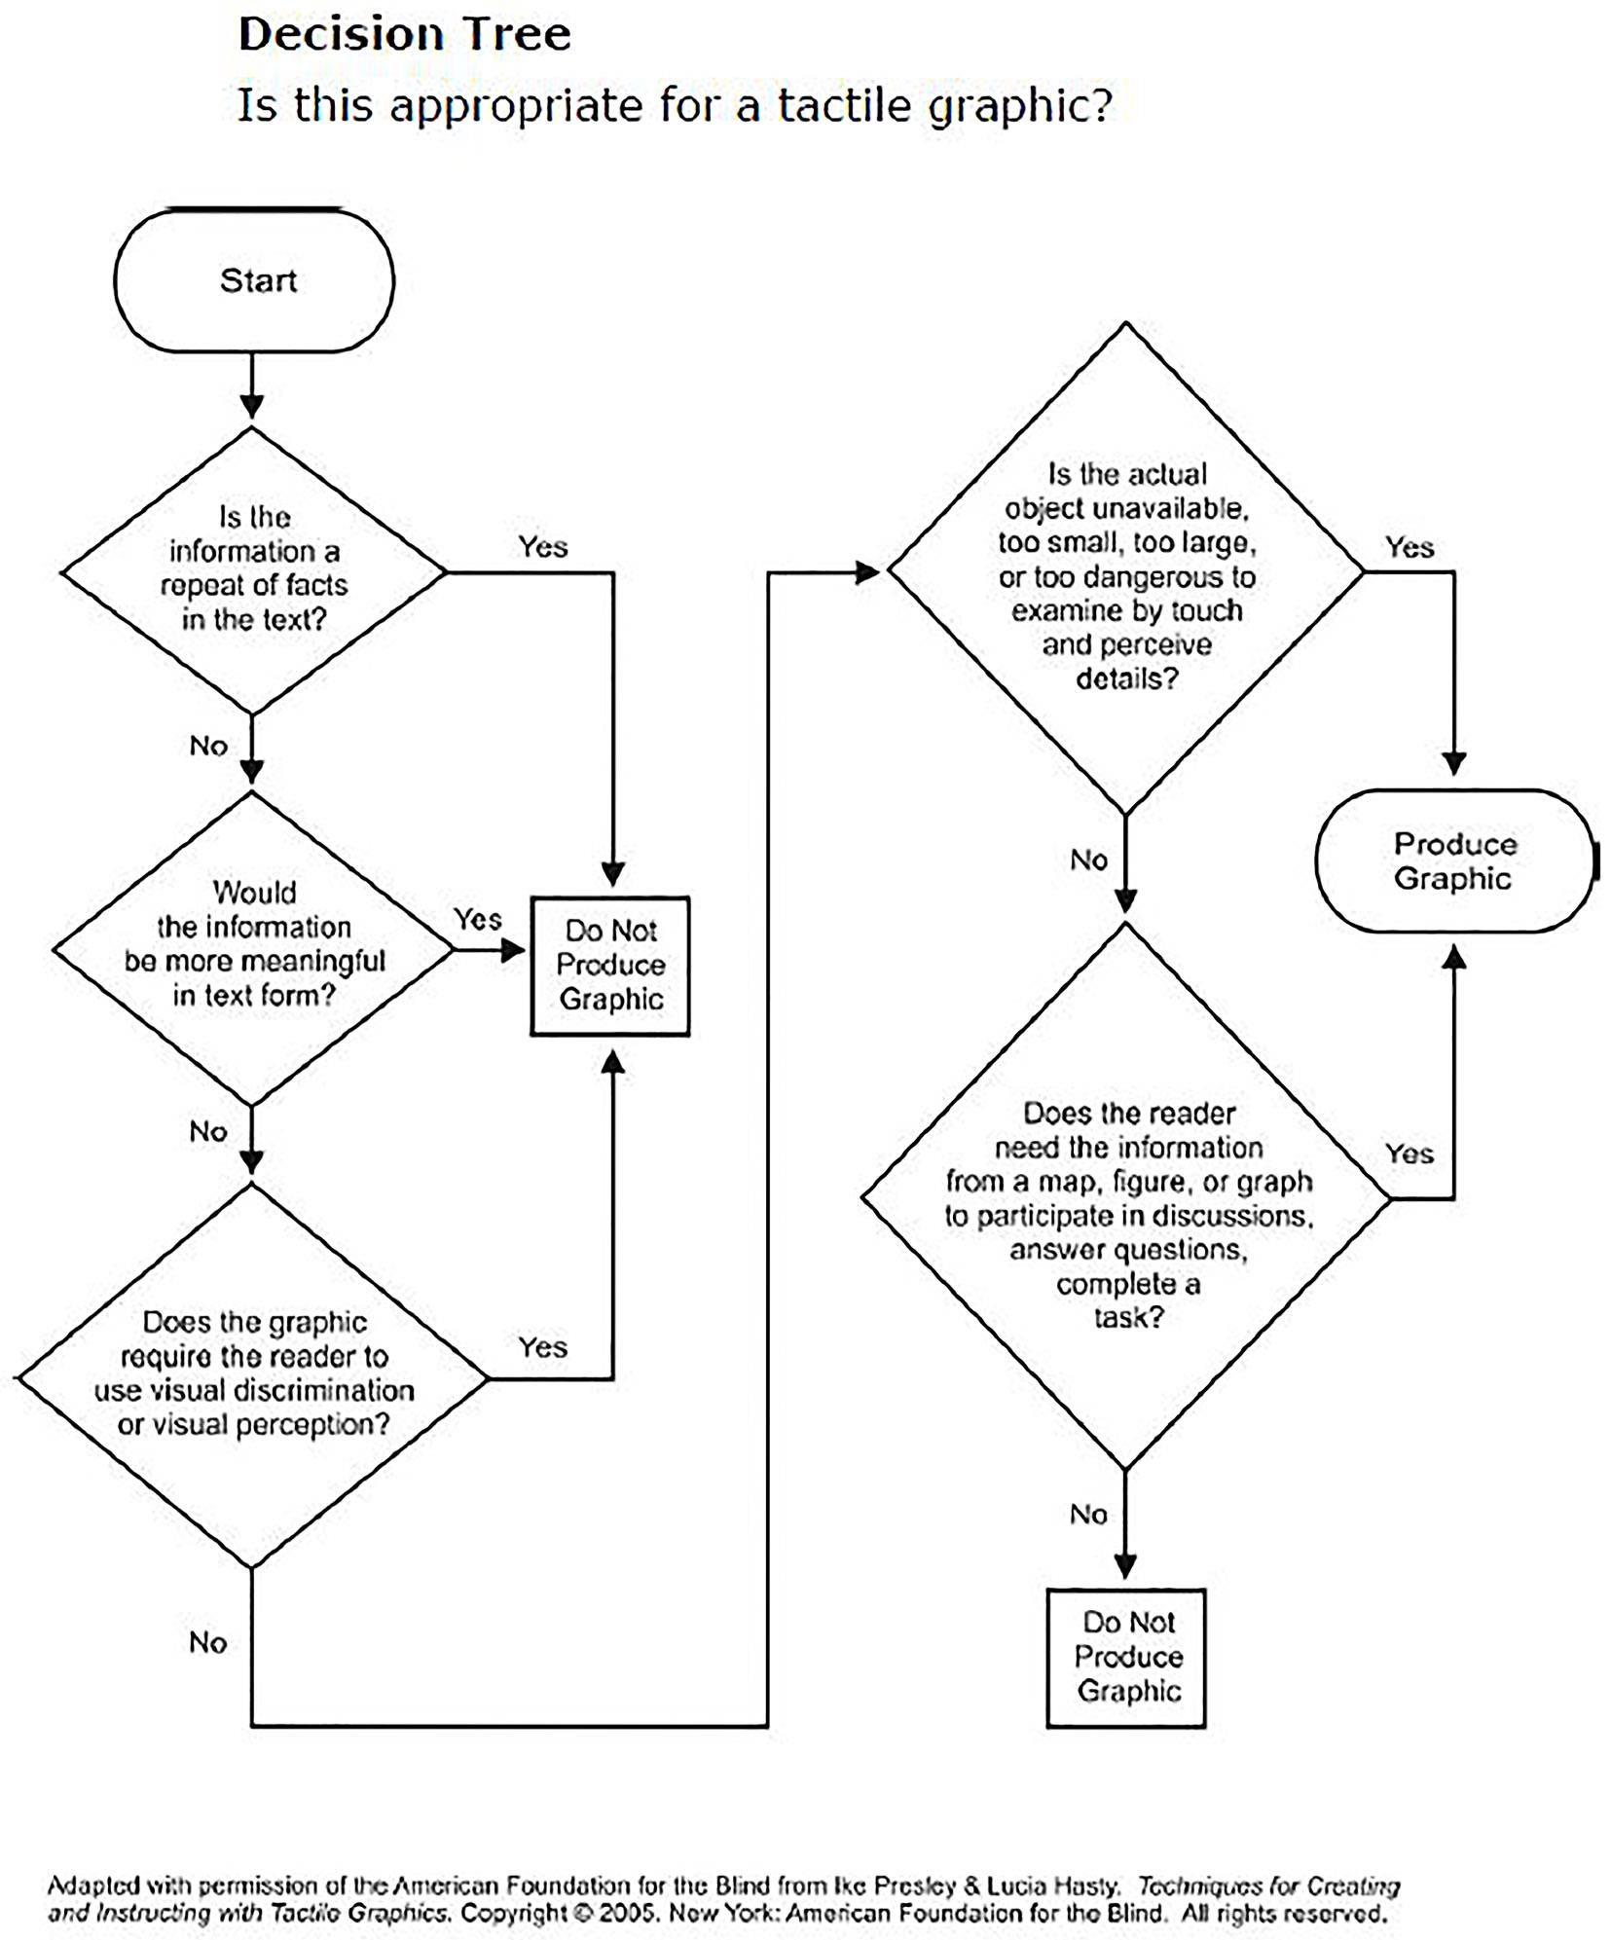
Decision tree.
Reference: Guidelines and Standards for Tactile Graphics BANA (Braille Authority of North America)

  - lack of specialist teacher knowledge about how to teach tactile graphics interpretation skills, pedagogy
  - not a core study unit of the sensory course
  - use of safe materials
  - too much focus on what a graphic looks like and not what it feels like
  - limited tactile textures to represent the visual world
- Do you have any advice to share regarding the teaching and learning of tactile graphics?
  - time is an issue; work smarter
  - find time to explicitly teach tactile graphics interpretation skills, not just as it arises in a lesson during class
  - encourage students to produce and interpret their own graphics
  - use part of your Braille withdrawal lessons to explicitly teach tactile graphics
  - tactile graphics are a major part of literacy and numeracy
  - tactile graphics is a challenging, yet essential skill
  - use the decision tree to determine when a graphic is appropriate.

Questions and answers from production staff
- How do you decide which medium to use for a graphic?
  - depends on the purpose, e.g. durability
  - availability of equipment
  - complexity of the graphic
  - cost
  - specialist teacher request
  - age of student
  - liaison with specialist teacher
  - timeframe
- Which considerations do you have when preparing a graphic?
  - time
  - check whether it’s been produced before
  - one-off use or multiple use
  - purpose
  - less clutter, avoid visual noise
  - read Braille left to right … collage books, e.g. feeling the head of the animal before feeling its tail
  - is the original good enough? explore options to maintain the integrity of the graphic
  - declutter technical material
  - student age and preference
  - stick to relevance of question and information
- What choices do you make when it comes to labelling, keys, textures and numbering?
  - labelling; the best option is for the label to be placed on the graphic
  - space is an issue; use lead line to label
  - add a label for clarity even though it’s not in print, for example, retort stand with beaker
  - refer to Australian Braille Authority tactile graphic guidelines
  - key is used if there is not sufficient space on a graphic for a label
  - key is used to explain textures on a graphic
  - use mnemonic key if label is too long
  - texture symbols; size is important and should allow for finger to feel between the texture, for example, an arrow head
- Do you close your eyes when you produce touch-test?
Producers said yes, and all alternative production teams had staff who are blind who did the proof reading.

Research Results

All specialist teachers (25) acknowledged the importance of explicitly teaching tactile graphics. Results show that, despite the importance of students developing tactile graphic skills, time is a major issue and all specialist teachers made reference to feeling time-poor. One teacher acknowledged the time factor and said that teachers have to be more innovative and work smarter.
Twenty out of the 25 specialist teachers mentioned lack of sequential programs and resources as a factor. Fourteen specialist teachers noted that university programs do not place sufficient emphasis on the pedagogy of tactile graphics. Reference was made to assessment and the Broehm assessment kit; this assessment was not common practice.
In some states and in New Zealand immersion programs are offered to students to explicitly teach tactile graphic skills, consolidate concepts and extend tactile graphics skills. Students benefit immensely and feel more confident with interpreting tactile graphics in curriculum materials at school.

Teaching and Learning
I think I know what it is like to see: It’s like telling the future because you know now that there will be a tree and I will know later, when I come up to it and touch it.
This is a vision impaired student’s perspective, confirming the importance of touch and feel to explore and create a concept. Developing concepts of shape, distance, body awareness and direction are prerequisite skills for future exposure to complex tactile graphics.
Exposure to and exploring and interpreting tactile graphics should start at an early age. In NSW Better Start kindergarten assessment identifies each kindergarten student’s literacy and numeracy skills at the beginning of kindergarten. The Better Start assessment has tactile graphics. NAPLAN, exams and assessment tasks are filled with tactile graphics.
Immersion in tactile graphics at an early age creates a solid foundation for future concepts. With the initial concept of 3D represented in 2D, the circle becomes a pie chart, multiple circles become a Venn diagram and the initial square becomes part of a Math fraction. Good, solid tactile graphics interpretation skills create a foundation for a smooth transition from 3D to 2D.
Solid concepts are developed through experience, exploration, manipulation and active engagement with their environment. Developing concepts through real-life experience allows students to express what they encounter and link language with their experience. Linking the language and experience to future experiences and transfer to similar concepts and creating comparisons is the intended outcome.
Being able to read a graphic is not enough; students must be encouraged to produce their own graphics of the pictures in their mind. Making their own allows the teacher to guide and support concept formation and to shift perspectives. A sighted person can make sense of a drawing of three lines, a person who is blind can puzzle a sighted person with a drawing of three lines. Boguslaw tells a story of an English girl who is blind who drew a picture of a London double-decker bus. She represented the bus using only three lines. One line was for the step to get on the bus, the other line was the railing and one line for her seat. She did not draw any elements of the bus of which she had no experience.

Alternative Format Production
All production staff I interviewed stressed the importance of the school, the specialist support teacher and the producer all working cohesively to ensure that students have access to quality graphics at the same time as their peers who require print copies.
The school is responsible for the education of the student and must clearly identify requirements. Reasonable timeframes for requests must be considered. The specialist teacher acts as a middle person who becomes the crucial link between the school and alternative production team. Any breakdown in communication may result in the student not having access to essential material required for teaching and learning at the same time as their sighted peers.
Alternate format production operates differently in each state; some states prepare work for other educational systems as well.
The Blind Fountain is the producer of Braille and Large Print in New Zealand and a majority of the work produced is for the Ministry of Education.

3D Printing and Tactile Graphics
I visited the Monash University Sensilab and met with Dr Matthew Butler, Professor Kim and research assistant Leona Holloway. Leona has a background in alternative format production. One of the projects I was impressed by integrates 3D printing with low cost electronics. A 3D map embedded with electronics that provide audio feedback was demonstrated. The 3D map of
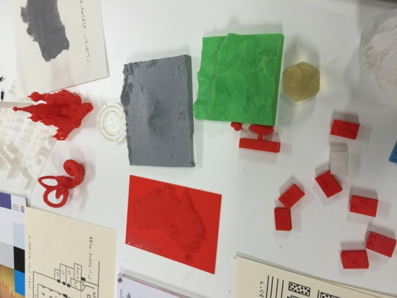 | 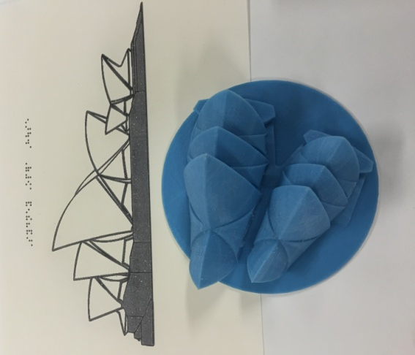
Samples from the Monash University Sensilab.
Australia had tactile indicators for the capital cities; when they were touched, audio feedback was activated and audio was given on the capital city and information about the area.
I also visited University of Wollongong Innovation iAccelerate Campus. The University’s Seed3D program engages schools and provides hands-on learning with 3D printers for all students. All activities are linked to the curriculum. This is powerful for the students who are blind as they will be able to participate in the design and have the opportunity to create their own 3D graphic.
The 3D printer opened a new world of possibilities:
- students designing, programming and creating their own graphics.
- specialist teachers using a 3D printer as a tool to create stimulus materials for lessons or exams for their students.
- tactile graphics with audio feedback (Sensilab)

Research and Evidence
There is very little research in the area of tactile graphics in Australia. My five week research and anecdotal evidence is a snapshot of the need in this area:
- Wild, Hinton (1997) ‘As today’s world of information transfer becomes increasingly visual there is the danger that the blind student with no concept of or access to the visual media will find it more and more difficult to come to grips with modern courses.’
- Kelly and Gale (1998) ‘If printed graphical material is not presented to students with a vision impairment they have been denied essential academic data.’
- Ryles, R., Bell, E., (2009, JVIB) ‘Tactile graphics for children is an underdeveloped, underresearched area.’
- Claudet (2014, JBIR) accurately describes the challenges for tactile readers. ‘To read a tactile picture by touch means to find within the tactile picture some known clues through firsthand experience. This is time-consuming, whereas for the sighted, it is all done instantaneously.’
- Dr Gillian Gale ‘To develop a comprehensive understanding, students must be encouraged to both read and interpret graphical material as well as to create and produce their own graphics.’ … ‘Although teachers have been assisting students to interpret and produce tactile graphics, systematic teaching programmes are not yet available.’ (Gale, 2000).
I completed my five week travel around Australia and New Zealand and this is still the case.

Recommendations
- discussion on how pedagogy of tactile graphics is addressed in the university teaching program for teachers who specialise in teaching students with a vision impairment
- immersion programs for students who are blind
- tactile graphics session at vision camp
- tactile graphics to be part of specialist teacher’s program
- discussing students tactile graphics skills at planning and review meetings
- integrate tactile graphic skills into Braille lessons
- more professional development opportunities for teachers in pedagogy of tactile graphics
- Department of Education (NSW) to purchase tactile graphic programs. Tactile Graphics programs to be part of resources available on loan from State Braille and Large Print Services

Useful Resources
- Facebook page – Australia & New Zealand Accessible Graphics Group (ANZAGG)
- Pinterest
- Twitter
- Lucia Hasty, Rocky Mountain Braille Associates
- Paths to Literacy for students who are blind or visually impaired

Acknowledgement and Special Thanks
- IOOF Centre for Educational and Medical Research
- Northern Territory Government, Department of Education
- Narbethong State Special School, Queensland
- South Australian School for Vision Impaired (SASVI)
- Blind and Low Vision Education Network, New Zealand (BLENNZ)
- Blind Foundation, New Zealand
- Statewide Vision Resource Centre for Vision Impaired Students, (SVRC), Victoria,
- Dr Gillian Gale, Home Visit
- Monash University, Victoria, Sensilab
- School of Special Educational Needs Sensory (SENS), Western Australia
- Visibility, Western Australia
- Media Access, Western Australia
- State Braille and Large Print Services, NSW
- Royal Institute for Deaf and Blind Children (RIDBC), NSW
- Wollongong University Innovation Campus, iAccelerate Hub, NSW
- Department of Education NSW, Vision Support Teams

