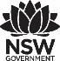
Premier’s Early Childhood Education Scholarship

The Intersection Between

Early Childhood Education for Sustainability and Reconciliation
  - A comparative study of complementary initiatives in Australian and New Zealand Early Childhood Services
Rosanne Pugh
Director
KU Ourimbah Preschool and Children’s Centre
Sponsored by

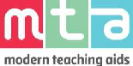

Introduction
The Australian Early Years Learning Framework (EYLF, 2011 p.6) distinguishes Australians as unique inheritors of the world's oldest living culture. In 2008, The Council of Australian Governments made a commitment to Closing the Gap in educational achievement between First Nations Australians and non-First Nations Australians within a decade. As of 2018, this initiative was on track in only three of seven objectives. The early childhood sector, uniquely positioned as foundational to life-long education, is critically influential and poised to shift cultural perspective on connectedness to Indigenous culture and therefore to Closing the Gap.

Closely linked to cultural perspective and intimately intertwined with it, is a focus on Early Childhood Education for Sustainability (ECEfS). Yet our developing Cultural Competence (EYLF, p.16; Educators’ Guide to the EYLF, p. 21) especially as seen through a First Nation People’s cultural lens is yet to keep pace with the momentum growing around sustainability (Miller 2015, p.125). In both areas of knowledge there is little Australian research and rare work on the interconnectedness of Aboriginal and Torres Strait Islander perspectives on country and Education for Sustainability. My study concerns itself with these twin educational imperatives and the complex interrelationship between them. It has been informed by contact with key educational centres in Australia and New Zealand that have fostered in children knowledge of "an intimate relationship with place…the stories and histories that are linked to place" (Ann Pelo 2008, p.128).

Focus of Study
“Life can only be understood backwards but it must be lived forwards.”
– Soren Kierkegaard (Kierkegaard, 1997, p 308).
Reconciliation is acknowledgement of past injustice and the link to present disadvantage. It is a process urging us to face our shared Australian history. The process has potential to shift thinking and cross-cultural relationships, begin cultural reform with informed generations, and realise the possibility of a renewed national identity.
First Nations culture challenges educators to appreciate divergent world views of land as “a sacred entity” as opposed to “property” or “real estate”. It urges us to reflect on “the relation of people and land” as “the template for society and social relations”, (Graham 2008, p.181). This requires educators to undertake a personal and professional reflection of their history, alongside First Nations history.
For many generations of humanity, living in nature according to its qualities, rhythms, relations, forces and movements was the way of life. Nature-literacy meant survival, and language and cultural practices were focussed on this connection for all people. Childhoods were intertwined with culture and nature. Biophilia is a term coined by Kellert (1996) to describe an "innate and genetically determined affinity of human beings with the natural world" (Wilson 1984). If we accept Kellert’s hypothesis that humanity possesses a biological affinity for nature, then we are now entering a precarious age of disassociation, where the focus of ECEfS and reconciliation seeks to narrow that gap.
The concern with ECEfS has arisen during a human-influenced geological epoch, where irreparable damage to the earth at the scale of the whole planet is seen in unprecedented species extinctions, climate change and social unrest (Klein, 2014: Steffan et al., 2007).
Many educators I interviewed in this research identified a ‘nature chasm’ in contemporary childhood. They characterised modern and typical Australian and New Zealand childhoods in terms of being over protected, highly structured, risk averse, non-resilient, micromanaged with decreased freedom and increased access to technology. There were mounting concerns for children across the single generation since they had experienced their own childhoods. Many spoke of the health issues for children and linked their pedagogy to redressing biophilia through nature immersions as a priority. It was significant that this unified all services visited.
Educators referenced the neuroplasticity of the brain in the beginning years of life where experience shapes brain architecture, to add to a mounting sense of urgency surrounding the Anthropocene for children into the future.
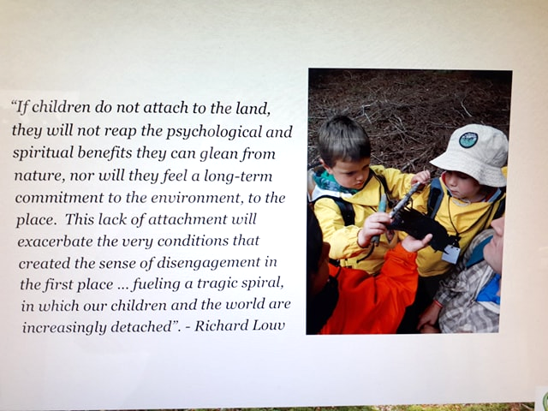
Image 1: Quote from Richard Louv taken from a presentation from the learning community (Fiordland Kindergarten, Southland New Zealand). Louv highlights a spiral of disengagement where children are in danger of increasing detachment from the land.

Significant Learning

The place of culture – New Zealand
In sharp contrast to NSW Education Services and Australian public spaces including Parliament House, bilingualism in In Aotearoa (New Zealand) is second nature to family and central to the education system. A typical public example of this includes signage from South Waikato Council and the iwi (people) of the region, Raukawa, inviting the public to be katiaki (guardians) with them of Blue Springs.
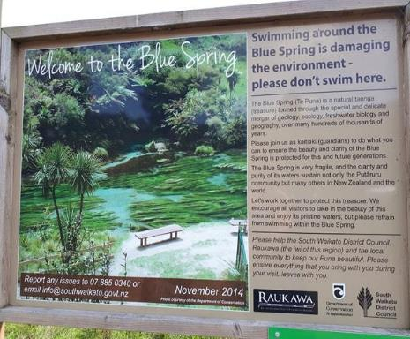
Image 2: Signage from South Waikato Council and the iwi (people) of the region, Raukawa, inviting the public to be katiaki (guardians) with them of Blue Springs.
Māori culture is shared among the many cultures in New Zealand and is the point of reference for all. Te Whāriki, the national curriculum framework for early childhood in New Zealand describes a holistic, child centred and local curriculum, based on Māori principles carefully interwoven using Māori Whāriki, (weaving with spiritual significance) as its symbol. A recent revision continues to use Māori belief systems where the bicultural, bilingual intent of the curriculum is declared (Ministry of Education, 2017).
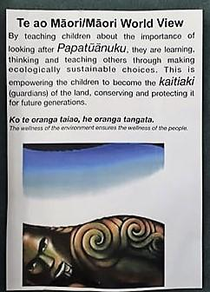
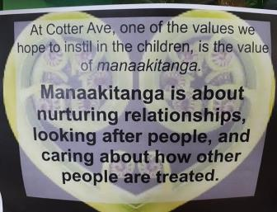
Images 3 and 4: Cultural representations on the walls of preschool for children under three years old (Cotter Ave Preschool, Arrowtown, South Island New Zealand

The place of language – New Zealand
What distinguished Aotearoa from current NSW education settings is the place language holds in forming the cultural and ecological identity of children.
All educators interviewed for this study incorporated Māori words in their everyday language regardless of their cultural backgrounds. This encompassed communications to families and their communities, to visitors and to one another; and took place whether children from Māori backgrounds were present in their services or not. The walls of rooms were full of dual language and cultural imagery and messaging. Educational concepts were imbued with Māori cultural references, both historic and current. Through this rich cultural experience, children are learning their living culture and were developing respect for it.
Māori legends were linked to the landscape of each service and the idea of Our Special Place, “To Matou Wahi Ahi Kaa” was explored with the children beyond the boundaries of the buildings in nature discovery programmes. Culture and ecology were intertwined.
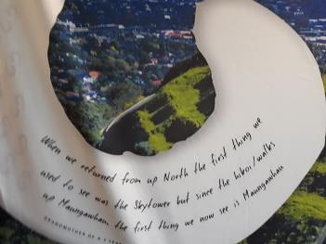
Image 5: This image describes how what is noticed changes as children experience culture intimately and refocus on significance of cultural legends to landscapes they regularly see (Māori Medium Early Childhood Services, University of Auckland)
Most significant and culturally empowering was the annual visit taken by Te Puna (Auckland) to selected Maraes of families attending their service. This exceptional cultural/environmental practice provided the greatest contrast to NSW educational settings. These extended weekend excursions made visible the Māori community of each whānau (family) to every other whānau and to staff. In this way traditional practices of communal living, sharing food and knowledge of local legends connected to landscape revitalised culture, connecting children to other children, family to family, and staff to both. The inter-cultural connections to Family Marae illustrated that relationship to place is inseparable to culture and identity. It is inseparable to being, belonging and becoming.

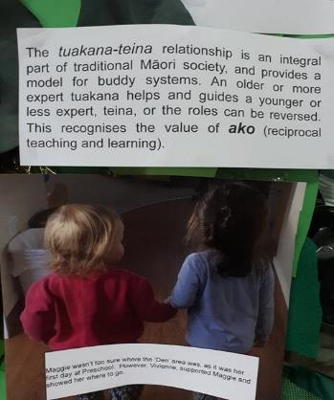
Image 6: This image embodies the principles of Te Whāriki which involve family, community and relationships (Cotter Ave Preschool, Arrowtown, South Island New Zealand)
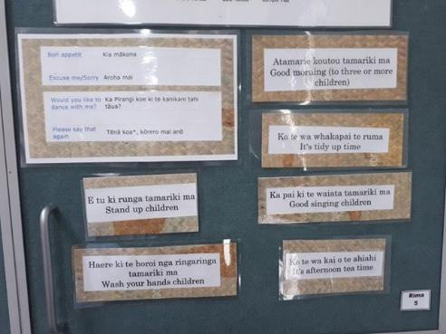
Image 7: The bilingual prompts in this image support English first language speakers to reference and share Maori for everyday phrases and instructions with children (Cotter Ave Preschool, Arrowtown, South Island New Zealand)
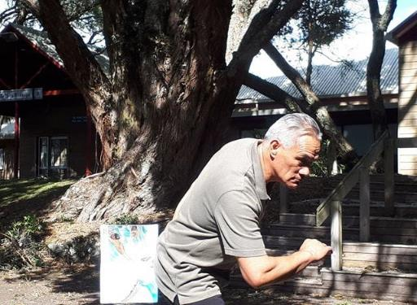
Image 8: Dramatising Māori legends outside the Marae (Hineteiwaiwa Te Kohanga Reo, Te Puna and Marae University of Auckland)

The place of culture – Australia
“The land and the sea can’t talk; we have to talk for them.”
– Djambawa Marawili AM (Gapu-Monuk, Journey to Sea Country exhibition (2018-19).
Of the services I chose to visit in Australia, in contrast to New Zealand, only one was bilingual (Yarrabah Queensland, where language had evolved from English and multiple Indigenous languages into their own creole, Yarrie Lingo). No services visited were truly bi-cultural, yet many had honoured their journey toward reconciliation through acknowledgement of local Indigenous knowledge, authentically represented through work in the arts, forays outside the services onto the land and through storying and relationships with Elders. I chose these services for their demonstrated excellence in either reconciliation or sustainability education, being innovative and inspirational sector leaders. It was unexpected that almost all services had regular outings to local natural spaces.
In practice it was clear that children attending these services were experiencing a type of mindfulness through their place-based education. This is similar to an Aboriginal form of meditation emanating from a deep connection to the land, a concentration and stillness that grounds you to place. Ms Baumann, Order of Australia recipient, senior Elder and Northern Territory Mother of the Year calls this amplified awareness “Dadirri” and like Kellert, sees this affinity with nature as supportive of mental health for all people.
Wiradjuri Preschool and Child Care Centre (ACT), as an example, found that children in close contact with a mob of kangaroos during their visits ’on Country’ over time began to move and play as if they were embodying kangaroos. This was reminiscent of Indigenous dance and ceremony. Quirindi Preschool (rural NSW) children partnered with sound engineers to create music as they explored wild spaces. Encounters with soundscapes were recorded and overlayed, made using natural materials and sounds from the environment. KU Wombarra Preschool (NSW) access their beachside proximity to immerse their children in local sea culture, beachcombing and contemplating tides, creatures, interrelationships. They explore Aboriginal histories,expressing a commitment to local wildlife through sponsorship of an endangered pygmy possum they share their playground with. Keiraville Community Preschool (NSW) use music to share their values of environmental and social justice and link song to Acknowledgement to Country. Yarrabah State School Pre-Prep is uniquely positioned to provide services in NSW with an insight into educating children who are living on native title land, situated on the largest inland Aboriginal settlement in Australia. Children in these services were awakened to ‘Dadirri’ simply be being in a state of uninterrupted communion with nature for extended periods of time.
For these children, ecological awareness was experienced in tandem with the beginnings of bi-culturalism as a natural fit and a basis for reconciliation.
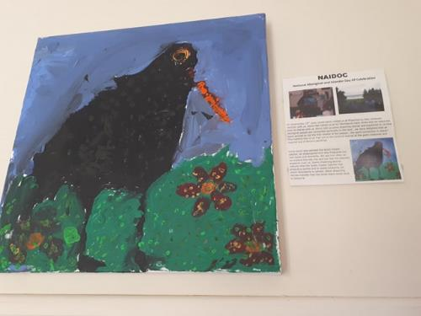
Image 9: Uncle Kevin Butler and the children at KU Wombarra Preschool painted a Sooty Oyster Catcher, an endangered bird and totem of the Yuin Nation. The children see this bird often as they explore the tide line and feel his watchful presence over them.

The place of language – Australia
“Our language is like a pearl inside a shell. The shell is like the people that carry the language. If our language is taken away, then that would be like a pearl that is gone. We would be like an empty oyster shell.”
– Yurranydjil Duurrkay, Galiwin’ku, North East Arnhem Land, Our Land Our Languages Submission, 2012
In a few services, some traces of local Aboriginal languages were present but not in children’s everyday experience. Unlike our NZ colleagues, this task is complicated given Australia’s tribal languages are far more complex in their distributions, retention and number.
“People are unlikely to value what they cannot name.”
– Elaine Brooks, quoted in Richard Louv, 2005.
There is a clear link between stewardship and naming the nature we encounter. Words connect the speaker to the landscape. As the landscape or seascape is experienced, words to describe its wonders form a “dialect of care” (Pelo, 2013 p.108). Relationships to place are powerful in determining our views and understanding of sustainability.
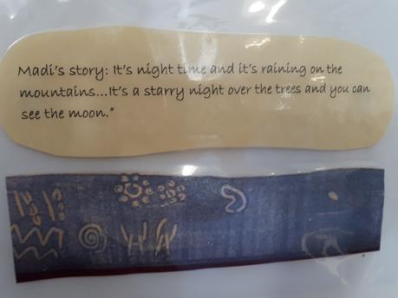
Image 10: Creating Stories using symbols from Indigenous culture (Quirindi Community Preschool, NSW)
Yarrabah Pre-Prep significantly differs from the approach NSW services take to the EYLF. Like many other Aboriginal communities, Yarrabah’s peoples, including educators I spoke with, have suffered a fragmented history. It is unsurprising then, that their main focus is on supporting children to believe in themselves, to respect who they are and understand their culture and in so doing, strengthen their identity. This valuable work extends to mentoring and supporting Indigenous educators and leaders.
Educators’ relationships go deeper and further than traditional teacher-child companionships in learning, given kinship ties to the children.
In Yarrabah the community have ownership over their everyday vernacular referred to as ‘Yarrie Lingo’, a creole evolving from contact languages. As children learn it as their first language, this creole has the integrity of a full language and as such, is their strongest language for learning.
“We welcome input from families to support children to benefit and learn these languages as we understand that Language supports children’s sense of identity, growing proud and strong in who they are and with whom they belong.”
– Classroom display
The walls of Pre-Prep speak of the vision for language learners. There are representations of the children’s current lives and their possible multiple heritages.
“As second language learners, we believe that children need lots of time to practice and consolidate new learning. We also believe that play empowers children with the ability to be decision makers, communicators, thinkers, negotiators and collaborators.”
– Classroom display
The position is to acknowledge many languages, simultaneously strengthen the community language alongside Standard English.
Aboriginal knowledge and native title influences the talk of the children of Yarrabah Pre-Prep. The children spoke to me of harvesting oysters and being allowed to open them with a butter knife, of hunting crabs, turtles, mussels, fishing, shooting and of cooking bird soup around camp fires. Children’s recollections of ‘who I am’ through annotated art images indicate the connection with family and knowing the land. Fishing and hunting looms large in their story telling. Children catch prawns with nets and are looked over by Elders who ‘read’ weather conditions for the presence of box jellyfish. Safety sits within custodial knowledge, where creeks are avoided in high tides and big rains. The educational environment complements home culture and the experiences children bring with them.
Like other environmentally instructive spaces for learning in NSW, bush and beach are brought inside to explore further. Many materials used are reflections of the culture and diversity of wildlife in the area, both plants and animals, illustrating connectedness to one another. Children paint on paper bark, on shells, they weave with traditional plants and use sticks as objects to paint on, as well as paper. Wirral shells were plentiful. Only children can harvest these under specific conditions, when the wattle blooms, and they can lightly traverse the mud flats as adults are too heavy and will sink. Aboriginal laws govern sustainability, respect and care for place. This rich home and community experience was reflected upon in preschool.

Conclusion
Our everyday lives are imbued with practices that degrade ecology and culture. This project draws on collaborative, cumulative and collective excellence in early childhood education to illuminate ways we can redress and create cultural change, to cultivate and nurture justice, to reconcile through learning and action.
Language is the glue that links culture, place and identity. It protects and sustains. It binds people together as individuals and as communities. A surprising outcome of this comparative study is the degree to which language impacts on cultural and ecological knowledge. The loss of language, of words to describe variation, unpredictability, moieties, beauty, creatures, diversity, pattern, relationship, protection means a loss in your ability to describe the landscape and your place within it. Naming nature requires being in and experiencing nature and is the strongest strand linking sustainability with reconciliation.
It is significant that the place of First Nation languages in the lives of NSW educators, like most Australians, is remote to our daily experience.
This is in sharp contrast to New Zealand. This study illustrates the contribution language makes to well-being, identity and a sense of belonging. This needs to be understood, having been absent from the Closing the Gap agenda in education. This study proposes that local First Nations languages might be the missing piece that bridges the gap. Multiculturalism complements and enriches the existing culture, so First Nations cultures must be held up, and their languages are integral to this. Australia is multi-cultural, but it should sit on a bilingual and bicultural platform that honours its First Peoples.
What is certain is that the pervasiveness of culture can act as either an obstacle or spur to socially just ways of being and to ecologically sound practices. This report reflects a refreshing collective capacity for culture building through action and living commitment. Looking through the lens of others gives a sense of how things could or might be in your own place. What better place to re-examine cultural messaging than in early childhood communities? The most significant recommendation for NSW services is to imagine the cultural shift that could happen if First Nation People’s language became less remote, if children could use local First People’s words to sustain their ecological awareness. If words and experience reflected the locality and imbued a sense of care, heritage and respect.
If we can name nature, we can also tell great stories and truths about it. There is interplay between ecological awareness, stewardship, relationship, culture, sustainability and ultimately reconciliation. No one peoples understood the landscapes of Australia better than the First Peoples. They valued and named the landscapes and seascapes. Both Māori and First Nation cultures had names that made creatures sacred and spiritual, described everchanging skies, mountains, water currents and the earth beneath. With these names came grave importance, relationship and reverence for the places they lived. Of an original number of 250 known Australian Indigenous languages, only 145 remain and of those 110 are in the critically endangered category. It is timely to act now.
If our aim is to impact practice, reconciliation and sustainability education demands a personal and professional view. To reconcile and to be sustainable is a way of ‘being’. As interest in reconciliation heightens, “ECEfS offers a unique opportunity for early childhood educators to put reconciliation front and centre and, in so doing, contribute to repairing the Earth, healing the shared but fractured histories of First Nations People, and creating a new and sustainable future, a new identity for all Australians.” (Miller in Davis 2015, p.124)

Acknowledgements
I acknowledge the contributions of educators and members of the many communities visited, who gave up personal time to attend to this project, in addition to their already full agenda of professional duties and whose thoughts, expertise and experiences were generously shared. Their many local contexts have enriched possibilities for others.
- Arrowtown Preschool, Southland NZ
- Australian National Maritime Museum - Gapu-Monuk, Journey to Sea Country exhibition
- Blue Springs, South Waikato Council, North Island, NZ
- Fiordland Kindergarten, Te Anau Southland NZ
- Hineteiwaiwa Te Kohanga Reo, Te Puna and Marae, Auckland NZ
- Keiraville Community Preschool, NSW
- KU Bulli Preschool, NSW
- KU Corrimal East Preschool, NSW
- KU Gwynneville Preschool, NSW
- KU Wombarra Preschool, NSW
- Museum of Auckland, NZ
- Parliament House, Canberra, ACT
- Quirindi Preschool Kindergarten, NSW
- Southland Art Gallery - Kā Uri Descendants exhibition
- Wiradjuri Preschool and Child Care Centre, ACT
- Yarrabah State School Pre-Prep, QLD
- Uncle Kevin Butler, Local Aboriginal Community Elder and Artist, NSW

References
- Department of Education, Employment and Workplace Relations, 2009. Belonging, being and becoming: The early years learning framework for Australia. Canberra: Department of Education, Employment and Workplace Relations for the Council of Australian Governments.
- Department of Education, Employment and Workplace Relations, 2010. Educators’ Guide to the Early Years Learning Framework for Australia. Canberra: Department of Education, Employment and Workplace Relations for the Council of Australian Governments.
- Djambawa Marawili AM, Australian National Maritime Museum - Gapu-Monuk, Journey to Sea Country exhibition
- Elaine Brooks, quoted in Louv, R, 2005. Last Child in the Woods: Saving our Children from Nature-Deficit Disorder. Chapel Hill, NC: Algonquin Books.
- Graham, M., 2008. Some thoughts about the philosophical underpinnings of Aboriginal world-views. Australian Humanities Review, 45, 181-94.
- Kellert, S., 2002. Children and Nature: Psychological, Sociocultural, and Evolutionary Investigations, The MIT Press.
- Klein, N. 2014. This Changes Everything: Capitalism vs. the Climate. New York: Simon & Schuster.
- Miller, M.G., 2015, quoted in Davis, J.M. Young Children and The Environment: Early Education for Sustainability: Reconciliation and ECEfS, Chapter 6,125. Cambridge University Press.
- Ministry of Education, 2017. Te Whāriki: He Whāriki Mātauranga mō ngā Mokopuna o Aotearoa: Early Childhood Curriculum, Wellington, Ministry of Education.
- Pelo, A., 2013. The Goodness of Rain, Developing an Ecological Identity in Young Children, Exchange Press Inc. USA.
- Pelo, A.,2008. A Pedagogy for Ecology - Rethinking Schools, https://www.rethinkingschools.org/articles/a-pedagogy-for-ecology (accessed 19 July 2018).
- Søren Kierkegaard, Journalen JJ:167 (1843), Søren Kierkegaards Skrifter, Søren Kierkegaard Research Center, Copenhagen, 1997, volume 18, page 306.
- Wilson, E.O., 1984. Biophilia. Harvard University Press
- Yurranydjil Dhurrkay, Galiwin’ku, North East Arnhem Land. House of Representatives Standing Committee on Aboriginal and Torres Strait Islander Affairs, 2012. Our Land Our Languages: Language Learning in Indigenous Communities.

