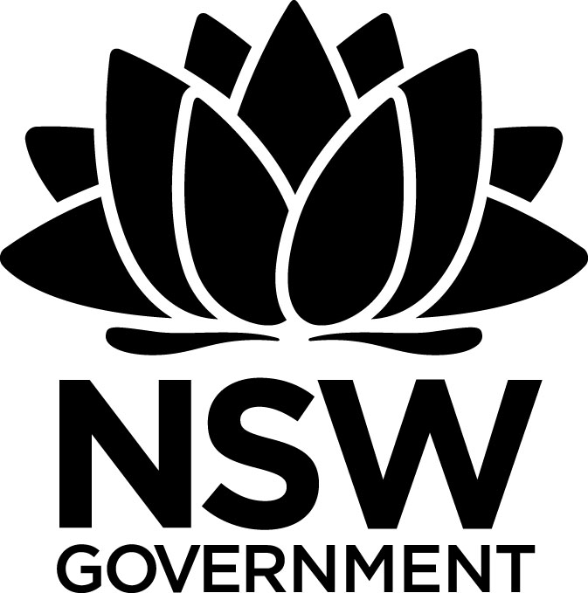
2017 Premier's Samsung Technology in Rural and Remote Education Scholarship

Investigating Science, Technology, Engineering and Mathematics (STEM) teaching in secondary schools
Mr John O’Neill
Assistant Principal, Carroll College, Broulee
Sponsored by
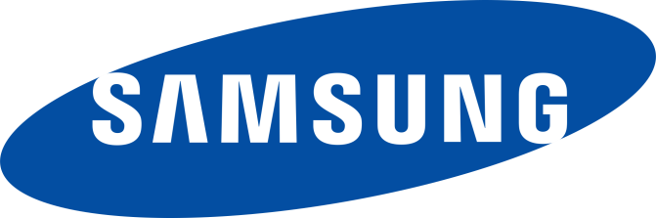

Introduction
I am the Assistant Principal at Carroll College, a regional Catholic high school on the south coast of NSW. During my 30 years as a science teacher, I have seen many changes to the way teachers practice and students learn. Undoubtedly, most of this has occurred in the last decade when the focus has changed from teaching to learning.
My study tour enabled me to investigate innovative ways of teaching Science, Technology, Engineering and Mathematics (STEM). Project Based Learning and the use of emerging technologies were central to my learning.
In January 2017, I travelled to Canada and several states in the USA for four weeks, before returning to Australia to visit schools in NSW and Queensland.
I attended three major international education conferences, participated in two teacher residency programs and met with many teachers and students in schools in both urban and rural settings.

Highlights
- Attended International Science Education Conference (ISEC) Clute Conference - Lahaina, Hawaii
- Visited Volcanoes National Park, Kīlauea Visitor Center and Thomas A. Jaggar Museum, Thurston Lava tubes
- Attended International Congress for School Effectiveness and Improvement ICSEI - Collaborative Partnerships for System Wide Educational Improvement- Ottawa
- Participated in an extended Immersion program on Project Based Learning at Tech Valley High School (TVHS)
- Toured the SUNY Polytechnic Institute’s Nanotech Complex - Albany New York
- Visited Smithsonian Air and Space Museum- Boeing Milestones of Flight, Apollo to the Moon, Albert Einstein Planetarium,
- Visited National Museum of Natural History- Human evolution, Coralyn W. Whitney Science Center- Q?rius Science education center - webcasts
- Participated in a Project Learning study tour at Center for Excellence, New Tech High Napa, California
- Attended Catholic Education’s Yearn to Learn Conference, Canberra
- Visited the Queensland Academy for Science, Mathematics and Technology - Brisbane, QLD
- Visited The Canobolas Technology High School- Orange, NSW

Focus of Study
The focus of the study tour was engaging teachers and students in innovative STEM learning. As I interacted with teachers and observed students, I particularly focussed on the depth of student learning and the integration of technology. Pivotal to my learning were the changing roles and expectations of teachers and the need for professional collaboration and learning from others. Questions stemmed from my wanting to know more about:
- what deep and authentic learning looks like
- the value and scope of project-based learning in STEM
- best practices in professional learning
- creative uses of technology in STEM learning?
An essential part of my learning was the ‘Where to from here?’ Implicit in my thinking throughout the tour, was ‘How can I apply this learning to lead improvements in the pedagogical practices at Carroll College and within the context of the NSW curriculum?’ Prior to the study tour, we had begun the journey of moving to a more student centred, inquiry focused pedagogy. The experiences of my study tour provided me with the knowledge, first hand experiences and the impetus to take that further.

Significant Learning

Deep and authentic learning
I was privileged to be able to attend the International Congress for School Effectiveness and Improvement Conference in Ottawa to listen to many leading educational experts from Canada and across the world. Michael Fullan’s keynote speech ‘The Deeper Meaning of Deep Learning’ challenged us with what he calls the ‘New Pedagogies’. Teaching must shift from focusing on content to focusing on the learning process. Through deep learning tasks, students develop the ability to build new knowledge and lead their own learning. Technology must be at the heart of learning for today's students. Using technology both inside and outside the classroom 24/7, students need to become creators, rather than simply consumers of technology.
Deep learning is reliant on three interrelated components:
- New learning partnerships must be formed between and among students and teachers
- Authentic learning tasks that re-structure the learning process towards knowledge creation and purposeful use.
- Digital tools and resources that enable and accelerate the process of deep learning.
With the emergence of cheaper technology and digital access, all schools are now able to provide students with innovative teaching and learning. Increasing teaching capacity, especially for those teachers not confident with technology, is fundamental for new pedagogies to be effective.
At the heart of change, is the teacher's understanding of their changing role. For deep learning to occur, teachers must have a more active role, both with students and with other teachers. They need to have strong and consistent impacts on their students’ learning by guiding and challenging them to clearly define their own learning goals. Teachers are responsible for helping students to develop growth mindsets and master the difficult process of learning. Deep learning is fostered by collaborative learning, peer tutoring and learning experiences that encourage risk taking and learning by failing.
At the Yearn to Learn Conference in Canberra, Kath Murdoch talked about using an integrated, inquiry approach to teaching as a natural context for a ‘thinking oriented’ curriculum. Consciously adding a layer of deep thinking to inquiry learning supports students to develop higher levels of transferable learning. When teachers make thinking explicit, by talking about it and modelling it, students develop a clearer understanding of their own thinking processes.
To maximise deep learning, teachers and students should ask questions such as:
- What will we need to think about before we get started?
- How might we go about organising this information?
- What should we do to get another point of view about this?
- How are you feeling about what you have learned so far?
- How are your ideas changing?
- What are you noticing about your thinking? Has it changed?
- Is there another way you can show me your learning?
- What kind of thinking will we need to do to achieve this?
My visit to Canobolas Technology High School CTHS, one of only eight STEM action schools in NSW was enlightening. The school is experiencing considerable success with its multidisciplinary Project Based Learning (PBL) approach to teaching STEM. Using PRIME- Problem, Research, Investigation, Making, Evaluating as a scaffold for learning, students engage in authentic real-world problem solving tasks.
The remodelled STEM centre incorporating the school library provides spaces for students to think, explore and make. The Thinker's Space is a comfortable space where students can spread out to design, draw and create ideas. The Explorer’s Space houses the library and other resources. The popular Maker's Space includes benches and craft spaces, a computer-aided design lab and 3D printers.

Project Based Learning
Whilst Project Based Learning (PBL) has recently appeared on the educational scene in Australia, it has been a major contributor to change and school improvement in the USA for twenty years. The New Tech Network provides extensive planning, design, and implementation support that guides schools towards transforming teaching and learning.
Through project-based learning, students collaborate on authentic projects that require critical thinking, creativity, and communication skills to answer challenging questions or solve complex problems. By making learning relevant and meaningful, students see a purpose for understanding new concepts and mastering skills. Students are not only assessed on their short-term memory and/or understanding of academic content, but on their ability to successfully apply that content when solving authentic problems in collaboration with others.

The essential elements of PBL are:
- Challenging problem or question
- Sustained inquiry
- Authenticity
- Student voice and choice
- Reflection
- Critique and revision
- Public product
The fundamentals of project learning align closely with the deep authentic learning that students in today's classrooms should experience In New Tech schools, students are engaged in learning content, knowledge and skills through school-wide learning outcomes (SWLO). Such learning outcomes are fundamental to success both at school and in the future.
Rubrics are used consistently to assess student learning against the following outcomes:
- Agency - the ability to develop a growth mindset and take ownership over learning
- Collaboration - the ability to be a productive team member through strong interpersonal communication, a commitment to shared success, leadership, and initiative
- Oral Communication - the ability to communicate knowledge and thinking through effective oral presentations
- Written Communication - the ability to communicate knowledge and thinking through writing
- Technology and Information literacy
- Knowledge and Thinking - the ability to reason, problem solve,, develop sound arguments and create new ideas by using appropriate sources and applying the knowledge and skills of a discipline.
My experiences throughout the immersion programs at schools within the New Tech Network were second to none. Tech Valley High School in Albany, New York and New Tech High in Napa, California both provided me with an intensive and personalised program of sustained inquiry and practical learning about PBL.
I shadowed teachers as they planned and taught interdisciplinary STEM classes and observed students involved in quality project learning. I was extremely impressed by the high levels of student engagement and student teacher collaboration. With the support of experienced staff, I planned several projects, rubrics and pacing charts to implement at my own school. Staff were adept at mapping and addressing the common core state standards (curriculum) and developing relevant projects to best teach those standards. Individual pacing charts were used to monitor and support each student’s learning and accountability.
The ‘Need To Know’ NTK strategy where teachers and students identify what they need to know at the beginning and throughout each project, is essential for ensuring key concepts or knowledge are taught and not overlooked. The NTK is visually displayed both on the whiteboard and on students’ devices and is continually updated as the project unfolds.
Students from Tech Valley High School spoke with me about their experiences, which were both positive and challenging. They were extremely candid and explained that not all students cope well with PBL. One student spoke about how difficult it was when she first commenced, as she had always been an ‘A’ student but could not sustain that level at her new school. Reflecting on her learning and realising that project learning required much more than learning content off by heart, was a significant milestone in her personal learning journey. Students’ self-monitoring their own learning using SWLO and pacing charts were considered essential for success.
Other students spoke about the importance of having Group Contracts and Group Agreements for each project. Group Contracts outline the roles of each member e.g., facilitator, quality control and Group Agreements establish shared expectations about behaviour during the project. Communication, decision making, access, accountability and conflict resolution are discussed and agreed upon by all group members. Both schools were incredibly proud of their students’ determination and commitment to improving all their school wide learning outcomes.
Whilst I thought I would be learning primarily about PBL at the New Tech schools, I came away from each program with a wealth of information about leadership; building teacher capacity through professional learning, collaboration, instructional rounds and classroom observations. I felt privileged to be in schools where the teachers were willing to share lessons learned from utilising project based learning and integrated curriculum design. My firsthand experiences provided me with many practical ideas and actions for making changes and ongoing improvements at my school. Furthermore, my involvement in the immersion programs was a first step as both schools have committed to providing ongoing professional support.

Professional Learning
At the International Science Education Conference, I attended a broad range of sessions, including several about leadership. Thomas Wright’s presentation on Sharing Content and Pedagogical Knowledge provided a research background about different types of professional learning. A professional learning culture is reliant on a high degree of leadership support for teacher learning and risk taking. High levels of teacher interaction and co-dependence, together with trying new ideas, leads to improved pedagogical practices.
Team planning and team teaching have positive impacts on STEM learning in schools. Colleagues jointly plan units of work, lessons, activities and homework tasks. Team teachers take responsibility for teaching a common group of students and cooperate in the planning and delivery of lessons to the student group. Where teachers share the teaching, individuals learn with and from each other. Teaching practice becomes less privatised and teacher and school performance more transparent. Teachers are supported by their colleagues to improve practice and try new ideas. In a team teaching environment, individuals are more likely to develop skills in their areas of need. Teachers’ professional goals can be jointly decided, monitored and reflected on. Feedback from trusted peers, rather than those in positions of leadership, is more likely to be taken positively and acted upon.

At the ICSEI conference in Ontario, Lyn Sharratt spoke about the of impact of collaboration or as she calls ‘co-labour’. Collaboration is foundational to improving learning and performance. Collaboration is more than teachers working together. It is when they are responsible for both their own learning and for the collective improvements in a school. Everyone needs to go through this process; they must own it and it needs to be sustainable. Risk taking and the ‘fail fast’ mentality are essential. As Sharratt explained, making teachers safe and comfortable will not disrupt things and therefore not make any change. They must have the ‘fail fast’ mentality to get change to happen.
My experiences at schools in the USA, especially those implementing PBL , suggest professional learning and collaboration are the norm. Learning teams plan and co teach regularly and significant collaborative planning time is allocated to each team. Instructional rounds (walks) are common practice. Leaders and teachers regularly visit classes to see students’ learning. Teachers spend 20 minutes in other’s classes and evaluate student learning and engagement in the projects. Using the 6As criteria for high quality projects; Authenticity, Academic Rigor, Applied Learning, Active Exploration. Adult Connections and Assessment Practices, and the School Wide Learning Outcomes, teachers assess student learning. A driving question for each visit is also developed .e.g. What practices or strategies can I apply in my own classroom? This ensures teachers are learning from each other. The visits vary slightly e.g. looking for student’s learning dispositions, engagement in projects, collaboration etc., however the focus is always on learning, rather than teaching. If teachers are struggling and have a limited range of pedagogical practices, student learning will be minimal. When performance is an issue, in-class observations of a specified element of teaching are conducted, with feedback and support provided.

Technology
Like most teachers in schools, I am yet to fully realise or even imagine what I could and should be doing with technology in the classroom. Whilst technology has the potential to be the biggest driver in changing education, my experiences both in Australia, Canada and the USA, suggest it continues to be primarily used to do what teachers have always done using a whiteboard or blackboard. The content may be more entertaining and visually attractive, but the learning is still limited to the practice of skills and delivery of content.
At the ICESP conference, Fullan suggested that without changes to the way most teachers teach, and most learners learn, technology will continue to be used to supplement conventional teaching strategies that focus on reproducing existing content knowledge delivery or basic skill practice. According to research, relative to other interventions, technology has a below average impact on improving student outcomes, but as Fullan suggests this is because it has only been used in such basic ways. With limited knowledge and skills, the great majority of teachers use technology to deliver content rather than have students create their own learning. Students are essentially ‘consumers’ of knowledge, albeit through a digital resource. Online research and the use of educational applications and digital tools have replaced libraries, board games, pen, and paper. The learning itself has not changed significantly.
The following data from the Innovative Teaching and Learning Research Project 2011 shows how teachers across seven countries report on the way that they ask their students to use information and communications technologies:

How teachers ask students to use technology (skills)

High-level uses of technology- Knowledge creation
- Work with others from outside class 5%
- Use simulations or animations 5%
- Create multimedia presentations 6%
- Collaborate with peers on learning 9%
- Access class resources or online materials 12%
- Analyse data or information 15%

Basic uses of technology - Information Consumption
- Write or edit stories, reports, or essays 15%
- Take tests or turn in homework 17%
- Practice routine skills and procedures 26%
- Find information on the Internet 36%
Technology is still primarily used in basic ways that layer technology on top of traditional teaching and learning, rather than for collaboration and knowledge creation.
In recent years, many schools have moved to using collaborative learning tools such as Google classroom and this has created a much broader use of technology. Students are now collaborating and co-constructing learning 24/7. In some classrooms, students are engaged in high quality use of technology. Teachers must be encouraged to experiment with innovative and creative learning using technology. Creating videos to explain learning and uploading to Youtube and creating simulations are examples of both powerful uses of technology and deep learning. Students are actively engaged as they participate in learning that is exciting and meaningful and develops their imagination and creativity.
Possibly, the most exciting part about technology in education is what we do not even know will exist into the future.

Conclusion
Since my return, I have implemented several structural changes at Carroll College designed to improve student learning. Teachers are provided with significant support and planning time to design, implement and reflect on collaborative teaching practices that improve student engagement.
- Year 7 and 8 Humanities (HUMS) classes have been created. The same teacher teaches English, HSIE and Religion. Teaching teams develop integrated units and team teaching is occurring.
- STEM Year 7 - An additional STEM line has been timetabled. Classes are timetabled together to allow for team teaching.
- Project learning is the pedagogical approach in STEM. School developed student learning outcomes (similar to those used at New Tech) are used to assess learning instead of content outcomes.
- Coding is part of the STEM program in Year 7.
- Learning teams established in Year 8 Mathematics - Five teachers released to collaboratively plan each unit. On a rotational basis, one teacher implements the agreed lesson plan with their class while the other four teachers observe student engagement. Following the lessons, all teachers discuss what worked well, identify areas for improvement and modify the lesson plan to suit. The modified lesson is then taught by the other teachers to their classes.
- Videotaping lessons- Teachers nominate to have lessons videotaped. Discussion with colleagues follows to suggest improvements.
- Google Applications - teachers and students use G Suite to share ideas, plan collaboratively and present their learning.
- A BYOD program is being implemented across the College from 2018.
- The STEM team has presented their work to the staff and prospective new students and parents at an Open Evening.
- Our STEM structure has been presented to all Science Coordinators in our system and they have been invited to visit us.
- The College reporting template is in the process of being revamped to focus on students’ learning habits rather than content recall.
- An article about my study tour was printed in the Sydney Morning Herald and the IEU “Newsmonth” publication.

Whilst Carroll College is still in the early stages of our STEM/PBL journey, we would welcome anyone who would like to visit to learn more about our programs. Please contact the author to arrange a visit.
For further information about PBL, please visit these sites.
https://newtechnetwork.org/resources/category/resources/
http://techvalleyhigh.org/ProfessionalDevelopment/index.htm
http://newtechhigh.org/
https://www.cluteinstitute.com/conference-proceedings
http://www.icsei.net/
http://www.bie.org/

