
Premier’s IOOF Centre for Educational and Medical Research Itinerant Support Teacher (Vision) Scholarship

Braille literacy research Australia and New Zealand

Tricia d’Apice
Royal Institute for Deaf and Blind Children
Sponsored by


Introduction
“There was minimal published data or accepted methodologies available that could be used to compare the reading speeds of Braille reading students to sighted students” (IOOF 2016). As a recipient of a NSW Premier’s Teacher’s Scholarship in 2016, I endeavored to rectify this, both around Australia and New Zealand.

Focus of Study
After ethical approval for the nature of the research, the appropriate authorities were approached with an invitation to for their region/organization to participate. Principal, parental, vision support teacher and child consent were required in order to have Braille reading speeds assessed.
Most of the Braille and dual media students around Australia and New Zealand were invited to participate in the research. The criteria included school-aged students from K/P – Year 12, who did not have a cognitive impairment, and who were reading Braille by touch.
During the researcher’s five-week study tour, (and some remote testing), 63 student participants were assessed.
As research was delayed in two states there are still further participants to be assessed, potentially fifty-seven students, however 100% participation level is not expected.
A secondary study took place that surveyed vision support teachers regarding the mainstream resources, braille specific resources, teaching strategies and mnemonics they used in their teaching of Braille to students; 31 have replied to date.
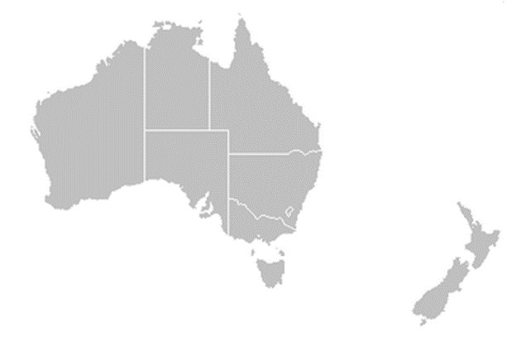
The majority of remote students were assessed via video conference.
Cities visited on the research trip
Cities to be visited (as ethics approval had not beenreceived)
Image 1: Map of Australia showing citites visited during the research trip

Details of Student participants




N = 63 to date

PARTICIPANT'S VISION LEVEL
No Light Perception 36%
Low vision 24%
Light perception 40%

Of the Participant’s with Low Vision 14 or 22% of the whole participant group were dual media readers

Image 2: Enter description
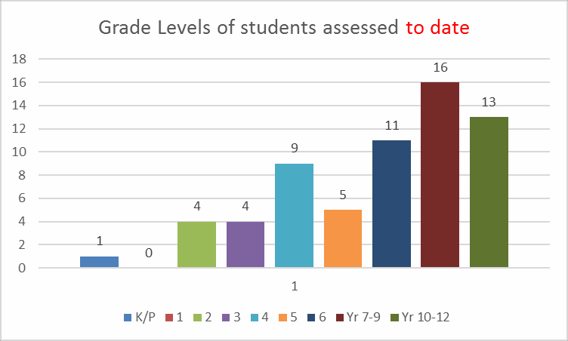
Image 3: Enter description

Instruments used throughout the study were:
- YARC assessment of reading for comprehension
- Lorrimer Braille Recognition Test
- TOOZE BRAILLE SPEED TEST

Significant Learning
As the research is ongoing, generalisations arising from the preliminary results are reported below. All reported data will be further analysed once all assessments have been completed. A series of interesting findings on the preliminary analysis of the data is presented in table 1 and discussed below.
Instrument | Purpose | Findings
Tooze Braille Speed Test | Test 3 letter words that do not contain Braille contractions | Many students were reading at or close to age level.
Lorrimer Braille Recognition Test | Test of ability in reading Braille contractions | Many students who did well in the Tooze, did not score as well on this assessment.
YARC Primary Level | Mainstream Fluency Test | Many students performed years below their age level.
YARC Secondary Level | Mainstream Fluency Test | Many students performed years above their age level.
Table 1: reported findings according to tests.

Explanations of possible reasons
Both the Braille assessment tools were developed in England at the Royal National Institute for the Blind in 1962, which pre dates the move from special schools for the blind to mainstreaming individuals into their local school. The rigors of teaching Braille contractions by staff who all know Braille and were with the students throughout their entire school week, may have been more intense.
Vision impaired children do not learn about worldly concepts beyond their physical reach, as sighted children do through watching television, looking out the car window, looking at picture books etc. Concepts beyond the vision impaired child’s life experiences have to be taught. Many of the students did not understand the stories they were reading, a number of the words and concepts were unfamiliar, resulting in a loss of reading fluency and confidence. Examples included:
2A. robins, red breast, woods, bank (of a river)
3A. Burglar, silver on the mantelpiece, overcoat, briefcase, baton, handcuffs
5A. Portion of a campsite, pole bearers, line of sausages, brandishing, judgement had been premature.
6A. Pirate, romantic heroes, cutlasses, musket, empires, buccaneers, Caribbean, corsairs,
Mediterranean, Blackbeard, condemned to hang, received a reprieve, eventual fate, matter of speculation.
SL1. English lawn, sudden climax of wind, parched earth
This lack of understanding regarding the stories they were reading could have influenced their performance on the YARC Primary.

Study results - vision support teachers
Vision support teachers were asked to complete a questionnaire regarding resources, teaching methods and Braille mnemonics. A brief summary of the findings is presented below.
N = 31 to date.

Fun and games
Many vision support teachers alluded to the fact that the reading content is most suitable when based around the individual’s interests and when experiencing books around the child’sdaily living, family and friends, as well as activities included the child’s life experiences. These were usually handmade books with tactile pictures. The student was then able to keep the books, not have to give back to a library after a short period of reading.
Interesting topics relating to the child were found on the internet, and then converted to Braille, including word searches, interesting facts, games, jokes, recipes. Other activities include:
- Go Fish
- Old man
- Flip books
- Language Master
- Posting boxes
- Fishing game
- Memory
- Board games
- Matching
- Book Bags / Sacks

Resources
The survey of vision support teachers emphasised the importance of personalised handmade experience books and materials, to assist the students to gain meaningful information through literacy. The commercial preferences to date for resources was for the Australian Braille reading program Ozzie Dots.

Serendipitous findings
Several interesting and serendipitous findings have arisen from the research, these are detailed below.

Non-slip mats
Reading Braille can be fraught with some inconveniences, such as books and pages often slip on the table surface, the pages can be large (11” x 11.5”), and the quality of the dots compromised by travel damage.
Non-slip mats in the past have hardly done their job, however a new kitchen product has ensured that non-slip mats are truly non-stick; these are silicon baking mats that were very much appreciated by participants and teachers alike.
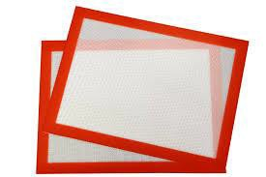
Image 4: Non-slip mats
Staff from South Australian School for the Vision Impaired were the first to alert the researcher to this product, however they did also inform me that they had bought out the whole supply from their local shops. The one mat purchased and used by the other sixty students remained firmly non-slip, even after many applications of baby powder (fairy dust) to allow for smoother reading.

Braille Trays
The old muffin tin is still popular, as well as variations of the concept. Students still enjoy representing the dots in a Braille Cell using gross motor reinforcement, the half egg carton, ice trays, magnets and the Braille key ring are also used.
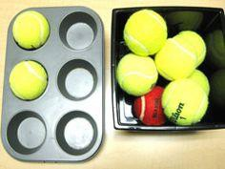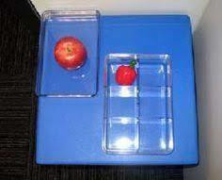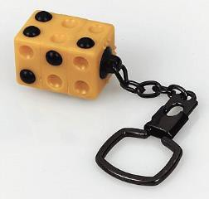
Image 5: Muffin Tins , Ice Trays and Braille key ring

Braille Mnemonics
Braille mnemonics are visual reminders for sighted people who are learning Braille, videos of these are online. Instructions are provided for the audio described version on this site.
Below are the mnemonics that were presented to the vision support teachers, and it appears that many of teachers have been using much the same ones for years.
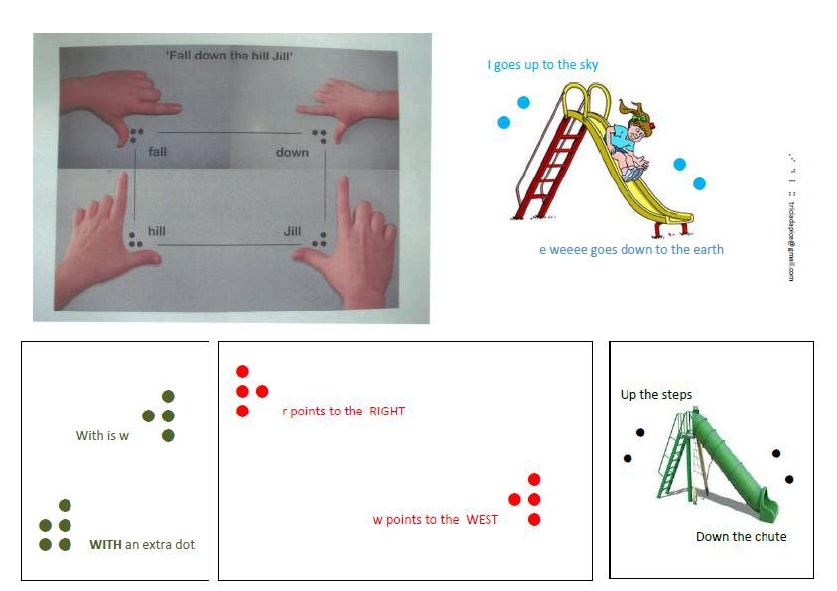
Image 8: Examples fo Braille Mnemonics
The mnemonics that appear below have been developed by the researcher as an outcome of the study. Animations of all of these can be viewed on YouTube. A double-sided laminated resource will be produced for circulation on completion.
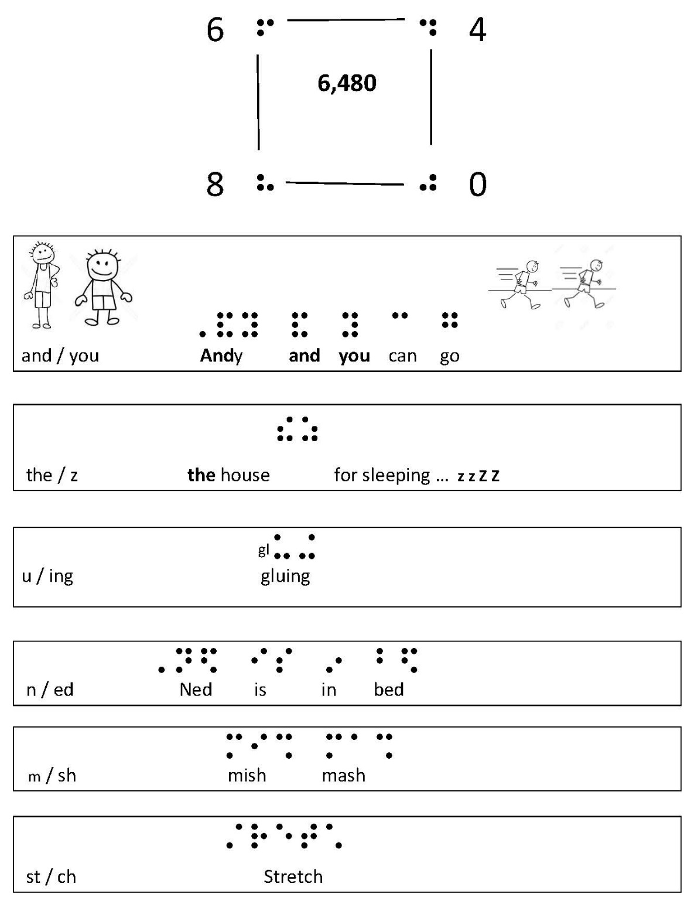
Image 9: Examples fo Braille Mnemonics

The following variations were provided by the vision support teachers.
Braille cells involved | Mnemonic
f, d , h, & j. | 
f, d , h, & j. | Block of wood with f,d,h,j, on student’s desk
f, d , h, & j. | Fat dogs high jump
f, d , h, & j. | d hooks to the left, f to the right
f, d , h, & j. | h says 168
i & e | E leans against the wall  I I don’t fall over
Jill is up the hill
I am up the hill with Jill
and & you | J y & me  just you and me
w | Wiggle to the left www (Skye Jones)

Dots 456 and Final Contractions
Dots 456 their world cannot have had many spirits
Dots 45 upon my word, whose are these and those
Dots 46 visionless counts danced around the fountain 46 times
Dots 56 The 56m long cement fence in the city was an awful section of ugliness

Popular Teaching Strategies
Below is a list that summarises the popular teaching strategies shared by vision support teachers.
- Repeated Reading
- Paired Reading
- Guided Reading
- Echo Reading
- Daily 30 minutes reading aloud to adult or peer
- Reading a variety of Braille, refreshable, books, thermoform
- Explicit teaching of new contractions, braille tray, rules etc.
- Act out stories
- Jump the shape of the letters out on the ground
- Beginner student labels own classroom
- Group reading with vision impaired peers

Braille Specific resources used by vision support teachers
The following list includes Braille specific resources shared by the vision support teachers.
- Ozzie Dots
- Mangold Braille Reading Program
- I do like it
- Patterns
- Mangold
- Spot the Dot
- Braille in Easy Steps
- Abi Books
- UEB Practice Sentences, Roberta Becker
- Ann and Friends, beginning Braille Readers
- Ready to read, PM (NZ curriculum)
- Braille for Infants (RNIB)
- Take Off Braille Reading Series 1,2,3, & 4,
- Ladybird Graduated Braille Readers
- Alphabet book with tactile pictures

Mainstream resources used for teaching Braille
- Reading with phonics, mainstream
- Oxford Reading Series
- Short novels from Go Girl, Boys Rule etc.
- Dr Seuss
- SRA
- A-Z reading

Apps
- Braille Large Print App
- Braille Tutor

Conclusion
Australia and New Zealand has a vast area to cover just to reach capital cities, let alone individuals with a vision impairment in rural and remote areas. Logistics to try and reach most children with a vision impairment was very challenging.
A thorough ethics process is mandatory to ensure the safety of participants particularly when doing research with children and those with disability. Gaining ethics approval changed the concept of a five-week study tour, into a lengthy research procedure requiring over a year to finalise. At the time of this report writing, there are still ethics applications being rewritten, for the vision impairment organisations in those states to be approached.
Comparison and benchmarking of results from other studies with this study have not been possible as this is the first of its kind in Australasia.
This work was produced by Tricia d’Apice a recipient of a Premier’s IOOF Centre for Educational and Medical Research for Itinerant Support Teacher (Vision) Scholarship, 2016, awarded by the Premier of NSW.
This study is the first of its kind in Australasia. It is anticipated that it will provide critical information on Australian Braille readers and provide a foundation for ongoing, necessary research.

